Topic 12. Muscle tissue

- Define terms: endoneurium, perineurium, epineurium, Ranvier node, schwann cell, mesaxon, afferent neuron, efferent neuron, exteroreceptors, proprioreceptor, interoreceptor, projection neurons, interneurons, membrane depolarisation, membrane hyperpolarisation, saltatory conduction.
- Classification of neurons.
- Morphofuctional features of encapsulated sensory receptors, example.
- Morphofuctional features of free nerve endings, example.
- Classification of synapses.
- Morphofuctional features of chemical synapse, a mechanism of action, example.
- Comparision of unmyelinated nerve fibers and myelinated nerve fibers.
- Molecular mechanism of nerve impulse transmission in myelinated nerve fiber.

Procedure
- All preparations must be examined with magnification of 100x and 400x.
- Drawings must be prepared using magnification of 400x.
- IF TWO NECESSARY CELLS ARE FAR SEPARATE IN THE SAMPLE– PLEASE DRAW THEM TOGETHER!
- Include, optical magnification, size of scale bar and structural elements of tissue in the figure legend.

Drawing | Structural | Minimal size in a drawing
1 Nerve x400 | Longitudinal section and cross section.  Endoneurium, perineurium, epineurium, bundle of collagen fibers, schwann cell, neuron, ranvier node, fibroblast nuclei, Schwan cell nuclei. | Nerve fibre  d - 1cm
2 motor end plate  x 400  “Terminacion de nervio motor” | Longitudinal section and cross section.  Sceletal muscle cell, A-band, bundle of neuros fibers, myelinated nerve fibers, motor nerve endings, presynaptic membrane, postsynaptic membrane. | Muscle fibre  d - 3cm
3 Taste bud x 400  „Seccion de papilas gustatavias” | Longitudinal section  Oral cavity, taste bud, taste pore, sensory cell, stem cell,glial like cell, stratified squamous epithelium, loose connective tissues, afferent nerve. | Taste bud  l – 5 cm

Example, small magnification
Muscle tissues. A – Sceletal muscle tissue, magnification 100x, H&E staining; B – Heart muscle cells, magnification 400x, , hematoksilin, C – Smooth muscle tissue, magnification 100x, H&E staining.

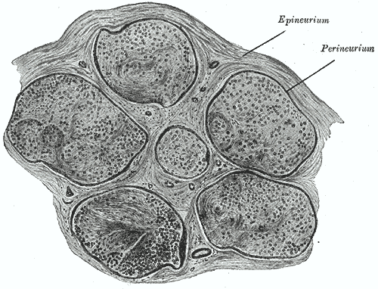 | 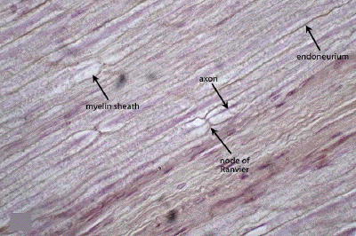

 | 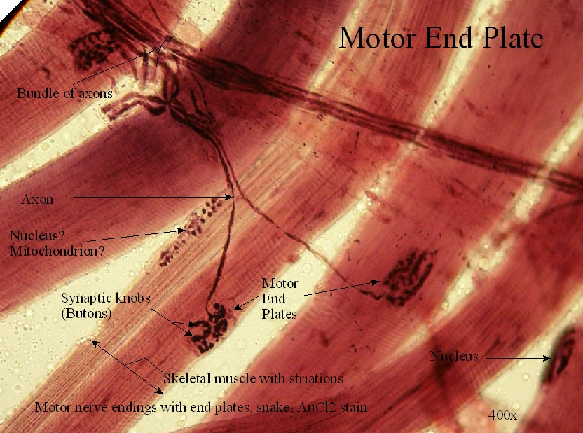 | 