Test questions in Unit I of Cell Biology, Chemistry of life

Name, Surname _____________________, faculty of Medicine, 2000.____._____

1. Please name or characterise
Major schools of taxonomy | Methods of nucleic acid investigations which are instrumental in taxonomy | The main hierarchic levels of the biological taxonomy
The principles used in phenetic taxonomy | Terms which are used to denote taxonomic units below the species level | The principles used in cladistic taxonomy
The concept of the molecular clock | Three domains of the classification of the living organisms | Five kingdoms of life
Methodological and didactic principles used in Biology | The contribution of Aristotle (approx. dates of life) in the development of biologic taxonomy. | The contribution of J. Cuvier (approx. dates of life) in the development of biologic taxonomy.
The contribution of C. Linneus (approx. dates of life) in the development of biologic taxonomy. | The contribution of J.Lamarc (approx. dates of life) in the development of biologic taxonomy. | The contribution of C. Darwin (approx. dates of life) in the development of biologic taxonomy
- Which of the branches and specialisations of Biology are involved with A (__), B (___) C (___). Put the appropriate number in the brackets
1)ichtiology 2)entomology 3)briology 4)mammology 5)herpetology 6)lichenology 7)physiology 8)genetics 9)histology 10)phycology 11)biotechnology 12)ornithology 13)protistology 14)biometry 15)mycology
- Which of the elements listed below make up more than/less than 1%/0.1%/0.01% of the vertebrate organism mass (circle the appropriate element symbols)
As, Ag, Au, C, Ca, Cl, Co, Cr, Cu, F, Fe, H, I, K, Mg, Mn, Mo, N, Na, O, P, Pb, S, Zn
- Element X is needed in the organism for (found in)
_________________________________________________________________
5. Prefixes “X” and “Y” denote units having order of magnitude (connect with a line)
10¹⁸; 10¹⁵; 10¹²; 10⁹; 10⁶; 10³; 10¹; 10⁻¹; 10⁻²; 10⁻³; 10⁻⁶; 10⁻⁹; 10⁻¹²; 10⁻¹⁵;10⁻¹⁸;
- Underline the elements or functional groups, which will be involved in ionic/covalent/hydrogen bonding
C, Ca, Cl, H, I, K, Mg, N, Na, O, amino-, hydroxyl-, carboxyl-, keto-, methyl-
- which of the molecules shown below belong to alkanes, alkenes, alkynes, carbonic acids, aromatic compounds (circle the appropriate)
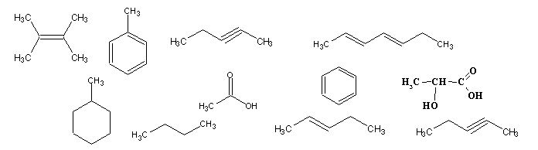
CH₃-(CH₂)₆-CH₃ HC=CH H₃C-COOH H₂C=CH₂
- Which of the shown amino acids are polar/non polar/ acidic or basic (circle the appropriate)
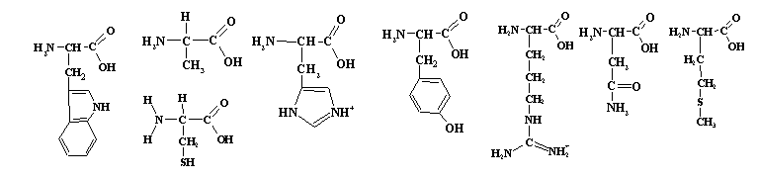
- Which of the compounds shown below belong to purines/ pyrimidines/ hexoses/ pentoses (circle the appropriate)
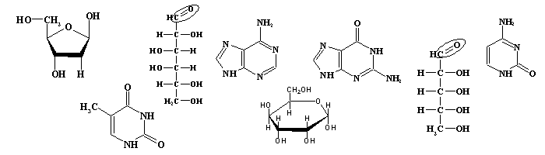

- Which of the compounds shown below belong to ethers and esters; alcohols and aldehydes, amines and ketones, carbonic acids (point an arrow towards appropriate formulae).
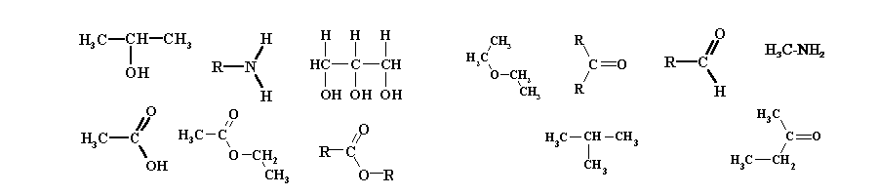
- Characteristic structural elements of nucleic acids/proteins/polysaccharides are (underline!)
peptide bond, phosphodiester bond, glycosidic bond, nucleotides, pentoses, hexsoses, amino acids, glycerol, C-terminus, N-terminus, 3’-terminus, 5’-terminus, hydrophobic part, α and β isomers.
- If pH of the solution the is increased / decreased by n units, hydrogen ion concentration increases/ decreases _________ times. The pH of x M acid/alkali is ______.
- The pH of solution X pH is about _________, this solution is strongly/weekly acidic/basic
- Which of the substances below may have isotopes/ structural isomers/ geometric isomers/ optical isomers (underline)
¹² C, H₃C-CHNH₂-COOH, ³⁰ P, CH₄, ¹⁴ N, H₃C-CH₃, CO₂, H₃C-CH₂-CH₃, H₃C-CH₂-CH₂-CH₃, H₃C-CH =CH-CH₃, H₃C-CHOH-COOH,
- Underline the reactions which are characteristic for the energy metabolism / information turnover/ catabolism/ anabolism
DNA synthesis, sugar degradation, synthesis of glucose, synthesis of amino acids, RNA synthesis, ATP formation, ADP formation, chemical oxidation, chemical reduction, release of energy, accumulation of energy, formation of complex compounds from simple ones, formation of simple compounds from complex ones.
- Adding small amount of strong acid/base to the buffer solution (underline the appropriate)
increases the pH slightly, decreases the pH is slightly, increases the pH considerably, decreases the pH is considerably, dissociation of week acid in the buffer system increases, dissociation of week acid in the buffer system decreases, dissociation of the conjugated base in the buffer system increases, dissociation of the conjugated base in the buffer system decreases
- Which of the listed below may be used by the cell as the primary sources of energy/ accumulators of energy (underline the appropriate)
light, oxidation of inorganic compounds, oxidation of organic compounds, heat, ATP, AMP, monosaccharides, starch, cellulose, amylose, fat, glycogen, oil.
- Which are the reactions of hydrolysis/condensation/isomerisation (underline the appropriate)
polysaccharides ± monosaccharides; nucleotides ± nucleic acids; D-glucose±α-D-glucopyranose, amino acids ± proteins; alcohol + carbonic acid ± ester, DNA ± nucleotides, L-alanine ± D-alanine
- Which of the compounds below will be dissolved in water/hexane/acetone/ ethanol (underline the appropriate)
phospholipids, polysaccharides, saturated fatty acids, unsaturated fatty acids, NaCl, wax, glucose
- Hydrophobic interactions/van der Waals forces/hydrogen bonding are involved in
primary structure of nucleic acids; secondary structure of proteins, tertiary structure of proteins, secondary structure of nucleic acids, phospholipid micelles and bilayers.
- Allosteric inhibitors / substrate analogues/ activators/ substrates/ products (underline the appropriate)
bind at the site of allosteric regulation, bind the active centre of the enzyme, diminish the rate of reaction, increase the rate of reaction, are changed during the course of the reaction, remain unchanged during the course of the reaction, participate in the feedback regulation of the enzyme activity

