Test in Cell Biology; Unit I: Chemistry of Life
Name, Surname _____________________, Faculty of Medicine ,Date: ____.____.2001
- Which branch of Biology is engaged in study of protists (__), amphibians (___) use of cells and tissues for production of useful compounds (___) ? Put the corresponding number in the brackets !
1)ichthyology 2)entomology 3)briology 4)mammology 5)herpetology 6)lichenology 7)physiology 8)genetics 9)histology 10)phycology 11)biotechnology 12)ornithology 13)protistology 14)biometry 15)mycology
- Element I in human organism is localised mostly in ______________________________________________. It is needed for _________________________________________________________________.
3. Prefixes “kilo” and “femto” denote units having order of magnitude (connect with a line):
10¹² ; 10⁹ ; 10⁶ ; 10³ ; 10¹ ; 10⁻¹ ; 10⁻² ; 10⁻³ ; 10⁻⁶ ; 10⁻⁹ ; 10⁻¹² ; 10⁻¹⁵ ; 10⁻¹⁸ ;
4. Which of the molecules shown below belong to alkynes ? Circle the appropriate.
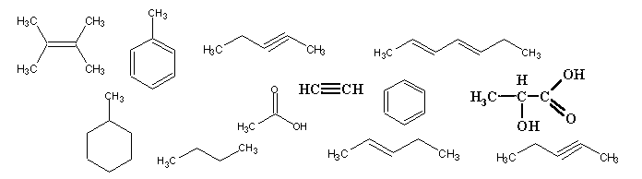
CH₃-(CH₂)₆-CH₃ H₃C-COOH H₂C=CH₂
- Which of the compounds shown below belong to aldehydes and ketones ? Point an arrow towards appropriate formulae.
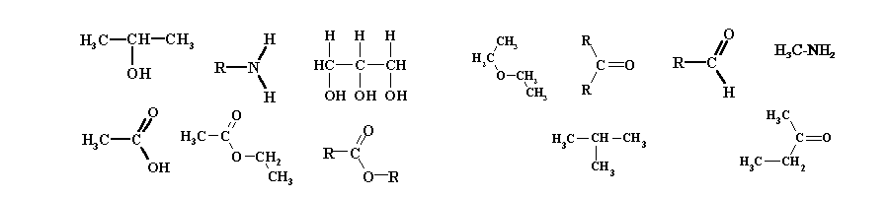
- Which of the compounds below are purines ? Circle the appropriate.
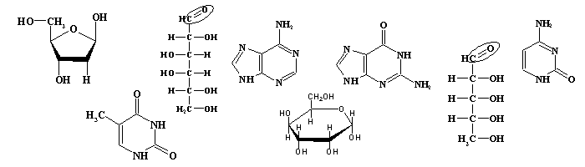
7. Hydrogen bonds participate in formation of (underline):
primary structure of nucleic acids; | secondary structure of proteins;
tertiary structure of proteins; | secondary structure of nucleic acids;
micelles and bilayers of phospholipids | branching points in polysaccharide chains;
primary structure of proteins; | biologically important properties of water.
- Which compounds can be dissolved in hexane ? Underline.
phospholipids, polysaccharides, saturated fatty acids, non-saturated fatty acids, NaCl, wax, glucose

- Enzyme substrates (underline the appropriate):
slow down the reaction; | bind the allosteric centre of the enzyme;
bind the active centre of the enzyme; | speed up the reaction;
are changed in the reaction; | participate in the feedback regulation of the enzyme;
are not changed in the reaction; | are metabolically related to the substrates.

10. Please name/characterise: the organism types which are frequently classified by numeric taxonomy
The contribution of Aristotle (approx. dates of life) to the development of taxonomy

Points
Grade

