Viral Pathogenesis

Samuel Baron, Michael Fons, Thomas Albrecht

General Concepts

Pathogenesis
Pathogenesis is the process by which an infection leads to disease. Pathogenic mechanisms of viral disease include
- implantation of virus at the portal of entry,
- local replication,
- spread to target organs (disease sites), and
- spread to sites of shedding of virus into the environment.
Factors that affect pathogenic mechanisms are
- accessibility of virus to tissue,
- cell susceptibility to virus multiplication, and
- virus susceptibility to host defenses. Natural selection favors the dominance of low-virulence virus strains.

Cellular Pathogenesis
Direct cell damage and death from viral infection may result from
- diversion of the cell's energy,
- shutoff of cell macromolecular synthesis,
- competition of viral mRNA for cellular ribosomes,
- competition of viral promoters and transcriptional enhancers for cellular transcriptional factors such as RNA polymerases, and inhibition of the interferon defense mechanisms.
Indirect cell damage can result from
- integration of the viral genome,
- induction of mutations in the host genome,
- inflammation, and
- the host immune response.

Tissue Tropism
Viral affinity for specific body tissues (tropism) is determined by
- cell receptors for virus,
- cell transcription factors that recognize viral promoters and enhancer sequences,
- ability of the cell to support virus replication,
- physical barriers
- local temperature, pH, and oxygen tension enzymes and non-specific factors in body secretions, and
- digestive enzymes and bile in the gastrointestinal tract that may inactivate some viruses.

Implantation at the Portal of Entry
Virions implant onto living cells mainly via the respiratory, gastrointestinal, skin-penetrating, and genital routes although other routes can be used. The final outcome of infection may be determined by the dose and location of the virus as well as its infectivity and virulence.

Local Replication and Local Spread
Most virus types spread among cells extracellularly, but some may also spread intracellularly. Establishment of local infection may lead to localized disease and localized shedding of virus.

Dissemination from the Portal of Entry
Viremic: The most common route of systemic spread from the portal of entry is the circulation, which the virus reaches via the lymphatics. Virus may enter the target organs from the capillaries by
- multiplying in endothelial cells or fixed macrophages,
- diffusing through gaps, and
- being carried in a migrating leukocyte.
Neural: Dissemination via nerves usually occurs with rabies virus and sometimes with herpesvirus and poliovirus infections.

Incubation Period
The incubation period is the time between exposure to virus and onset of disease. During this usually
- asymptomatic period,
- mplantation,
- local multiplication, and
- spread (for disseminated infections) occur.

Multiplication in Target Organs
Depending on the balance between virus and host defenses, virus multiplication in the target organ may be sufficient to cause disease and death.

Shedding of Virus
Although the respiratory tract, alimentary tract, urogenital tract and blood are the most frequent sites of shedding, diverse viruses may be shed at virtually every site.

Congenital Infections
Infection of the fetus as a target "organ" is special because the
- virus must traverse additional physical barriers,
- the early fetal immune and interferon defense systems may be immature,
- transfer of the maternal defenses are partially blocked by the placenta,
- the developing first-trimester fetal organs are vulnerable to infection, and
- hormonal changes are taking place.

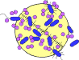

INTRODUCTION
Pathogenesis is the process by which virus infection leads to disease. Pathogenic mechanisms include
- implantation of the virus at a body site (the portal of entry),
- replication at that site, and
- then spread to and multiplication within sites (target organs) where disease or shedding of virus into the environment occurs.
Most viral infections are subclinical, suggesting that body defenses against viruses arrest most infections before disease symptoms become manifest. Knowledge of subclinical infections comes from serologic studies showing that sizeable portions of the population have specific antibodies to viruses even though the individuals have no history of disease. These inapparent infections have great epidemiologic importance: they constitute major sources for dissemination of virus through the population, and they confer immunity (see Ch. 48).
Many factors affect pathogenic mechanisms. An early determinant is the extent to which body tissues and organs are accessible to the virus. Accessibility is influenced by
- physical barriers (such as mucus and tissue barriers),
- by the distance to be traversed within the body, and
- by natural defense mechanisms.
If the virus reaches an organ, infection occurs only if cells capable of supporting virus replication are present. Cellular susceptibility requires
- a cell surface attachment site (receptor) for the virions and
- also an intracellular environment that permits virus replication and release.
Even if virus initiates infection in a susceptible organ, replication of sufficient virus to cause disease may be prevented by host defenses (see Chs. 49 and 50).
Other factors that determine whether infection and disease occur are the many virulence characteristics of the infecting virus.
To cause disease, the infecting virus must be able to overcome the inhibitory effects of physical barriers, distance, host defenses, and differing cellular susceptibilities to infection. The inhibitory effects are genetically controlled and therefore may vary among individuals and races. Virulence characteristics enable the virus to initiate infection, spread in the body, and replicate to large enough numbers to impair the target organ.
These factors include the ability to replicate
- under certain circumstances during inflammation,
- during the febrile response,
- in migratory cells, and
- in the presence of natural body inhibitors and interferon.
Extremely virulent strains often occur within virus populations. Occasionally, these strains become dominant as a result of unusual selective pressures (see Ch. 48). The viral proteins and genes responsible for specific virulence functions are only just beginning to be identified.
Fortunately for the survival of humans and animals (and hence for the infecting virus), most natural selective pressures favor the dominance of less virulent strains. Because these strains do not cause severe disease or death, their replication and transmission are not impaired by an incapacitated host. Mild or inapparent infections can result from absence of one or more virulence factors. For example, a virus that has all the virulence characteristics except the ability to multiply at elevated temperatures is arrested at the febrile stage of infection and causes a milder disease than its totally virulent counterpart.
Live virus vaccines are composed of viruses deficient in one or more virulence factors; they cause only inapparent infections and yet are able to replicate sufficiently to induce immunity.
The occurrence of spontaneous or induced mutations in viral genetic material may alter the pathogenesis of the induced disease, e.g. HIV. These mutations can be of particular importance with the development of drug resistant strains of virus.
Disease does not always follow successful virus replication in the target organ. Disease occurs only if the virus replicates sufficiently:
- to damage essential cells directly,
- to cause the release of toxic substances from infected tissues,
- to damage cellular genes or
- to damage organ function indirectly as a result of the host immune response to the presence of virus antigens.
As a group, viruses use all conceivable portals of entry, mechanisms of spread, target organs, and sites of excretion. This abundance of possibilities is not surprising considering the astronomic numbers of viruses and their variants (see Ch. 43).

Cellular Pathogenesis
Direct cell damage and death may result from disruption of cellular macromolecular synthesis by the infecting virus. Also, viruses cannot synthesize their genetic and structural components, and so they rely almost exclusively on the host cell for these functions. Their parasitic replication therefore robs the host cell of energy and macromolecular components, severely impairing the host's ability to function and often resulting in cell death and disease.
Pathogenesis at the cellular level can be viewed as a process that occurs in progressive stages leading to cellular disease. As noted above, an essential aspect of viral pathogenesis at the cellular level is the competition between the synthetic needs of the virus and those of the host cell. Since viruses must use the cell's machinery to synthesize their own nucleic acids and proteins, they have evolved various mechanisms to subvert the cell's normal functions to those required for production of viral macromolecules and eventually viral progeny. The function of some of the viral genetic elements associated with virulence may be related to providing conditions in which the synthetic needs of the virus compete effectively for a limited supply of cellular macromolecule components and synthetic machinery, such as ribosomes.
Damage of cells by replicating virus and damage by the immune response are considered further in Chapters 44 and 50, respectively.

Tissue Tropism
Most viruses have an affinity for specific tissues; that is, they display tissue specificity or tropism. This specificity is determined by
- selective susceptibility of cells,
- physical barriers,
- local temperature and pH, and
- host defenses.
Many examples of viral tissue tropism are known. Polioviruses selectively infect and destroy certain nerve cells, which have a higher concentration of surface receptors for polioviruses than do virus-resistant cells. Rhinoviruses multiply exclusively in the upper respiratory tract because they are adapted to multiply best at low temperature and pH and high oxygen tension. Enteroviruses can multiply in the intestine, partly because they resist inactivation by digestive enzymes, bile, and acid.
The cell receptors for some viruses have been identified. Rabies virus uses the acetylcholine receptor present on neurons as a receptor, and hepatitis B virus binds to polymerized albumin receptors found on liver cells. Similarly, Epstein-Barr virus uses complement CD21 receptors on B lymphocytes, and human immunodeficiency virus uses the CD4 molecules present on T lymphocytes as specific receptors.
Viral tropism is also dictated in part by the presence of specific cell transcription factors that require enhancer sequences within the viral genome. Recently, enhancer sequences have been shown to participate in the pathogenesis of certain viral infections. Enhancer sequences within the long terminal repeat (LTR) regions of Moloney murine leukemia retrovirus are active in certain host tissues. In addition, JV papovavirus appears to have an enhancer sequence that is active specifically in oligodendroglia cells, and hepatitis B virus enhancer activity is most active in hepatocytes. Tissue tropism is considered further in Chapter 44.

Sequence of Virus Spread in the Host

Implantation at Portal of Entry
Viruses are carried to the body by all possible routes (air, food, bites, and any contaminated object). Similarly, all possible sites of implantation (all body surfaces and internal sites reached by mechanical penetration) may be used. The frequency of implantation is greatest where virus contacts living cells directly (in the respiratory tract, in the alimentary tract, in the genital tract, and subcutaneously). With some viruses, implantation in the fetus may occur at the time of fertilization through infected germ cells, as well as later in gestation via the placenta, or at birth.
Even at the earliest stage of pathogenesis (implantation), certain variables may influence the final outcome of the infection. For example, the dose, infectivity, and virulence of virus implanted and the location of implantation may determine whether the infection will be inapparent (subclinical) or will cause mild, severe, or lethal disease.

Local Replication and Local Spread
Successful implantation may be followed by local replication and local spread of virus (Fig. 45-1). Virus that replicates within the initially infected cell may spread to adjacent cells extracellularly or intracellularly.
- Extracellular spread occurs by release of virus into the extracellular fluid and subsequent infection of the adjacent cell.
- Intracellular spread occurs by fusion of infected cells with adjacent, uninfected cells or by way of cytoplasmic bridges between cells.
Most viruses spread extracellularly, but herpesviruses, paramyxoviruses, and poxviruses may spread through both intracellular and extra cellular routes. Intracellular spread provides virus with a partially protected environment because the antibody defense does not penetrate cell membranes.
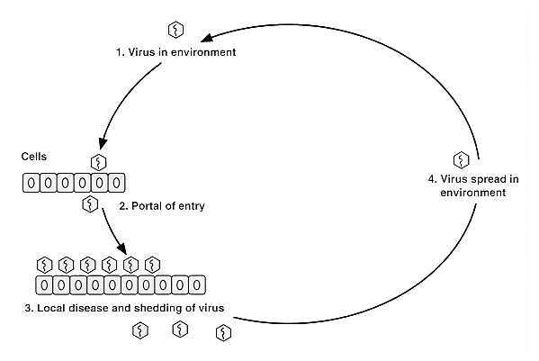
FIGURE 45-1 Virus spread during localized infection. Numbers indicate sequence of events.
Spread to cells beyond adjacent cells may occur through the liquid spaces within the local site (e.g., lymphatics) or by diffusion through surface fluids such as the mucous layer of the respiratory tract. Also, infected migratory cells such as lymphocytes and macrophages may spread the virus within local tissue.
Establishment of infection at the portal of entry may be followed by continued local virus multiplication, leading to localized virus shedding and localized disease. In this way, local sites of implantation also are target organs and sites of shedding in many infections (Table 45-1). Respiratory tract infections that fall into this category include influenza, the common cold, and parainfluenza virus infections. Alimentary tract infections caused by several gastroenteritis viruses (e.g., rotaviruses and picornaviruses) also may fall into this category. Localized skin infections of this type include warts, cowpox, and molluscum contagiosum. Localized infections may spread over body surfaces to infect distant surfaces. An example of this is the picornavirus epidemic conjunctivitis shown in Figure 45-2; in the absence of viremia, virus spreads directly from the eye (site of implantation) to the pharynx and intestine. Other viruses may spread internally to distant target organs and sites of excretion (disseminated infection). A third category of viruses may cause both local and disseminated disease, as in herpes simplex and measles.
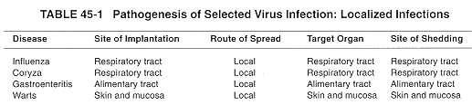
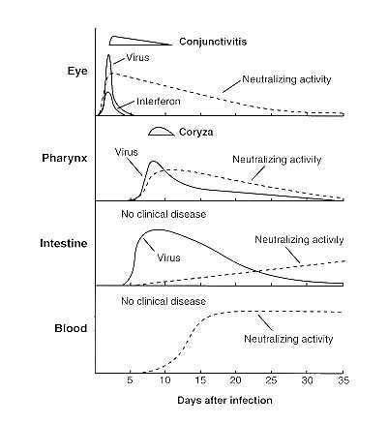
FIGURE 45-2 Spread of picornavirus over body surfaces from eye to pharynx and intestine during natural infection. Local neutralizing antibody activity is shown. (Adapted from Langford MP, Stanton GJ, Barber JC: Early appearing antiviral activity in human tears during a case of picornavirus epidemic conjunctivitis. J Infect Dis 139:653, 1979, with permission.)

Dissemination from the Portal of Entry

Dissemination in the Bloodstream
At the portal of entry, multiplying virus contacts pathways to the blood and peripheral nerves, the principal routes of widespread dissemination through the body. The most common route of systemic spread of virus involves the circulation (Fig. 45-3 and Table 45-2). Viruses such as those causing poliomyelitis, smallpox, and measles disseminate through the blood after an initial period of replication at the portal of entry (the alimentary and respiratory tracts), where the infection often causes no significant symptoms or signs of illness because the virus kills cells that are expendable and easily replaced. Virus progeny diffuse through the afferent lymphatics to the lymphoid tissue and then through the efferent lymphatics to infect cells in close contact with the bloodstream (e.g., endothelial cells, especially those of the lymphoreticular organs). This initial spread may result in a brief primary viremia. Subsequent release of virus directly into the bloodstream induces a secondary viremia, which usually lasts several days and puts the virus in contact with the capillary system of all body tissues.
- Virus may enter the target organ from the capillaries by replicating within a capillary endothelial cell or fixed macrophage and then being released on the target organ side of the capillary.
- Virus may also diffuse through small gaps in the capillary endothelium or penetrate the capillary wall through an infected, migrating leukocyte.
- The virus may then replicate and spread within the target organ or site of excretion by the same mechanisms as for local dissemination at the portal of entry.
Disease occurs if the virus replicates in a sufficient number of essential cells and destroys them. For example, in poliomyelitis the central nervous system is the target organ, whereas the alimentary tract is both the portal of entry and the site of shedding. In some situations, the target organ and site of shedding may be the same.

Dissemination in Nerves
Dissemination through the nerves is less common than bloodstream dissemination, but is the means of spread in a number of important diseases (Fig. 45-4). This mechanism occurs in rabies virus, herpesvirus, and, occasionally, poliomyelitis virus infections. For example, rabies virus implanted by a bite from a rabid animal replicates subcutaneously and within muscular tissue to reach nerve endings. Evidence indicates that the virus spreads centrally in the neurites (axons and dendrites) and perineural cells, where virus is shielded from antibody. This nerve route leads rabies virus to the central nervous system, where disease originates. Rabies virus then spreads centrifugally through the nerves to reach the salivary glands, the site of shedding. Table 45-2 shows other examples of nerve spread.
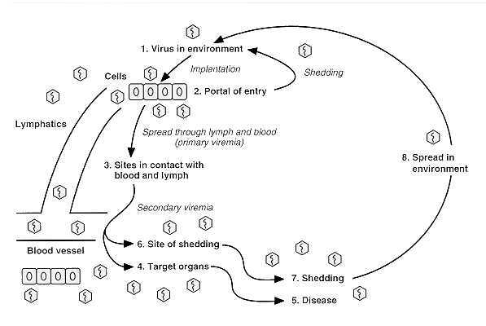
FIGURE 45-3 Virus spread through bloodstream during a generalized infection. Numbers indicate sequence of events.

Incubation Period
During most virus infections, no signs or symptoms of disease occur through the stage of virus dissemination. Thus, the incubation period (the time between exposure to virus and onset of disease) extends from the time of implantation through the phase of dissemination, ending when virus replication in the target organs causes disease. Occasionally, mild fever and malaise occur during viremia, but they often are transient and have little diagnostic value.
The incubation period tends to be brief (1 to 3 days) in infections in which virus travels only a short distance to reach the target organ (i.e., in infections in which disease is due to virus replication at the portal of entry). Conversely, incubation periods in generalized infections are longer because of the stepwise fashion by which the virus moves through the body before reaching the target organs. Other factors also may influence the incubation period. Generalized infections produced by togaviruses may have an unexpectedly short incubation period because of direct intravascular injection (insect bite) of a rapidly multiplying virus. The mechanisms governing the long incubation period (months to years) of persistent infections are poorly understood. The persistently infected cell is often not lysed, or lysis is delayed. In addition, disease may result from a late immune reaction to viral antigen (e.g., arenaviruses in rodents), from unknown mechanisms in slow viral infections during which no immune response has been detected (as in the scrapie-kuru group), or mutation in the host genetic material resulting in cellular transformation and cancer.
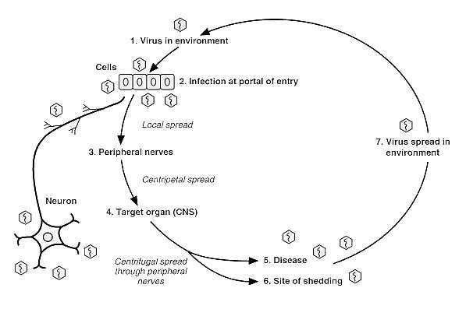
FIGURE 45-4 Virus spread through nerves during a generalized infection. Numbers indicate sequence of events.

Multiplication in Target Organs
Virus replication in the target organ resembles replication at other body sites except that
  - the target organ in systemic infections is usually reached late during the stepwise progression of virus through the body,
  - clinical disease originates there.
At each step of virus progression through the body, the local recovery mechanisms (local body defenses, including interferon, local inflammation, and local immunity) are activated.
Thus, when the target organ is infected, the previously infected sites may have reached various stages of recovery. Figure 45-2 illustrates this staging of infection and recovery in different tissues during a spreading surface infection. Circulating interferon and immune responses probably account for the termination of viremia, but these responses may be too late to prevent seeding of virus into the target organ and into sites of shedding. Nevertheless, these systemic defenses can diffuse in various degrees into target organs and thereby help retard virus replication and disease.
Depending on the balance between virus and host defenses (see Chs. 49 and 50), virus multiplication in the target organ may be sufficient to produce dysfunction manifested by disease or death. Additional constitutional disease such as fever and malaise may result from diffusion of toxic products of virus replication and cell necrosis, as well as from release of lymphokines and other inflammatory mediators. Release of leukotriene C4 during respiratory infection may cause bronchospasm. Viral antigens also may participate in immune reactions, leading to disease manifestations. In addition, impairment of leukocytes and immunosuppression by some viruses may cause secondary bacterial infection.

Shedding of Virus
Because of the diversity of viruses, virtually every possible site of shedding is utilized (Table 45-2); however, the most frequent sites are the respiratory and alimentary tracts. Blood and lymph are sites of shedding for the arboviruses, since biting insects become infected by this route. HIV is shed in blood and semen. Milk is a site of shedding for viruses such as some RNA tumor viruses (retroviruses) and cytomegalovirus (a herpesvirus). Several viruses (e.g., cytomegaloviruses) are shed simultaneously from the urinary tract and other sites more commonly associated with shedding. The genital tract is a common site of shedding for herpesvirus type 2 and may be the route through which the virus is transmitted to sexual partners or the fetus. Saliva is the primary source of shedding for rabies virus. Cytomegalovirus is also shed from these last two sites. Finally, viruses such as tumor viruses that are integrated into the DNA of host cells can be shed through germ cells.
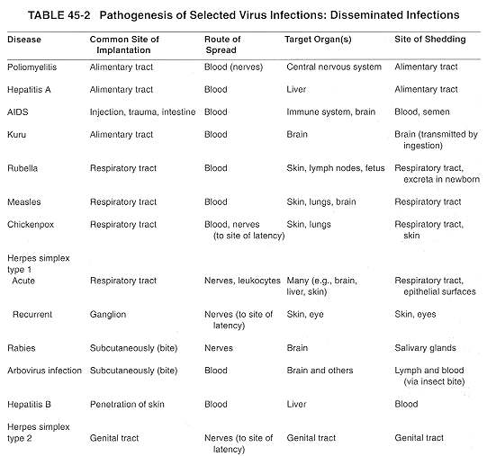

Congenital Infections
Infection of the fetus is a special case of infection in a target organ. The factors that determine whether a target organ is infected also apply to the fetus, but the fetus presents additional variables. The immune and interferon systems of the very young fetus are immature.
- This immaturity, coupled with the partial placental barrier to transfer of maternal immunity and interferon, deprive the very young fetus of important defense mechanisms.
- Another variable is the high vulnerability to disruption of the rapidly developing fetal organs, especially during the first trimester of pregnancy.
- Furthermore, susceptibility to virus replication may be modulated by the undifferentiated state of the fetal cells and by hormonal changes during pregnancy. Although virus multiplication in the fetus may lead to congenital anomalies or fetal death, the mother may have only a mild or inapparent infection.
To cause congenital anomalies, virus must reach the fetus and multiply in it, thereby causing maldeveloped organs. Generally, virus reaches the fetus during maternal viremia by infecting or passing through the placenta to the fetal circulation and then to fetal target organs. Sufficient virus multiplication may disrupt development of fetal organs, especially during their rapid development (the first trimester of pregnancy). Although many viruses occasionally cause congenital anomalies, cytomegalovirus and rubella virus are the most common offenders. Virus shedding by the congenitally infected newborn infant may occur as a result of persistence of the virus infection at sites of shedding.

REFERENCES
Albrecht T, Boldogh I, Fons M et al: Cell activation signals and the pathogenesis of human cytomegalovirus. Intervirology 31:68, 1990
Coen DM: Acyclovir-resistant, pathogenic herpesviruses. Trends Microbiol 2:481, 1994
Fields BN: How do viruses cause different diseases? J Am Med Assoc 250:1754, 1983
Grieder FB, Davis NL, Aronson JF, et al: Specific restrictions in the progression of Venezuelan equine encephalitis virus-induced disease resulting from single amino acid changes in glycoproteins. Virology 206:994, 1995
Singh IP, Chopra AK, Coppenhaver, DH et al: Vertebrate brains contain a broadly active antiviral substance. Antiviral Research 27:375, 1995
Strayer DS, Laybourne KA, Heard HK: Determinants of the ability of malignant fibroma virus to induce immune dysfunction and tumor dissemination in vivo. Microb Pathos 9:173, 1990
Wold WE, Hermiston TW, Tollefson AE: Adenovirus proteins that subvert host defenses. Trends Microbiol 2:437, 1994

