Tumor Viruses

Joan C. M. Macnab

David Onions

General Concepts

Causation of Tumors
Biologic criteria for causal association of viruses with tumors include the
- presence of virus in tumor tissues,
- the presence of virus before disease onset,
- viral persistence,
- the location of virus at appropriate sites, and
- prevention of disease by prevention of viral infection.

Oncogenic RNA Viruses

Classification of Retroviruses
Retroviruses are divided into oncoviruses, lentiviruses, and spumaviruses. These in turn can be divided into three broad groups of which only one contains a human virus, human T cell leukemia virus type (HTLV) which is characterized by the proliferation of mainly CD4+ T-lymphocytes and the development of adult T cell leukemia (ATL).
1. Feline, murine, and avian leukemogenic retroviruses replicate efficiently in their hosts, produce a broad range of diseases, and interact with cellular proto-oncogenes to produce leukemia.
2. Human leukemogenic retroviruses are exemplified by the human viruses HTLV-I and HTLV-2 and the related bovine and simian viruses; they often establish a latent infection in their host cells, have a narrow disease spectrum, and carry a transactivating gene, tax, associated with transformation.
3. Simian type-D retroviruses and mouse mammary tumor virus make up the final group.

Human T-cell lymphoma types 1 and 2
Clinical Manifestations: Cutaneous T-cell lymphoma and hairy cell leukemia are almost exclusively associated with HTLV-1.
Clinical manifestations include hypercalcaemia, lymphadenopathy, skin lesions caused by infiltration of leukemic cells, spleen and liver involvement and immune suppression. Carriers are asymptomatic. Preleukemic and ATL patients are usually diagnosed with leukocytosis and morphologically abnormal lymphocytes. Approximately 30% of pre-ATL patients progress to chronic ATL from which acute ATL can progress in a matter of months. Acute ATL is characterized by aggressive clonal malignancy of CD4+ T lymphocytes. There is usually a latency period of 20-30 years following primary infection with HTLV-1.
Epidemiology and Geographical Distribution: HTLV-1 is endemic in South Japan, Central Africa, North Eastern South America, the Caribbean and South Eastern United States but is also found in intravenous drug users in the US and Europe.
Replication: Retroviruses generally replicate by binding to a cellular receptor and causing transcription of genomic RNA into proviral DNA and integration of proviral DNA into chromosomal DNA. Latency may be established at this point, or transcription may occur to produce new genomes and mRNA. Virus is released by budding, usually without cytopathology. HTLV-1 has a specific pattern of replication involving transactivation by tax, followed by a switch to viral structural proteins as the level of rex protein builds up, by means similar to those of HIV replication (see Chapter 62).
Molecular Mechanism of Oncogenic Transformation: Studies of other oncogenic retroviruses have identified viral genes (v-onc) that have been acquired by recombination from cellular genes (c-onc). The c-onc genes mainly regulate cellular growth and differentiation, but like their viral counterparts, they can be disregulated or mutated, a process associated with their oncogenic capacity. The general classes of oncogenes encode growth factors, cellular receptors, signaling proteins, DNA binding proteins, and other regulatory proteins.
No virus coded oncogene has been detected in HTLV-I which appears to have a distinct transforming mechanism. It carries a transactivating gene, tax which is required for replication and can transactivate several cellular genes whose expression could lead to transformation by an autocrine mechanism. Ongoing studies of secondary events in the development of HTLV-induced leukemia in vivo illustrate that multiple genetic events are necessary for transformation.
Cofactors: They include mutations.
Diagnosis: By PCR amplification and lymphocyte pathology.
Persistence of virus: HTLV infections are generally asymptomatic and virus is latent in only a few cells. HTLV-1 is associated also with myelopathy or spastic paraparesis. Although the virus persists, it is not generally expressed in leukemia.
Control: Full blown adult T cell leukemia has a poor prognosis with an average survival of only months after diagnosis. As yet preventive and therapeutic approaches to disease control are hampered by the lack of a good small animal model. The most promising therapy is currently AZT combined with interferon.

Oncogenic DNA Viruses
Oncogenic human DNA viruses include hepatitis B viruses, herpesviruses, and papillomaviruses. Their mechanisms of replication and epidemiology are considered in each of the specific chapters describing these viruses.

Human Hepatitis Virus
Hepatitis virus types A-E infect humans but only hepatitis B virus (HBV) and hepatitis C virus (HCV) are associated with the development of hepatocellular carcinoma (HCC).
Clinical Manifestations: Tumors usually develop after chronic infection with HBV over a long period of time during which cirrhosis develops. The chronic condition progresses to primary hepatocellular carcinoma.
Epidemiology and Geographic Distribution: Hepatitis B virus is prevalent in Southeast Asia and Africa. Tumors are associated with primary infection at an early age, with viral persistence and chronic infection. The virus can be sexually transmitted particularly among homosexuals.
Molecular Mechanisms of Transformation: These are not understood.
- One possible mechanism to account for the oncogenicity of hepatitis B virus could be integration within or near a cellular gene responsible for growth control or regulation (e.g., an oncogene).
- Other possible mechanisms of viral involvement in oncogenesis are (1) repression of the cell interferon beta promoter by a trans mechanism; (2) integration within a cell cycle control gene, cyclin; and (3) integration near a hormone response gene, thus altering control. Chromosome deletions are common. Deletion of the anti-oncogene p53 is associated with development of HCC. However, the strongest association with cancer occurs with chronic liver disease.
Diagnosis: Viral DNA is detected commonly by Southern blotting using a labeled probe or, by PCR amplification.
Animal Model: The wood chuck and duck both provide good model systems.
Control: Control of the development of hepatocellular carcinoma is being tried by vaccination to control HBV infection. Safe and effective vaccines have been available since 1982 but infant vaccination is not yet universal in high risk countries. That universal vaccination should be implemented by 1997 is a World Health Assembly recommendation. An Alaskan Eskimo study suggests that vaccination against HBV reduces the number of cases of primary hepatocellular carcinoma.

Hepatitis C Virus
Previously classified as non A non B hepatitis this virus has only recently been routinely isolated (1989) and characterized.
Clinical Manifestations: Patients develop typical hepatitis and can go on to chronic infection. The virus is found in hepatocellular carcinoma, frequently together with HBV.
Epidemiology and Geographic Distribution: Hepatitis C virus is found worldwide. It is mainly acquired by blood transfusions or intravenous drug abuse but is not efficiently sexually transmitted.
Molecular Mechanism of Transformation: The mechanism is not clear as for hepatitis B but may be associated with integration or effected through chronic infection.
Diagnosis: Viral DNA is usually detected by PCR.
Control: The development of vaccines is dependent on further studies on protein expression and immunogenicity as protective immunity does not follow single or multiple episodes of infection.

Herpesviruses: Epstein-Barr Virus and Lymphoma
The vast majority of immunocompetent individuals carry Epstein-Barr virus (EBV) as an asymptomatic infection. If the infection is acquired in young adulthood it often presents as infectious mononucleosis. In certain cases, however, EBV is strongly associated with tumors.
Clinical Manifestations: EBV is strongly associated with three classes of B-cell lymphoma.
1. Burkitt's lymphoma (BL) has the highest incidence of any childhood cancer in central Africa and New Guinea. The tumor develops in the jaw but may also affect abdominal viscera. EBV is present in all cells of at least 95% of these tumors.
2. Sporadic BL has a much lower incidence than 1 and involves abdominal and lymphoid tissue but rarely the jaw. The EBV genome is found in only 10-20% of tumors.
3. BL develops in the immunosuppressed, i.e., those receiving transplantation or those immunosuppressed by AIDS. EBV is found in 90-100% of these patients cells. In AIDS patients lymphomas arise in immune privileged sites, e.g., the CNS and invariably contain the EBV genome.
Further classes of lymphoma in which EBV is found are Hodgkins lymphoma (HL) and EBV-positive T cell lymphomas. A subset of Hodgkins lymphomas contain monoclonal EBV genomes in Reed-Steinberg cells. Almost half the HL seen in Europe and America is associated with EBV genomes and more than 80% of the more aggressive mixed cellular/lymphocyte-depleted forms of HL contain EBV genomes.
Epidemiology and Geographic Distribution: Epstein-Barr virus is present in all populations but causes BL in regions of equatorial Africa and New Guinea where vector-borne disease eg malaria is common. Primary infection occurs at a very early age and malaria coinfection serves to repress the immune defenses.
Persistence of the Virus: EBV infection persists in asymptomatic individuals. In infected B lymphocytes and tumors only a small proportion of cells replicate the virus and the other cells contain latent virus. Only the virus antigen, EBNA1, is expressed and the latency pattern is termed type 1.
Host Response to the Tumor: In African BL, both the cellular and viral phenotype escape immune recognition. HLA class antigen processing pathways are expressed at low levels and EBNA 1 is not a preferred target for CTL responses. In contrast lymphomas arising through T cell dysfunction may become sensitive to host T cell surveillance.
Molecular Mechanism of Transformation: The most important molecular mechanism associated with African BL is the increased transcription of the proto-oncogene c-myc, which is translocated from chromosome 8 to chromosome 14, where it may be more actively transcribed under control of the heavy chain of the immunoglobulin gene. Other translocations into chromosomes 2 and 22 and mutated p53 anti-oncogenes have been found.
Cofactors: Immune suppression at an early age by infection with malaria, HIV, as well as medication, may influence the pathogenesis of EBV infection where BL is prevalent in young children. Translocation of c-myc may also be considered to be a cofactor in African BL but is not reported in the immune suppressed.
Diagnosis: Diagnosis is by pathology and histology and in the case of African BL by tumor site. Episomal EBV DNA is usually detected in the tumor by Southern blotting with a labeled probe, by PCR amplification or by detection of the EBV-encoded EBNA1 antigen.
Control: The tumor responds well at least primarily, to chemotherapy. Long-term control is being attempted by vaccines.

Herpesviruses: Epstein-Barr Virus and Nasopharyngeal Carcinoma (NPC)
Clinical Manifestations: The tumor presents as a non or poorly differentiated squamous carcinoma of the nasopharynx with considerable infiltration of non-malignant T-lymphocytes. All NPC tumors retain episomal EBV genomes.
Epidemiology and Geographic Distribution: NPC is prevalent in China and Southeast Asia where it is mostly seen in the fifth and sixth decades of life.
Persistence of the Virus: The virus is latent in the monoclonal tumor where the Epstein-Barr virus genome persists as multiple copies of episomes in the tumor cells with lytic infection linked to full terminal differentiation. Latent virus expresses EBNA1, LMP1 and LMP2 known as the latency type II pattern.
Molecular Mechanisms of Transformation: The molecular mechanisms are not fully understood. An increased IgA activity precedes the development of NPC. Tumor cells express EBNA1, LMP1 and LMP2.
Cofactors: Genetic factors and dietary carcinogens may be cofactors.
Diagnosis: Epstein-Barr virus DNA is detected by Southern blotting with a labeled probe or by PCR amplification and by the expression of EBNA1, LMP1 and LMP2.
Control: The tumor may respond to chemotherapy. Vaccines as described for control of infectious mononucleosis or BL could be tried in NPC control but the late age of onset creates difficulties in maintaining antibody levels in third world countries.

Herpesviruses: Kaposi's sarcoma-associated herpesvirus.
Kaposi's sarcoma-associated herpesvirus (KSHV) has been detected in homosexual AIDS patients who are HIV positive. Detection is by the presence in tumor DNA of KSHV DNA sequences with homology to DNA coding for capsid antigens of the gamma herpesviruses EBV and herpesvirus saimiri (HVS). The latter is the causative agent of T cell lymphomas in monkeys. No virus particles have, as yet, been detected.
Clinical Manifestations: This normally slow growing tumor is often aggressive in homosexual AIDS patients.
Diagnosis: Diagnosis is by pathology/histology and clinical presentation. The association with KSHV is by molecular analysis of tumor DNAs.
Cofactors: Cofactors are immune status and other virus infections.

Virus Co-factors

Herpesviruses: Herpes Simplex Virus Type 2
Herpes simplex type 2 (HSV-2) does not cause cancer but the virus is included here because it may be considered as a cofactor in the development of cervical cancer whose etiology is strongly associated with human papillomavirus. However, it is known that exposure to a number of genital infections increases the probability of developing cervical cancer.
Clinical Manifestations: HSV-2 is the cause of painful recurrent genital lesions. After primary infection the virus becomes latent and reactivates frequently. Reactivation is triggered by external stimuli including stress, menses and other infections affecting the immune response. Prior infection with HSV-2 is associated with cervical intraepithelial neoplasia (CIN) and carcinoma of the uterine cervix both of which are usually diagnosed by abnormal cytological smears of the cervix.
Epidemiology: HSV-2 is generally sexually transmitted. HSV-1 is also found, but less frequently, in genital infections.
Diagnosis: HSV-2 DNA is detected in only about 10 percent of tumors by Southern blotting using a labeled probe. Evidence of HSV-2 infection is usually assessed by the presence of antibody to HSV-2. These antibodies may be neutralizing or complement fixing antibodies.
Persistence of the Virus: Herpes simplex virus type 2 infections are persistent and latent but replicating virus in tumors is often infrequent.
Host Response to the Tumor: Studies have consistently detected higher antibody titers and a greater incidence of herpes simplex virus infection in patients with squamous cervical carcinoma.
Control: Control measures include the use of condoms, avoidance of early first intercourse and of multiple sexual partners. Vaccines to prevent HSV infection and/or reactivation are currently being assessed. These include subunit vaccines based on a truncated secreted gD either alone or in combination with gB and an attenuated virus with a mutation in the HSV virulence gene. Virus lesions respond well to treatment with acyclovir, a nucleotide analog. There is no chemotherapy, as yet, for latent virus.

Herpesviruses: Human Cytomegalovirus
Human cytomegalovirus (HCMV) like HSV-2 may be a cofactor in the development of cervical cancer and has also been associated with the development of Kaposi's sarcoma.
Epidemiology: The cytomegalovirus is widespread and like HSV can infect vaginal cells and be transmitted to neonates where it may cause mental retardation. In some cases it is reported to be present in a high percentage of cervical tumors, and the virus has been linked with Kaposi's sarcoma, a tumor thought to be sexually transmitted.
Diagnosis: The virus is detected in tumors by Southern blotting using a labeled probe.
Host Response: It has not been convincingly demonstrated that antibody titers to human cytomegalovirus are raised in patients with cervical carcinoma.
Persistence of the Virus: The virus persists in its host, usually remaining latent and frequently causing no apparent illness.
Molecular Mechanisms of Transformation: The mechanism is not clear but the most likely proposal is that an early event in cytomegalovirus infection possibly stimulates expression of a cascade of cell genes, c-fos, c-jun and c-myc and thereby alters cell growth regulation.
Control: Chemotherapy is by gancyclovir, a nucleotide analog.

Human Papillomaviruses
Infection with human papillomavirus (HPV) generally gives rise to warts. Certain types however, have a strong association with cervical intraepithelial neoplasia (types 6 and 11) whereas other types (principally, types 16 and 18) are present in over 90% of tumors. HPV 5 or 8 is associated with epidermodysplasia verruciformis, an inherited disease in which individuals develop skin cancers on exposure to sunlight.
Clinical Manifestations: Genital strains are closely associated with cervical intraepithelial neoplasia and cervical, vulval and anogenital cancer, diagnosed by abnormal cytology and pathology. It is on the cervical and anogenital cancers that work has concentrated although cancers of the head, neck and oral cavity have also a strong association with certain HPV strains, including HP16. Macular skin lesions of epidermodysplasia verruciformis precede the development of squamous skin carcinomas.
Epidemiology: The virus is ubiquitous. Genital strains are sexually transmitted.
Classification: The different strains (over 60) show host cell and tissue tropism. About 20 strains have been isolated from cancers.
Cofactors: In cervical carcinoma, other viruses (e.g., herpes simplex virus type 2 or human cytomegalovirus) or other infectious agents (e.g., chlamydia) have been implicated as cofactors with human papillomavirus 16. For decades, multiple sexual partners and early age of first intercourse have been recognized as cofactors. In epidermodysplasia verruciformis, impaired cell-mediated immune responses and exposure to sunlight are important cofactors.
Host Response to the Tumor: In epidermodysplasia verruciformis, host-mediated immunity is significantly impaired. This disease is mainly associated with human papillomavirus types 5 and 8. The exact role of the host immune response in patients with cervical intraepithelial neoplasia and cervical carcinoma is not clear but increases in both. Precancerous lesions and cervical cancer occur in immunosuppressed patients. Proliferation of peripheral blood lymphocytes is observed after stimulation with HPV16 L1, and E6 and E7 proteins. Rodents immunized with L1, E6 or E7 are protected against syngeneic tumor transplants transfected with L1, E6 or E7 by CD8+ lymphocytes.
Molecular Mechanisms of Transformation: Human papillomavirus can immortalize keratinocytes, but another step is required for full transformation to an oncogenic phenotype. HPV does not code for a virus-encoded oncogene. Oncogenesis is associated with the two early proteins E6 and E7 which respectively bind to cell cycle control gene products, the Rb and p53 proteins.
State of the HPV Genome in Tumors: In cervical carcinoma the human papillomavirus genome is usually detected as an integrated fragment. Deletions do occur but E1, E6 and E7 are retained and can be expressed.
Control: Recommendations for prevention include the use of condoms and avoidance of early age of first intercourse and of multiple sexual partners. Vaccine production is currently under consideration as BPV4 vaccine has been useful in controlling cancer of the bovine alimentary tract. Several suitable T cell recognition epitopes have been located in E6 and E7 and may be suitable for peptide vaccines.
Association of human papillomaviruses with cancers of the head, neck and mouth
There are many reports of different papillomavirus types being detected in cancers of the head, neck and mouth. Although initially it was thought that HPV16 was confined to the genital tract there are reports of HPV16 being found in the other tumors.

Causation of Tumors
Viruses whose association with human oncogenic disease is considered to be causative should ideally fulfill certain criteria:
1. The virus or part of its genome should be closely associated with the oncogenic disease (e.g., should be present in tumor tissues).
2. The virus should persist throughout the disease.
3. A prospective study should show that infection with the virus precedes disease.
4. Prevention of virus infection (e.g., by vaccine) should prevent disease.
5. The location of the virus should be appropriate to account for disease.
In the absence of the ability to test whether the virus will induce a tumor, several of these criteria are good evidence for some causative role for the virus in the development of the tumor. Almost always, further cofactors are essential. Viruses from three DNA and one RNA genera fulfill at least some of these criteria, and their association with human tumors deserves further study.

Human Oncogenic RNA Viruses (Retroviruses)

Classification of Retroviruses
Although several groups of DNA viruses are oncogenic in their natural hosts, only one group of RNA viruses, the retroviruses, has this property. The retroviruses are classified into three major subfamilies.
1. The oncoviruses contain the oncogenic retroviruses and are divided into type B, type C, and type D viruses on the basis of their morphology and genome structure.
2. The lentiviruses contain viruses (e.g., human immunodeficiency virus [HIV]) associated with slowly progressive, usually fatal conditions (see Ch. 62).
3. The spumaviruses are believed to be apathogenic.

Oncovirus Groups

Type B Oncoviruses
Only one member of the type B oncoviruses mouse mammary tumor virus (MMTV)has been clearly identified. This virus has a distinctive morphology and is produced when a preformed core buds through a cytoplasmic membrane (Fig. 47-1).
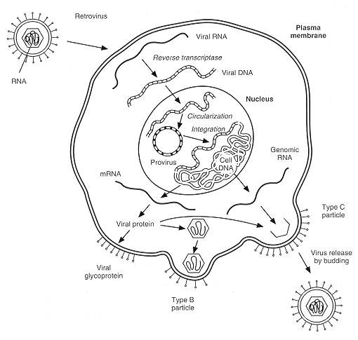
FIGURE 47-1 Replication of retroviruses. Type B and D particles develop from the budding of preformed cores known as type A particles.

Type C Oncoviruses
The type C oncoviruses include the human and animal leukemogenic retroviruses. Neoplastic transformation is induced by these viruses through direct interaction with cellular genes called proto-oncogenes.
One group of type C oncoviruses includes human T-cell leukemia viruses types I and 2 (HTLV-l and HTLV-2), as well as bovine (BLV) and simian (STLV-l) leukemogenic viruses. These viruses establish predominantly latent infections, often with the concurrent production of antiviral antibody. They produce a narrower disease spectrum than the other type C oncoviruses (such as avian leukemia virus); for HTLV-l, the disease spectrum includes adult T-cell leukemia, lymphoma, and tropical spastic paraparesis. The HTLV group of viruses carry a viral gene, tax, which is probably involved in neoplastic transformation

Type D Oncoviruses
Type D oncoviruses have been isolated only from nonhuman primates, in which they induce both immunosuppression and proliferative syndromes.

Replication

General Features
Although there are important differences in the replication strategies among the oncogenic retroviruses, there is a strong common theme. Retroviruses are enveloped RNA viruses, and two copies of the viral genome are enclosed within a core, together with the virion-associated enzyme reverse transcriptase. Surrounding the core is an envelope containing the viral glycoproteins, which serves as the anti-receptor for the virus to bind to its target cell (Fig. 47-1). Once bound, the core is released into the cytoplasm and the RNA genome of the virus is transcribed into double-stranded DNA by reverse transcriptase. The double-stranded DNA copy of the viral genomecalled the provirusmigrates in a nucleoprotein complex to the nucleus, where it becomes covalently integrated into the chromosomal DNA. Integration of the provirus is dependent on an integrase function of reverse transcriptase.
At the gross level, integration appears to be a random process occurring anywhere within open chromatin, although fine-structural features of the chromosomal target may influence the exact integration point. In HTLV infection, the proviral copy number usually ranges from one to three proviruses per cell. The HTLV replication cycle may be halted at this point, and then a latent infection is established within the cell.
Once transcription is initiated, new genomic RNA and mRNA encoding viral proteins are transcribed from the provirus. Viral glycoproteins become substituted into the plasma membrane, and in the type C viruses internal core proteins assemble beneath this region, forming a nascent virion, which is released by a budding process (Fig. 47-1). In contrast to infection with HIV, release of the type C oncoviruses is not usually a cytopathic process; hence, a cell can continue to divide and function normally while releasing virions. These features, coupled with the integration of the provirus into chromosomal DNA, lead to persistent, usually life-long infections with these viruses.

Genomic Organization
The genomic organization of the oncoviruses is discussed in Chapter 62 and illustrated in Figure 47-2.
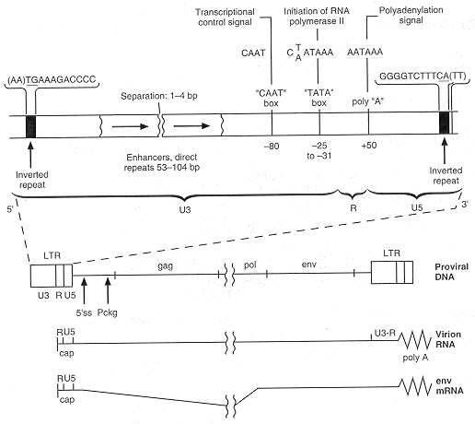
FIGURE 47-2 Proviral structure and transcription of murine leukemia virus.

Oncogenic Transformation

Oncogenes
Oncogenes are cellular and viral genes that influence cell growth and differentiation and may lead to oncogenic disease. The discovery of the human oncogenic and immunosuppressive retroviruses has been of major importance in human medicine; however, study of animal retroviruses has led to the discovery of the cellular oncogenes, whose mutation or dysregulation leads to oncogenic disease.
When avian leukemia virus infects a chicken, many months may pass before tumors occur, if they occur at all. However, when viruses are isolated from tumor tissue, they may contain acutely transforming viruses (e.g., Rous sarcoma virus [RSV]) that are capable of rapidly reproducing the same type of tumor. Rous sarcoma virus was found to contain an additional gene, src, which is responsible for the transforming activity of the virus. This gene is of cellular origin and becomes incorporated into the virus by recombination (Fig. 47-3).
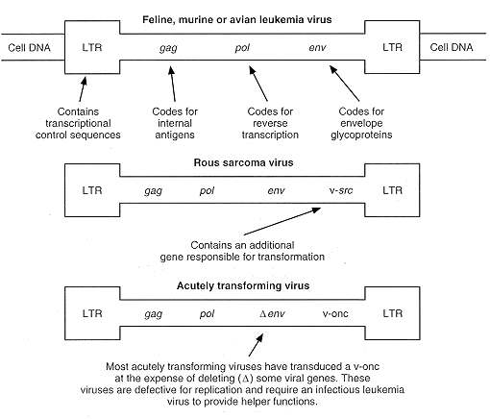
FIGURE 47-3 Proviral structure of rapidly transforming oncogene-containing viruses
Subsequently, other acutely transforming retroviruses were characterized, and the generic term viral oncogene (v-onc) became used to describe the transduced cellular gene within the viral genome. The cellular homologs of the viral oncogenes are referred to as c-oncs or proto-oncogenes, to indicate that the cellular genes fulfill normal functions governing signal transduction, cell proliferation and differentiation. Rous sarcoma virus is unique in that it is replication competent, which most acutely transforming retroviruses are not. The other viral oncogene-containing retroviruses are defective, having lost viral sequences and require the presence of a conventional leukemia virus to complement their defectiveness and permit their replication. Most of the evidence suggests that viral oncogene-containing viruses are generated de novo in each individual and are not transmitted from animal to animal.

Viral Oncogenes Are Derived from Processed Cellular RNA
Examination of viral oncogenes indicates that they differ from their normal cellular counterparts. The most obvious difference is that viral oncogenes lack introns, indicating that they were derived by reverse transcription of spliced mRNA from which the introns have been removed.
Often, there are other important differences, ranging from point mutations to deletions of large domains of the gene, that affect its transforming capacity. Viral oncogenes may also be expressed as a fusion protein with part of the viral gag sequences, a factor that can also influence their transforming activity.
Features that influence the transforming properties of an oncogene have been described for the oncogene v-myc, which encodes a phosphoprotein that localizes in the nucleus. A major factor governing the target cell that can be transformed resides in the properties of the enhancers within the viral long terminal repeat sequences (LTRs), although other factors, including mutations within myc, may play a part.
In one form of insertional mutagenesis, a defective retrovirus integrates upstream of exon 2 and a hybrid mRNA is produced from the promoter within the viral long terminal repeat. This process disrupts the normal feedback regulation of c-myc expression, leading to uncoordinated production of the myc gene product. Hybrid virus-myc RNAs of this form are probably precursors of v-myc-containing viruses.
A more complex situation is also shown in Figure 47-4. In this case, the virus integrates some distance from the myc gene, but the enhancers within the viral long terminal repeat influence the transcription from the normal c-myc promoters. Again, this process disrupts the normal feedback control of myc expression.
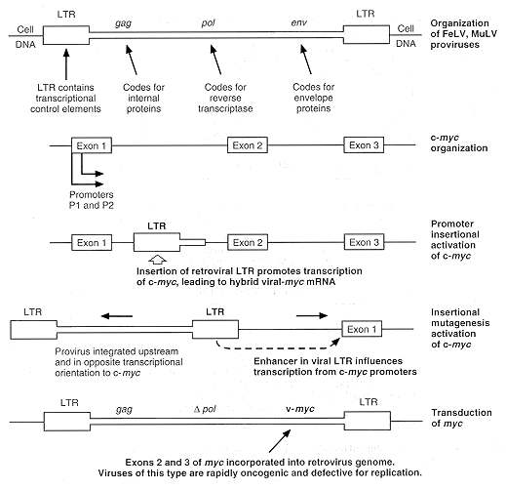
FIGURE 47-4 Examples of insertional mutagenesis of c-myc by a retroviral provirus. The c-myc gene consists of three exons: exons 2 and 3 code for the protein, and exon 1 contains promoters.
Nature of Oncogenes
A wide range of genes are activated or transduced by retroviruses, and where their gene products have been identified, it has been possible to assign them to putative functional groups (Fig. 47-5).
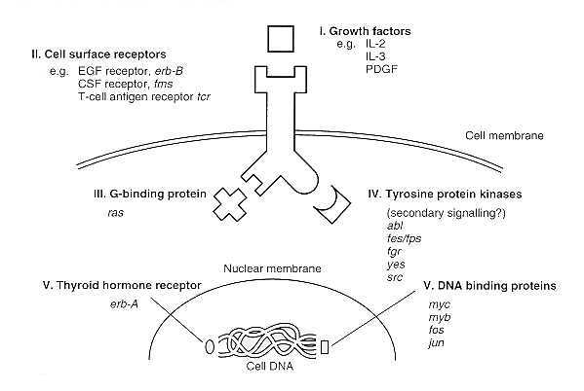
FIGURE 47-5 Representative types of substances derived from oncogene groups.
A clearly defined group in Figure 47-5 consists of the growth factors interleukin-2 (IL-2) and interleukin-3, which are expressed in response to insertional activation. Since receptors for these factors were present in the cells in which these genes were activated, an autocrine mechanism governing cellular proliferation appears likely in these cases.
Growth factor receptors have been identified as viral oncogenes, and genes for other cell surface structures, like the beta chain of the T-cell antigen receptor, have also been found in retroviruses. For instance, the oncogene v-erb-B is the homolog of the epidermal growth factor (EGF) receptor. In this case, there has been extensive modification of the protein, including deletion of the extracellular domain, forming the putative epidermal growth factor-binding site. Other changes in the cytoplasmic domain include the loss of a site for autophosphorylation. Phosphorylation of proteins is an important method of regulating protein activity and of communicating signals intracellularly. Consequently, the net effect of these changes is to produce a receptor that is constitutively active in the absence of its natural ligand.
Another large group of oncogenes, which includes the src gene of Rous sarcoma virus (Fig. 47-5, III), also have a tyrosine-protein kinase activity (i.e., they phosphorylate proteins on tyrosine residues). The products of this group of oncogenes appear to be associated with the plasma membrane and may increase levels of second messengers, transducing signals from cell surface receptors.
A distinct group of oncogenes, the ras oncogenes, appears to be related to the signal-transducing G proteins, which are regulated by binding to GTP and GDP, the GTP-bound forms being active and the GDP-bound forms inactive. The active form of ras bound to GTP is regulated by another protein, GAP, which has a GTPase activity, converting GTP to GDP. However, both v-ras genes within retroviruses and ras genes activated in nonviral cancers possess point mutations that prevent GAP-mediated GTPase activity. Consequently, these ras gene products remain in their GTP-bound activated state.
Other oncogene products, such as those of myc, myb, fos, ski, and erb-A genes, are located within the nucleus. The c-erb-A gene is the thyroid hormone receptor gene. Like other receptors of this class, the normal thyroid hormone receptor activates transcription through the binding of a hormone receptor complex to enhancer elements of their target genes. The v-erb-A gene is unable to bind thyroid hormone and is likely to be constitutively active.

Role of Multiple Genetic Events in Transformation
A common theme in viral oncogenesis is the concept that viruses act as initiators of transformation, with secondary genetic events being required for progression to the full neoplastic phenotype. Many of the oncogenes identified as retrovirus-activated genes are also activated in nonviral cancers. Moreover, different groups of oncogenes appear to complement one another in transformation. For example, genes such as myc exert an immortalizing function on primary embryo fibroblasts, which are normally capable of only a restricted number of divisions in vitro. Such immortalized cells are not tumorigenic, but become so when other genes such as ras are activated.
Recently, attention has been directed to a new, important class of repressor genes that exert an anti-oncogenic effect. The best-characterized example is the p53 protein. The anti-oncogene or tumor suppressor gene p53 is bound by the transforming proteins of papova, papilloma and adenoviruses, a state which inhibits normal cell function. Mutations in p53 similarly destroy the anti-oncogene activity in non-virus induced tumors (see papillomavirus later).

HTLV Replication
HTLV-1 and HTLV-2, as well as the bovine and simian leukemia viruses, have a genomic organization and replication pattern that distinguish them from other animal leukemia viruses (Fig. 47-6). In addition to the gag, pol, and env genes, these viruses contain a 3' px region encoding two genes, tax and rex, which are generated from a double spliced message.
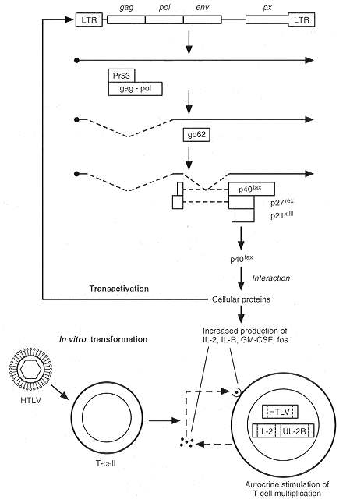
FIGURE 47-6 Genomic structure and transcription of the HTLV-1 provirus leading to autocrine stimulation of T cell multiplication.
HTLV-1 appears to remain as a latent infection in most infected cells in vivo. However, when the virus is activated, tax and rex transcripts are produced. The tax gene product acts as a transactivator, up-regulating the transcription of the provirus and thus creating a positive feedback loop. The effects of the tax protein are not direct but are mediated through cellular activating transcription factors namely the cAMP response-element binding proteins which bind to three 21bp repeat elements in U3 of the virus LTR; and ATF/CREB, AP2 and ETS transcription factors. These factors act through protein interactions, the modification of pre-existing proteins or by the induction of new cellular proteins.
The Rex nuclear phosphoprotein of MW 27Kd has a different regulatory function from tax. It favors the accumulation of unspliced and single-spliced mRNA encoding structural proteins over the double-spliced mRNAs encoding the regulatory proteins. The mode of action of Rex is not fully resolved but it has been implicated in stabilizing certain cellular mRNAs or the protein may be involved in the nuclear export of the structural mRNAs or play a role in the polyadenylation of transcripts. The balance between Rex and Tax production leads to an early/late switch in replication. When the provirus is first activated, all of the mRNA will be double spliced because of the low level of Rex. As Tax, which encodes two nuclear phosphoproteins of MWs 37 and 40, increases the level of transcription, Rex also increases, switching the balance toward the production of structural proteins. Thus Tax may regulate the switch from latency to virus production which might be achieved by increasing the stabilization of the transcription factor CREB binding to the virus promoter.

Mode of Action of Tax
When HTLV-1 infects cord blood lymphocytes, a polyclonal proliferation of mainly CD4+ but also CD8+ T cells occurs, and these events are associated with the expression of IL-2 and the IL-2Rd receptor by these cells. The genes for both interleukin-2 and the interleukin-2 receptor are among several cellular genes transactivated by Tax, indicating that HTLV- 1 can initiate an autocrine stimulatory pathway. Tax also transactivates c-fos, c-myc, c-jun and c-sis (encoding PDGF) MHC class 1, AP1, ERG-1, GM-CSF and stimulates the overgrowth of transfected 3T3 and rat 1 cells as well as inducing anchorage independence in transfected cells.
However, the pathogenesis of HTLV- 1 -associated T-cell leukemia and lymphoma remains an enigma. Although clonal HTLV-1 proviruses can be detected in the neoplastic cells, viral RNA transcripts are not usually detected. This situation is somewhat similar to the role of Epstein-Barr virus (EBV), a herpesvirus which remains latent in Burkitt's lymphoma, and suggests that HTLV-1 is necessary for initiation of disease but secondary genetic events are important in the development of HTLV-1-associated T-cell leukemia and lymphoma. These events remain to be elucidated. Tax induces N-F Kappa B transcription factors via degradation of I Kappa B-alpha and involving signalling pathways which converge with those used by the tumor promoter phorbol 12 merysterate, ionomycin or TNF. The possibility that Tax may also modulate signals from the cell surface receptors such as CD4 and the T-cell receptor remains an interesting speculation.

Animal Model
Recent studies show that severe combined immunodeficient (SCID) mice can support HTLV replication. Furthermore human lymphomas can arise when PBL from ATL patients are injected intraperitoneally. This suggests the SCID mouse may prove useful in the future for studying the development of ATL.

Control
As it is important to prevent HTLV-1 infection of very young children to avoid the onset in adult life of ATL, the effort in Japan has gone into publicizing the need for hygiene, the control of breast feeding to only three months and the use of condoms. Chemotherapy for ATL has only recently shown any success using a combination of AZT with interferon. Vaccine developments include efforts to include peptides to interfere with the binding of HLV-1 to its cell receptor and a recombinant adenovirus vector in which the envelope glycoprotein (env) can be expressed in Hela cells. This latter may be tested in countries with a high prevalence rate (New Guinea) and used for oral administration.

Host Response
In ATL the HTLV-1 is not generally expressed so there is no routine lymphocytic response.

Oncogenic DNA Viruses

Human Hepatitis B Virus (also see Ch. 70)

Clinical Manifestations and Epidemiology
Beasley and coworkers showed in 1981 that 40% of Chinese males infected with hepatitis B virus (HBV) will die owing to HBV related hepatocellular carcinoma (HCC). In common with many other tumors, primary hepatocellular carcinoma (PHC) is prevalent in certain geographic areas, principally in Africa and Asia. Its study has produced a convincing association of HBV with PHC. PHC is usually associated with chronic liver disease and with chronic liver injury and regeneration. Infection with HBV often goes from mother to child and within family groups living together.

Prospective Studies
Infection with HBV prior to the onset of primary hepatocellular carcinoma has been demonstrated in a study of 22,707 patients in Taiwan. The study showed a very strong association between infection with HBV and the subsequent development of primary hepatocellular carcinoma. The 10 percent of individuals in this series who were HBV carriers had a 223-fold higher risk of developing primary hepatocellular carcinoma than did the individuals not carrying the virus. That this is a very high risk is shown by the fact that moderate cigarette smoking increases the risk of developing lung cancer by 10-fold.

Cofactors
Infection with HBV at an early age, the development of chronic hepatitis and impaired immunity are risk factors in the development of HBV-associated primary hepatocellular carcinoma. Another risk factor is alcohol-associated hepatic cirrhosis. A potent fungal carcinogen, aflatoxin, is frequently found in the areas in which primary hepatocellular carcinoma is prevalent which may act synergistically to increase the risk of carcinogenesis.

Host Response and Viral Persistence
Because HBV cannot yet be cultured in vitro, another method is necessary to diagnose the continuing presence of the virus in patients. Therefore, the presence of HBV antigen in serum is monitored; in particular, the presence of HBV surface antigen (HBsAg) is used to indicate persistent infection. Patients with a poor antibody response (HBsAb) to HBsAg are those who frequently progress to develop primary hepatocellular carcinoma. Low levels of HBsAb indicate an impaired immune response. Another factor implicated in primary hepatocellular carcinoma is early age of infection of the patient before maturation of the immune system. The virus is often spread from mother to infant, and close family members also spread the virus. Low standards of living are also a contributing factor. Early infection may occur before maturation of the immune system.. In more developed Western countries, where primary hepatocellular carcinoma is not common, the initial infection takes place later in life (i.e., in the teens).

Diagnosis and Persistence of Hepatitis B Virus DNA in Primary Hepatocellular Carcinoma Cells
Biopsy material from patients with primary hepatocellular carcinoma has been tested for the presence of HBV DNA. HBV DNA is integrated into the host genome, and isolation of restriction fragments larger than the HBV genome confirms HBV integration within the cell genome, as do DNA sequencing studies, which show that integration is usually random. The total genome is frequently not retained, and deletions, rearrangements, insertions and mutations are observed, indicating that the integrated HBV genome is probably not the source of the persistent infection. This finding also suggests that the primary role of HBV in carcinogenesis does not require the continuing expression of the integrated HBV genome (i.e., a hit-and-run mechanism). Indeed, integration frequently occurs during chronic infection with no evidence of HCC.

Molecular Mechanisms of Transformation
Despite numerous studies, no viral oncogene has been detected in HBV. One possible mechanism for the oncogenicity of HBV is integration of the HBV genome in or near a proto-oncogene. Such an integration event has been observed: in this case integration took place near a gene with homology to v-erb-A, the putative DNA-binding domain of the human glucocorticoid and estrogen receptors. This gene might subsequently be inappropriately transcribed. In addition, integration of HBV DNA within the DNA sequences coding for human cyclin A has been recorded. Cyclins are important proteins which control progression through the cell cycle. Integration of HBV at such a site could alter the growth control of the normal cell. However, there is no general pattern in tumors to suggest that this is a regular mechanism.
The fact that HBV encodes a reverse transcriptase and replicates via an RNA intermediate similar to that of the retroviruses suggests that the mechanism of oncogenicity may be similar in the two virus groups. The X open reading frame of HBV DNA (Fig. 47-7) corresponds in position to the HTLV tax gene discussed above. Experimental evidence has shown that the X gene can transactivate promoters and enhancers and stimulate itself and other genes in the presence of cellular factors. Integrated HBV retains the X gene, in contrast to other HBV genes, which are frequently lost.
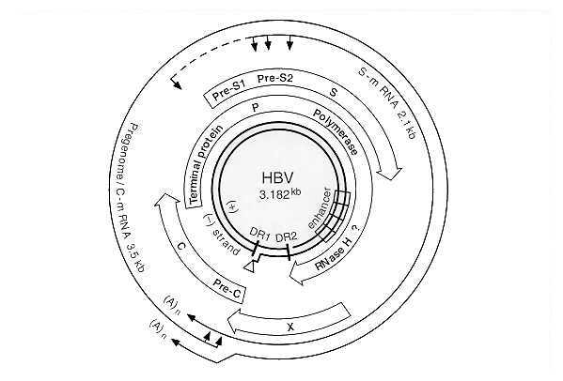
FIGURE 47-7 Genome map of HBV. (From Schlicht H-J, Schaller H: Analysis of hepatitis B virus gene functions in tissue culture and in vivo. Curr Top Microbiol Immunol 144:253, 1989, with permission.)
Another possible mechanism of HBV oncogenesis is repression of the cellular interferon beta promoter by a trans mechanism. This event could promote persistent infection by HBV, leading to cirrhosis and ultimately to cancer. Infection with HBV correlates with deletion of p53, suggesting that one mechanism by which the virus achieves oncogenicity is deletion of an anti-oncogene.
HBV is an almost complete double stranded DNA genome which codes for its proteins in overlapping frames. Two transactivating gene products, pre-S and X, may be responsible for oncogenicity by transactivation of cellular genes important in growth control (see Figure 47-7 and Chapter 70).

Animal Models
Receptors for HBV are present only in human and chimpanzee cells. Other viruses of this genus have been clearly demonstrated to be tumorigenic (e.g., woodchuck hepatitis virus, which induces tumors in 90 percent of infected woodchucks within 1 to 2 years, and duck hepatitis virus, which is oncogenic in ducks).

Control
Effective vaccination has shown a decrease of hepatocellular carcinoma in Alaskan Eskimos. However, it is essential that targets are met for the vaccination of neonates and young people in third world countries and vaccination of teenagers in the west where the incidence of HBV in heterosexual teenagers is increasing dramatically. Use of condoms and other hygiene precautions should decrease the risk of spread.

Conclusions
HBV is strongly associated with primary hepatocellular carcinoma by its presence in the tumor cell and by the striking role of persistent HBV infection as a risk factor for the development of primary hepatocellular carcinoma. If it is generally shown that vaccination significantly decreases the incidence of primary hepatocellular carcinoma in individuals with persistent infection, that will be a clear indication that HBV is involved in the development of primary hepatocellular carcinoma.

Herpesvisuses (also see Ch. 18)

Epstein-Barr Virus Association with Burkitt's Lymphoma

Epidemiology and Geographic Distribution
African Burkitt's lymphoma (BL), the most frequent childhood tumor in Africa, arises in areas where malaria is endemic and infection with EBV occurs very early in life when the immune system may be depressed by malaria or not yet mature. The most common age of onset of BL is 6 to 8 years. Boys are two to five times more often affected than girls. The tumor, a poorly differentiated lymphocytic lymphoma, is of monoclonal origin, implying that it is derived from a single viral transforming event. Primary infection with EBV leads to the activation of CD4+ and particularly CD8+ T cells. If a young immunosuppressed patient who is EBV negative receives a bone marrow transplant from an EBV positive donor, immunoblastic lymphoma may arise.

Diagnosis and State of the Viral Genome
The presence of EBV genomes in Burkitt's lymphoma is shown by Southern blot hybridization, by in situ hybridization with a labeled DNA or RNA probe or by PCR amplification. The viral genome is maintained mostly as multiple episomal copies which rely on expression of the nuclear protein EBNA-1, although some EBV DNA is also integrated into the cell genome. African Burkitt's lymphomas express the nuclear antigen EBNA1 only whereas most other EBV positive lymphomas express EBNA1 and the latent membrane proteins LMP1 and LMP2. Immunoblastic lymphomas, in contrast, express EBNAs 1,2,3A,3B,3C,-LP, LMP1 and LMP2 due to lack of host immune response.

Host Response to the Tumor
The EBV genome codes for many proteins of which EBNA 1 is essential for replication and maintenance of viral DNA in episomal form. Antibody to this protein can be found together with antibody to other EBV-nuclear proteins and antibody to membrane proteins whose expression has been correlated with tumor expression (see above). The amount of antibody to viral capsid antigen is proportional to the tumor mass. Successful therapy and remission are correlated with a decrease in the viral capsid antigen titer. A subsequent increase in viral capsid antigen titer indicates tumor recurrence. Burkitt's lymphoma is also associated with a high titer of antibodies to the restricted (i.e., restricted to the cytoplasm) and diffuse (i.e., diffused throughout the cell) components of the early antigen complex. Rising titers to the restricted complex indicate relapse and tumor recurrence. High titers of anti-membrane antigen and antibody-dependent cellular cytotoxic antibodies are associated with good prognosis in therapeutically induced remission. Patients with immunoblastic lymphoma have impaired T cell function and tumors in AIDS patients often arise in immune privileged sites eg the CNS and most proteins are expressed. EBNA is apparently poorly recognized by T cells and no T cell specific peptides have been generally detected although there is one report of such a peptide which may be useful in the future.

Persistence of the Virus
African Burkitt's lymphoma tumors contain cells that shed no virus or a very low percentage of cells (called producer cells) that replicate infectious virus. Producer cells can be identified by staining with antibody to viral capsid antigens. In addition, the presence of multiple EBV genome copies indicates persistence of the virus from the time of the initial transformation event. Sporadic cases of BL only harbor the EBV genome in a proportion of cases as does BL associated with AIDS and Hodgkins Disease.

Molecular Mechanism of Transformation
The most important mechanism of transformation associated with Burkitt's lymphoma is the increased transcription of the cellular oncogene c-myc. This event, which can be observed cytogenetically, is brought about by a translocation in which c-myc is transferred from its location on chromosome 8 to chromosome 14, where it is much more actively transcribed under control of the gene for the immunoglobulin heavy chain. Translocation to chromosome 2 and 22 is also seen, in this case into the light immunoglobulin chain. The translocation events lead directly to transcriptional activation of c-myc but it is not absolutely clear what sequences effect this transcriptional activation.
The virus itself can infect lymphocytes and immortalize them by amplification of CD4+ and CD8+ T cells, thus displaying the ability to code for immortalizing functions. Translocations of c-myc are not seen in lymphocytes immortalized in vitro. The EBV BNLF-1 gene product, also known as latent membrane protein 1 (LMP1), has been shown in vitro to transform Rat-l or murine BALB/c 3T3 cells to anchorage independence. LMP1 in B cells induces expression of Bcl-2 and A20, two proteins with anti-apoptotic activity, thus preventing normal programmed cell death. Binding of EBNA LP to the anti-oncogene proteins p53 and Rb may be an important mechanism of abrogating normal growth cell cycle control (see Papillomavirus section).

Cofactors
Cofactors thought to be involved in EBV-associated carcinogenesis are the early age at which the initial infection with EBV occurs in endemic areas (i.e., at a time when the immune system is not fully developed). Malaria is considered to be a cofactor because it impairs the host cell-mediated immunity at an early age. Cytotoxic T cells from patients with malaria cannot suppress EBV-induced lympho-proliferation. Other cofactors are disease eg AIDS or immunosuppression pending transplantation.

Animal Models
EBV is capable of infecting cotton-top tamarins as well as humans. EBV-induced tumors in cotton-top tamarins have been used as an animal model for disease and to test the efficacy of possible EBV vaccines eg gp340.

Epstein-Barr Virus Association with Nasopharyngeal Carcinoma

Epidemiology and Geographic Distribution
Nasopharyngeal carcinoma is prevalent in distinct geographic regions, namely South China, other parts of Southeast Asia, and Alaska. The incidence may be as high as 98 cases per 100,000 population per year among Cantonese Chinese. The disease affects men twice as often as women. Incidence peaks between ages 50 and 70. The tumor is an undifferentiated or poorly differentiated monoclonal carcinoma of the nasopharynx.

Diagnosis and State of the Viral Genome
Viral DNA is detected by Southern blotting or in situ hybridization with a labeled DNA probe. EBV is often detected by PCR. The viral DNA is present in tumor cells as multiple episomal copies. In addition, EBNA1 can be detected by anti-complementary immunofluorescence. LMP1 and LMP2 transcription are detected by PCR.

Persistence of the Virus
As mentioned above, the tumor is monoclonal and the EBV genome persists in all tumors as multiple episomal copies. The cells in a tumor which give rise to infectious virus are terminally differentiated, and latency is the most common state of the viral genome.

Host Response to the Tumor
The host response to nasopharyngeal carcinoma differs from that of Burkitt's lymphoma. Patients with nasopharyngeal carcinoma develop high IgG anti-viral capsid antigen titers and high titers to the diffuse component of the early antigen complex. IgA antibodies to viral capsid antigen and diffuse early antigens and antibodies to membrane proteins reach high levels in patients with nasopharyngeal carcinomas. High titers of antibodies to EBV-specific DNAse are also found in these patients. Antibodies are used in diagnosis, and when anti-diffuse early antigen IgG, anti-viral capsid antigen IgA, and anti-diffuse early antigen IgA are all found, nasopharyngeal carcinoma is extremely likely to be present. The characteristic pattern may not be detectable if the tumor is very small and is limited to the postnasal space, however, or if the tumor has spread through the bones but has a small mass. Patients who respond well to therapy show declining antibody titers, and an increase in these titers may signal relapse. High titers of antibody-dependent cellular cytotoxic antibodies correlate with a good prognosis. At present it is known that EBNA1, LMP1 and LMP2 can be detected in NPC as transcripts but levels of LMP1 and LMP2 proteins can be too low to be detected by Western blotting.

Molecular Mechanisms of Transformation
The molecular mechanisms by which EBV converts epithelial cells to potentially tumorigenic cells are not understood. Why a virus which is usually carried latently as an asymptomatic infection should transform epithelial cells is not clear. Some later event in multistage carcinogenesis is likely to be important.

Cofactors
In contrast to the case in Burkitt's lymphoma, no translocations of c-myc are detected in nasopharyngeal carcinoma. In addition, the age of onset (sixth decade) of the tumor does not suggest that infection at a very early age leads to an immunocompromised state. South Chinese who emigrate to the United States still show a high incidence of EBV-associated nasopharyngeal carcinoma, suggesting that genetic factors are involved in the etiology of this tumor. Dietary factors may also be involved. Sprouting fern shoots, which are consumed in Asia, are thought to have high levels of carcinogens or immunosuppressants similar to those that have been found in bracken and shown to act as cofactors in the development of alimentary tumors in cows infected with bovine papillomavirus.

Control
The late age of onset and socio-economic status of NPC patients suggest vaccination would be difficult. Seroconversion to EBV positivity may be sufficient to cause decreases in later tumor development if antibody titers could be maintained effectively. The tumor can respond to chemotherapy.

Kaposi's Sarcoma-associated Herpesvirus
Being only recently identified, there is limited information on KSHV.
Clinical Manifestations: Originally detected in AIDS patients, the KSHV DNA has now been found in classic KS (i.e., elderly men with slow growing tumors) and in squamous lesions (benign and malignant) from transplant patients and those undergoing immune suppression.
Diagnosis: Diagnosis is by detection of KSHV DNA sequences using the techniques of PCR and/or Southern blotting with a labelled probe followed by DNA sequence analysis.
Cofactors: Immune deficiency and infection with other viruses including HCMV, HPVs, human herpesvirus (HHV) type 6 or HBV are cofactors.

Virus Cofactors
Herpesviruses: HSV-2 and HCMV: Infection with these viruses is often associated with tumorigenesis but molecular evidence for integration of either virus is not strong. Both HSV-2 and HCMV may be important in multistage carcinogenesis by altering growth control or mutagenesis.
Molecular Mechanisms of Transformation: HSV-2 may act as a cofactor with HPV. Studies report a greater incidence (9-fold) of cervical carcinoma in patients infected with both viruses than with HPV-16 alone. HCMV is associated with Kaposi's sarcoma. Both viruses may induce immediate early cell cycle genes, amplify expression of cell genes that influence cell multiplication, induce endogenous retroviruses or cause mutagenesis (Fig. 47-8).
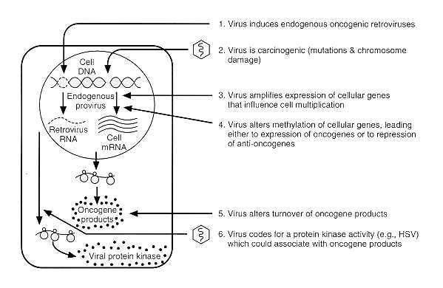
FIGURE 47-8 Possible mechanisms by which HSV and HCMV may induce one stage of multistage carcinogenesis.

Human Papillomaviruses (also see Ch. 66)

Epidemiology and Association with Disease
The papillomaviruses are specifically associated with proliferative lesions. The virus can multiply only in differentiating keratinocytes. The proliferative lesions are mainly benign, giving rise to warts of the skin and mucosa. However, certain types of human papillomavirus are strongly associated with the development of carcinoma. This association is supported by the presence of papillomavirus DNA in the tumor cells.
The papillomaviruses have a close association with cancer of the uterine cervix; HPV types 18, 31, 33 and 45 are found but the principal type is HPV16, associated with at least 90 percent of cervical tumors. Cancer of the uterine cervix is associated with sexual transmission of an infecting agent presumably papillomaviruses. The virus is also found in vulval tumors. Epidermodysplasia verruciformis, a tumor of the skin, is strongly associated with several different human papillomaviruses but mainly types 5 and 8.
Over 60 different types of human papillomaviruses have been described. The viruses are ubiquitous but highly tropic. The cancers with which they are associated are monoclonal, moderately to poorly differentiated carcinomas.

Diagnosis and State of the Viral Genome
Viral DNA is detected in tumor cells usually by Southern blotting with labeled probes, or by in situ hybridization and, more recently, the polymerase chain reaction has also been used. Integration does not occur frequently in normal tissue, and transcription of the episomal viral DNA in normal tissues has not been investigated. In benign lesions, the virus usually persists as multiple episomes. However, in cervical cancers the viral genome is integrated. The viral genome is often integrated in cells from cervical intraepithelial neoplasias as well and the significance of finding HPV16 is thought to relate to progression to cancer in the future.
In cervical cancer cells, the genome can be detected as an integrated 8-kb DNA fragment by Southern blotting. However, careful investigation of the integration sites of human papillomavirus types 16 and 18 has revealed that the viral El, E6, and E7 open reading frames (ORFs) are integrated, whereas the genome is frequently cut through the viral E2 open reading frame and integrated into the cellular DNA at that point (Fig. 47-9). Thus, viral open reading frames E2 through E5 are lost and are not transcribed in tumors.
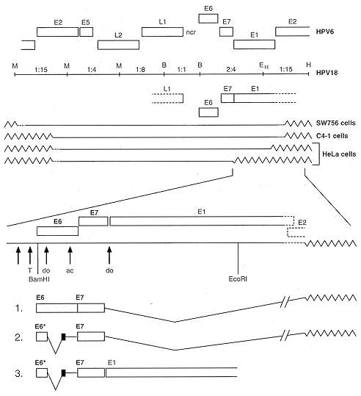
FIGURE 47-9 Integration and transcription patterns of human papillomavirus type 18 sequences in human cervical carcinoma cell lines HeLa, C4-1, and SW756. (Top) Solid lines indicate integrated viral DNA sequences, and zigzag lines indicate host cell sequences. A restriction map of the linearized prototype human papillomavirus type 18 DNA is shown above, indicating the cleavage sites for BamHI (B), EcoRI (E), and HindII (H). Open reading frames and the noncoding region (ncr) of human papillomavirus types 18 and 6 DNAs are also given. (Bottom) E6-E7-E1 are part of integrated human papillomavirus DNA and cDNA structures. Open boxes indicate the open reading frames, and "do" and "ac" denote splice donor and acceptor sites, respectively, Open arrows indicate TATA box sequences. (Adapted from Schwartz E, Schneider-Gadicke A, Zur Hausen H: Human papillomavirus type 18 transcription in cervical carcinoma cell lines. Cancer Cells 5:48, 1987, with permission.)

Classification
Over 60 different strains of human papillomavirus show host cell tropism. The criteria for deciding that an isolate is a new strain is based on the DNA homology to existing known strains. If a strain shows less than 50 percent DNA homology to other strains under stringent conditions of hybridization, it is considered to be a new strain. Cervical intraepithelial neoplasia, some cervical cancers, and some vulval intraepithelial neoplasias have been associated with human papillomavirus types 11, 16, 18, 30, 31, 33, 34, 35, 39, 40, 41, 42, 43, 44, 45, 51, 52, 56, and 57. Types 5 and 8 in particular, and to a lesser extent types 14, 17, and 20, are found in patients with epidermodysplasia verruciformis, a condition that progresses to carcinoma in 30 to 50 percent of patients.
Early studies of human papillomavirus implied that the presence of certain virus types (e.g., type 16) is prognostically significant and is associated with more advanced stages of cervical intraepithelial neoplasia (CIN) or other tumors. Human papillomavirus types 6 and 11 are associated with lower grades of cervical intraepithelial neoplasia. Studies from the West of Scotland on patients attending a colposcopy clinic as a follow-up measure after an abnormal result on a cytology smear test showed human papillomavirus type 16 to be the prevalent strain in that area. Human papillomavirus types 6 and 11 were rarely detected in specimens from cervical intraepithelial neoplasias. Moreover, human papillomavirus type 16 was found frequently in histologically normal tissue adjacent to the tumor and was present in histologically normal women without either cervical intraepithelial neoplasia or cancer (Macnab et al., 1986). In some of these specimens of normal tissue, the genome was integrated; thus, factors other than the presence of human papillomavirus type 16 may contribute to the formation of cancer. Women in other areas of the United Kingdom and the United States also have a high incidence of human papillomavirus type 16 in both normal tissue and cervical intraepithelial neoplasia. HPV is associated with neoplasia of the anus particularly in homosexual men where other factors may be of important in virus transmission.
In premalignant lesions (i.e., cervical intraepithelial neoplasia (CIN)), prospective studies have shown fluctuation in the ability to detect HPV at six monthly intervals. In addition presence of HPV-16 in a lesion did not always act as a good prognostic factor for the development of more severe disease.

Host Response to the Tumor
It has been clearly shown for epidermodysplasia verruciformis that host cell-mediated immunity is significantly impaired. The fact that the disease is associated with several strains of human papillomavirus strengthens the correlation with impaired immunity.
The exact role of the host immune response in patients with CIN and cervical cancer is not clear, but the immune system could be involved in the disease process and immunosuppression appears to lead to an increase in cervical cancer and CIN. The HPV gene products contain T-cell specific epitopes. Humoral antibody to type-common human papillomavirus antigen is abundant and ubiquitous, and the use of genetically engineered constructs expressing different open reading frames has shown that antibody to different open reading frames is present at different times of life. Antibody to the viral E4 antigen is associated with replicating virus and increases in the mid-teens. Its appearance is thought to coincide with first intercourse. Antibody to the viral E7 antigen is present in patients with CIN and cervical cancer.

Molecular Mechanisms of Transformation
Human papillomavirus type 16 transforms rodent cells in vitro by expressing the E6 and E7 open reading frames (Fig. 47-10). Rat embryo fibroblasts can be transformed by the viral E7 open reading frame of human papillomavirus type 16 in the presence of dexamethasone to cell multiplication not requiring attachment. Moreover, the viral E7 open reading frame can immortalize human keratinocytes but will not cause these to be oncogenic in nude mice. It is clear that human papillomavirus can immortalize cells; however, it does not code for a viral oncogene and other cofactors, not yet defined, are essential for malignant conversion. Of importance are the E6 and E7 ORFs which code for proteins capable of immobilizing the p53 protein and the Rb protein respectively. Both these proteins are involved in cell cycle control and as p53 acts as an anti-oncogene its impairment can prevent correct cell cycle regulation, particularly after DNA damage eg by radiation. The Rb protein is a recessive tumor suppressor gene product first detected in retinoblastoma where there is deletion of both alleles or deletion of one allele and mutation of the second allele. Binding of E7 to Rb is regulated by phosphorylation which is in turn regulated by cell cycle control. E7 binds underphosphorylated Rb in resting cells where Rb is bound to the transcription factor E2F. When E7 binds Rb then E2F is freed and can stimulate new activity promoting cell division. High risk HPVs (16 and 18) bind Rb tightly whereas low risk HPVs (6 and 11) do not.
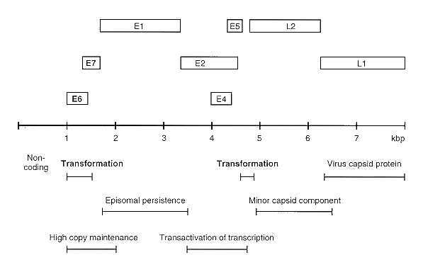
FIGURE 47-10 Genome organization of papillomaviruses. Open bars represent open reading frames, which are labeled E or L depending on their position in the early or late region of the genome. The position of reading frame ES is rather variable. This prototype example is derived for bovine papillomavirus type 1. Gene functions that have been mapped for bovine papillomavirus type 1 are listed below the genome. This organization formed a model with which other virus types were compared. (Adapted from Pfister H, Krubke J, Dietrich W et al: Classification of the papillomaviruses mapping of the genome CIBA Found Symp 120:10, 1986, with permission.)
E6 from high risk HPVs (16 and 18), on the other hand, binds to p53 and permits degradation of the ubiquinated form of p53 by ATP-dependent hydrolysis. Thus, the inability of p53 to play its normal role in the cell cycle is destroyed. Although the Mdm-2 gene product can interact with p53 and prevent p53 transactivation and growth suppression, tumors infected with HPV-16 E6 show no direct evidence that E6 can inactivate p53 in this way. In HPV-negative tumors p53 is often mutated and in this role it can act as an oncogene. Human papillomavirus type 16 will cooperate with activated oncogenes, such as ras, to produce oncogenic cells. For a comprehensive review see Lane D.P. (1994) in Viruses and Cancer, Eds. Minson, Neil and McCrae.

Cofactors
In cervical cancer, other viruses (e.g., HSV-2 and HCMV) and other infectious agents (e.g., Chlamydia species) have been implicated as cofactors acting in concert with human papillomavirus type 16. Evidence of HSV-2 infection together with HPV-16 has been shown to increase the risk of developing cervical cancer by nine-fold. For decades, it has been realized that multiple sexual partners and an early age at first intercourse contribute to the development of the disease.
In cases of epidermodysplasia verruciformis, an impaired cell-mediated immune response is characteristically present, and numerous human papillomavirus strains are often detected in the same patient. Exposure to sunlight is another cofactor: the cancers typically develop on skin sites exposed to the sun.

Animal Models
Bovine papillomavirus type 4 is strongly associated with alimentary carcinoma in cattle. The viral genome is not retained in the cancer cells in this disease, indicating that the virus plays a role in initiation but that further cofactors are needed for progression. The disease progresses to cancer in regions where bracken is eaten by the cattle (e.g., West of Scotland). The carcinogen quercetin, found in bracken, is thought to be a cofactor. However, bracken also contains immunosuppressive agents, and these may act synergistically with the virus.
Cottontail rabbits can be infected by the cottontail rabbit papillomavirus. These animals develop warts in which the DNA is episomal. In a high percentage of laboratory animals, the benign infection progresses to carcinomas in which the papillomavirus genome is integrated. This is an excellent animal model for the situation in which integration of the viral genome is strongly associated with progression to malignancy.

Control
Sexual transmission can be averted by hygiene precautions including the use of condoms. The possibility of vaccine production is under consideration and might involve E6 or E7 to prevent expression of these proteins or a vaccine expressing HPV virus capsid L1 and L2 proteins to prevent infection. On the other hand peptide vaccines inducing CTL responses are also under consideration but may require a cocktail of peptides to cover different papilloma types.

Vaccines in the Prevention of Virus-Associated Cancers
It has been popular to respond to the problem of virus-associated carcinogenesis by vaccination. Live attenuated virus vaccines have been used, but a more popular approach recently has been to construct live recombinant virus vaccines that are specifically engineered to express a viral protein known to be immunogenic and to confer immunity to the virus. Such a vaccine is the vaccinia virus recombinant that contains a gp340 EBV glycoprotein. This vaccine prevents the cotton-top tamarin from developing lymphomas when challenged with EBV. However, there are two problems. First, primary hepatocellular carcinoma, Burkitt's lymphoma, and nasopharyngeal carcinoma occur with high incidence in geographic areas where the standard of living is low and access to patients and cost of vaccine is expensive. Second, the high incidence of HIV causing AIDS, which is so specifically immunosuppressive, has altered the approach to live vaccines, since such vaccines could be more deadly than the disease in an HIV-positive recipient who is unable to raise antibodies.

REFERENCES

RNA Viruses
Alt FW, Harlow E, Ziff EB: Nuclear Oncogenes: Current Communications in Molecular Biology. Cold Spring Harbor Laboratory, Cold Spring Harbor, NY, 1987
Bishop JM, Varmus H: Functions and origins of retroviral transforming genes. p.999. In Weiss R, Teich N, Varmus H, Coffin J (eds): RNA Tumor Viruses. Cold Spring Harbor Laboratory, Cold Spring Harbor, NY, 1984
Greene WC, Bohnlein E, Ballard DW: HIV-1, HTLV-1 and normal T-cell growth: transcriptional strategies and surprises. Immunol Today 10:272, 1989
Land H, Parada LF, Weinberg RA: Tumorigenic conversion of primary embryo fibroblasts requires at least two cooperating oncogenes. Nature 304:596, 1983
Lezzoni JC, Gaffey MJ, Weiss LM: the role of Epstein-Barr virus in lymphoepithelioma-like carcinomas. Amer J Clin Path, 103(3):308, 1995
Neil JC, Forrest D, Loggett DL, Mullins JC: The role of feline leukemia virus in naturally occurring leukaemias. Cancer Surv 6:117, 1987
Onions D, Lees G, Forrest D, Neil JC: Feline leukaemia virus carrying the myc gene rapidly produce clonal tumors expressing T-cell antigen receptor genes. Int. J. Cancer 40 :40, 1987
Stehelin D, Varmus HE, Bishop JM, Vogt PK: DNA related to the transforming gene(s) of avian sarcoma viruses is present in normal avian DNA. Nature 260: 170, 1976
Varmus H, Swantstrom R: Replication of retroviruses. p. 369. In: Weiss R, Teich N, Varmus H, Coffin J (eds): RNA Tumor Viruses. Cold Spring Harbor Laboratory, Cold Spring Harbor, NY, 1984
Yoshida M, Inoue J-I, Fujisawa J-I, Seiki M: Trans-Regulation of HTLV-1 expression. p.251. In: Franza B, Jr, Cullen BR, Wong-Staal F (eds): The Control of Human Retrovirus Gene Expression. Cold Spring Harbor Laboratory, Cold Spring Harbor, NY, 1988

DNA Viruses
Baichwal VR, Hammerschmidt W, Sugden B: Characterization of the BNLF-1 oncogene of Epstein-Barr virus. Curr Top Microbiol Immunol 144:233, 1989
Boldogh I, Abubakar S, Albrecht T: Activation of protooncogenes: an immediate early event in human cytomegalovirus infection. Science 247:561, 1990
Chang Y, Cesarman E, Pessin MS, Lee F, Culpepper J, Knowles D, Moore PS: Identification of herpesvirus-like DNA sequences in AIDS-associated Kaposi's Sarcoma. Science 266:1865, 1994
Koshy R, Hofschneider PH: Transactivation by hepatitis B may contribute to hepatocarcinogenesis. Curr Top Microbiol Immunol 144:265, 1989
Levine AJ: The cellular and molecular biology of Epstein-Barr virus. Curr Top Microbiol Immunol 144:217, 1989
Macnab JCM, Walkinshaw SA, Cordiner JW, Clements JB: Human papillomavirus in clinically and histologically normal tissue of patients with genital cancer. N Engl J Med 315:1052, 1986
Schlicht H-J, Schaller H: Analysis of hepatitis B virus gene functions in tissue culture and in vivo. Curr Top Microbiol Immunol 144:253, 1989
Schwartz E, Schneider-Gadicke A, Zur Hausen H: Human papillomavirus type 18 transcription in cervical carcinoma cell lines and in human cell hybrids. Cancer Cells 5:47, 1987
Steinberg BM: Role of human papillomaviruses in benign and malignant lesions. Cancer Treatment & Res, 74:1, 1995

General
Perkus ME, Tartaglia J, Paoletti E: Poxvirus-based vaccine candidates for cancer, AIDS, and other infectious diseases. J Leukocyte Biology, 58(1):1, 1995
Viruses and Cancer. Ed Minson A, Neil J and McCrae M.. Soc for Gen Microbiol Symp 51. Cambridge University Press, Pitt Building, Trumpington Street, Cambridge CB2 1RP, England, 1994
Vaccines against Virally Induced Cancers. Ciba Foundation Symp 187. John Wiley & Sons, Baffins Lane, Chichester, PO19 1UD, England, 1994
A New Look at Tumour Immunology. Eds. McMichael AJ and Bodmer WF. Cold Spring Harbor Laboratory Press, 10 Skyline Drive, Plain View, New York 11803-9729, USA., 1992
Introduction to the Cellular and Molecular Biology of Cancer (Second Edition) Eds. Franks LM and Teich NM. Oxford University Press, Walton Street, Oxford OX2 6DP, 1990

