Persistent Viral Infections

Istvan Boldogh

Thomas Albrecht

David D. Porter

General Concepts

Definition
Persistent infections are characterized as those in which the virus is not cleared but remains in specific cells of infected individuals. Persistent infections may involve stages of both silent and productive infection without rapidly killing or even producing excessive damage of the host cells. There are three types of overlapping persistent virus-host interaction that may be defined as latent, chronic and slow infection.

Pathogenesis
The mechanisms by which persistent infections are maintained involve both
- modulation of virus and cellular gene expression and
- modification of the host immune response.
Reactivation of a latent infection may be triggered by various stimuli, including
- changes in cell physiology,
- superinfection by another virus, and
- physical stress or trauma.
Host immunosuppression is often associated with reactivation of a number of persistent virus infections.

Persistent Infections by Organ System
Some viruses can establish persistent infection at the same time in different cell types of one or more tissues or organs. For example, the primary site for latency of cytomegalovirus is thought to be peripheral blood monocytes, but the virus may induce disease and can be detected in cells of several organs (e.g., kidney, lung, and those of the digestive or central nervous system). Table-1 categorizes selected human viruses by organ systems in which the virus is believed to be primarily persistent.

In Vitro Models of Persistence
Three kinds of persistent infection can be maintained in cell cultures:
- chronic focal,
- chronic diffuse, and
- latent.
These infections may model key aspects of persistent infections in vivo.

Control
No measures to eradicate persistent viruses have been developed. Vaccination, interferon and antiviral drugs can reduce the frequency of clinical recurrence and ameliorate clinical symptom, yet the virus continues to remain associated with the host.

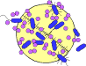

INTRODUCTION
Medical science has begun to control a number of acute virus infections, many by drug treatment and/or immunization, but persistent virus infections are largely uncontrolled.
Diseases caused by persistent virus infections include
- acquired immune deficiency syndrome (AIDS), AIDS-related complexes,
- chronic hepatitis,
- subacute sclerosing panencephalitis (chronic measles encephalitis),
- chronic papovavirus encephalitis (progressive multifocal leukoencephalopathy),
- spongioform encephalopathies (caused by prions),
- several herpesvirus-induced diseases, and
- some neoplasias.
The pathogenic mechanisms by which these viruses cause disease include disorders of biochemical, cellular, immune, and physiologic processes. Ongoing studies are rapidly advancing our understanding of many persistent infections. Viruses have evolved a wide variety of strategies by which they maintain long-term infection of populations (see Ch. 48), individuals, and tissue cultures. This chapter primarily describes persistent infections in vivo and focuses on viruses that persist in humans.

Classification
Persistent infections are those in which the virus is not cleared from the host following primary infection, but remains associated with specific cells. Figure 46-1 presents a classification scheme of the principal types of persistent infections in vivo.
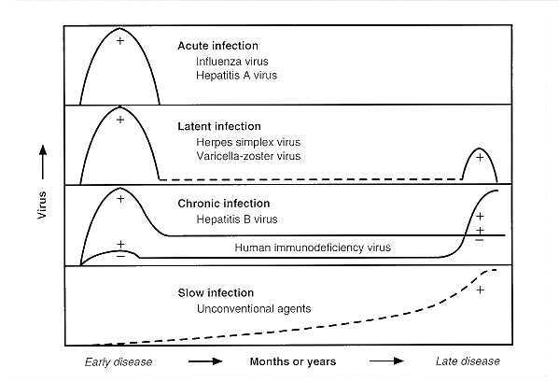
FIGURE 46-1 Natural history of acute and persistent human infections. Solid line, shedding of infectious virus; dashed line, virus not readily demonstrable; +, disease episode.
- Latent infection is characterized by the lack of demonstrable infectious virus between episodes of recurrent disease.
- Chronic infection is characterized by the continued presence of infectious virus following the primary infection and may include chronic or recurrent disease.
- Slow infection is characterized by a prolonged incubation period followed by progressive disease.
Unlike latent and chronic infections, slow infection may not begin with an acute period of viral multiplication.
During persistent infections, the viral genome may be either stably integrated into the cellular DNA or maintained episomally.
Some viruses can maintain more than one type of persistent infection at the same time, but in different cells.
The type of persistent infection may or may not be dependent on the cell type and the physiologic state of the cell. For example, Epstein-Barr virus (EBV) latently infects B cells, but in the same individual it is released for long periods from productively-infected pharyngeal epithelial cells (chronic infection). Therefore, in one individual, persistent infection with a single virus may involve multiple types of persistence, each of which may become more or less important as the individual responds to the disease.

Models of Virus Persistence in Vitro
Three types of persistent infection can be distinguished in cultured cells (Table 46-1).
- In the first, known as chronic focal infection (carrier culture), only a small portion of the cell population is infected. These cells release virus and are killed. Low concentrations of antiviral substances (e.g., antibody, interferon) reduce extracellular virus to a low level so that only a small number of susceptible cells are infected at any time, maintaining the infection. Such chronic focal persistent infections can be "cured" by increasing the concentration of antiviral antibody, interferon, or nonspecific inhibitor.
- In chronic diffuse infections (steady-state infections), all of the cells are infected and both virus and cell multiplication proceed without the cells being killed. Virus is continually released from the cells, and the infection cannot be eliminated by antiviral antibodies.
- The third type is the so-called true latent infection, in which the viral genome is replicated and segregated to the daughter cells either within the chromosomes or extrachromosomally.
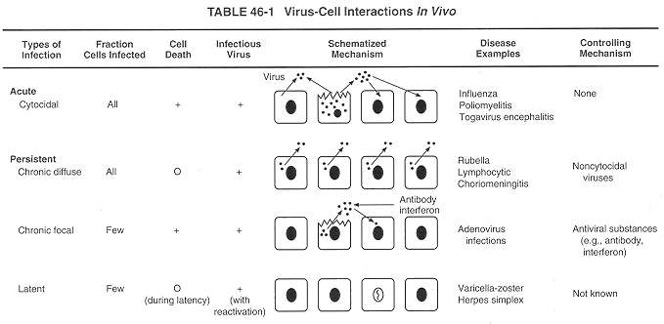

Pathogenesis of Persistent Virus Infections
Persistent infections are caused by a wide variety of viruses through diverse pathogenetic mechanisms that may cause strikingly different diseases (see Chs. 57, 59, 62, 66, 67, 68, 70, and 71 for thorough discussions of the viruses that cause persistent infections). Although the mechanisms by which any of these viruses produce persistent infection are not completely understood, some common factors have been identified.
- The first is immune modulation. Many viruses that cause persistent infection avoid the specific and nonspecific immune defenses in several ways. Examples include:
1. Limitation of recognition molecules on infected cells:
a. Restricted expression of viral antigens (e.g., HIV, measles virus in subacute sclerosing panencephalitis).
b. Antiviral antibody-induced internalization and modulation of viral antigens (e.g., measles virus).
c. Viral antigenic variation (e.g., HIV).
d. Blocking antibody that prevents the binding of neutralizing antibody (e.g., measles virus).
e. Decreased expression of cell major histocompatibility complex recognition molecules (e.g., CMV, adenoviruses).
f. Restricted expression of the cell adhesion molecules LFA-3 and ICAM-1 (e.g., EBV, CMV).
2. Altered lymphocyte and macrophage functions, including modified production of cytokines and immunosuppression (e.g., HIV-1, HIV-2, EBV).
3. Infection in immunologically privileged anatomic sites (e.g., HSV-1, HSV-2, VZV in the central nervous system).
4. Compromised nonspecific defenses (e.g., interferon).
5. Immune tolerance (?).
- The second factor is modulation of viral gene expression. Examples include down regulation of some viral genes by viral or cellular regulatory gene products (e.g., HIV, HPVs), specific latency-associated proteins (e.g., EBNA-1) and possibly by synthesis of latency-associated transcripts (e.g., HSV-1, HSV-2) and viral variants (e.g., HIV, measles).
Further work is being directed toward defining the relative importance of various mechanisms in the initiation and maintenance of persistent viral infections.

Reactivation of Persistent Viruses
For disease to recur in a latent infection the virus must be reactivated and begin replicating. Some factors associated with reactivation are infection with other viruses (as in HIV), nerve trauma (e.g., herpes facialis following surgery of the trigeminal ganglion), physiologic and physical changes (e.g., fever, menstruation, and sunlight), and immunosuppression (as in CMV disease). Papovavirus encephalitis in immunosuppressed patients may represent exacerbation and spread of a chronic infection.

Persistent Infections by Organ System

Immune System
A number of viruses can infect cells of the lymphoid system during acute infection, and some of these viruses persist (Table 46-2).
Thus, the lymphoid system also may serve as a reservoir for seeding other organs with the persisting virus. Persistent infection of the immune system may lead to evasion of immunologic surveillance.
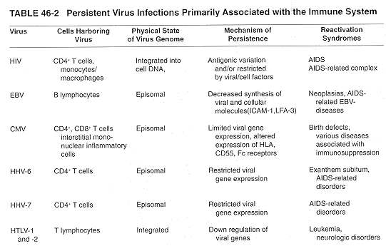

Human Immunodeficiency Virus
HIV infection is often followed by a clinical latent period of many years before AIDS develops (see Ch 62). A variety of immune cells (e.g., CD4+ lymphocytes, B cells, monocyte-macrophages, promyelocytes, dentritic cells) can be infected by the virus.
The long lag time between infection and development of AIDS is called clinical latency.
During the clinically asymptomatic stage of infection nearly 1 % of peripheral blood mononuclear cells (PBMCs) carry HIV proviral DNA as detected by in situ PCR. In contrast, less then 1 in 1000 PBMCs were actively expressing HIV-specific transcripts.
There are two early levels of restriction in HIV gene expression.
- The first is determined at the level of viral transcriptional initiation and is influenced by a number of cellular DNA binding factors (NF-kB, Sp-1, AP-1, LBP-1 URS, USF, COUP) that interact with the HIV LTR.
- The second is influenced by the levels of the HIV regulatory proteins (Tat, Rev) derived from multiply spliced mRNA that determine the fate of the initiated viral transcript by promoting more efficient elongation of initiated viral mRNA (tat) and by preventing the splicing that promotes translation of the viral structural proteins (rev) and production of genomic RNA (see Ch 62 and Fig. 46-2).
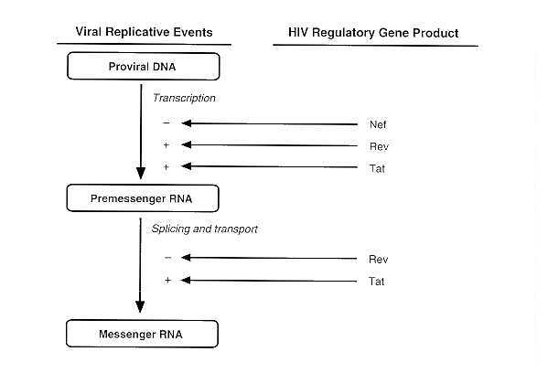
FIGURE 46-2 Regulation of HIV mRNA production by HIV gene products during persistent infection. Host regulatory mechanisms also are important in modulating HIV expression and replication.
The transition from a latent to a productive infection may occur in response to cytokines (e.g., TNF-alpha/beta, IL-1, -2, -3, -6, -7, CSF, TGF-beta) that perturb T cell functions (see Ch 62). Gene products from other viral infections, including CMV, HHV-6, EBV, and HTLV can enhance and/or activate HIV transcription and may be important in HIV pathogenesis.

Proposed mechanisms for persistence and escape of immune surveillance by HIV-infected cells include:
1. Restricted expression of provirus by cellular and viral factors.
2. Avoidance of neutralizing antibodies by spreading directly from cell to cell.
3. Budding of virus particles into cytoplasmic vacuoles, resulting in masked virus production.
4. Inhibition of antigen-induced lymphocyte proliferation by Tat protein.
5. Genetic (antigenic) variation among HIV isolates.
6. Multiplication in immunologically privileged sites.
7. Mobility of latently infected cells within the host.
8. Inhibition of immune and nonspecific defenses.

Human T-Cell Leukemia Viruses
Infection by these viruses is followed by a 10- to 30-year clinically latent period before development of leukemias or neurologic disorders in a minority of infected individuals. The expression of viral genes is regulated
- at the level of transcription by the interplay of various cellular transcription factors (CREB, ATF-2)
- and HTLV regulatory proteins (e.g., Rex, Tax).
Infected T cells expressing HTLV proteins are eliminated by the immune system. The few cells containing truly latent provirus escape the immune surveillance because HTLV expression is efficiently down regulated as a result of DNA methylation and a lack of protein-protein (Tax-CREB) interaction or appropriate transcription factors in quiescent T cells.

Epstein-Barr Virus
After the initial EBV infection and replication in epithelial cells (e.g., pharynx, salivary glands), the virus persistently infects hematopoietic cells.
It has been demonstrated that EBV persists in the peripheral blood of all seropositive individuals, in CDIg+, CD23- and CD80- (B7-) B cells. In these cells, the virus is truly latent, but when it is reactivated, infectious immortalizing virus is produced. The estimated frequency of EBV-carrying cells in healthy individuals varies from 20 to 60% per 107 B cells.
Immortalized B cells obtained by in vitro infection of normal cells are a well-studied model for latent EBV infection.
These cells are phenotypically lymphoblasts, expressing EBV-encoded latent proteins, six in the nucleus (Epstein-Barr nuclear antigens) and three in the membrane (LMP1, LMP2A, LMP2B).
EBV-seropositive healthy individuals maintain humoral and cellular immunity against these latent proteins, suggesting that immortalized EBV lymphoblasts can occur and persist for long periods of time in vivo.
Since virus-specific antigens are present in the membrane of latently infected B cells, it is appropriate to examine how these cells escape immune surveillance. These cells were not killed by MHC-matched, virus-specific cytotoxic lymphocytes (CTLs) in assays in which EBV-transformed B lymphoblastoid cells derived from the normal B cells of the patients were readily lysed. Resistance of these cells to CTLs is correlated with a reduced level of the cellular adhesion molecules LFA-3 and ICAM-l on the cell surface (Fig. 46-3). Therefore, the initial interaction that normally occurs between CTLs and target cells does not take place, and the infected cells may survive, even though they express class 1 major histocompatibility complex molecules and the EBV-encoded latent membrane proteins.
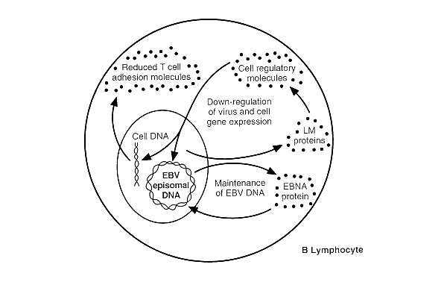
FIGURE 46-3 Maintenance of EBV DNA and immune avoidance by latently infected cells. LM, EBV-latent membrane protein; EBNA, EBV nuclear antigen.

Human Cytomegalovirus
The strongest evidence for the existence of latent CMV infection comes from the increased incidence of reactivated infection in seronegative individuals who undergo transplants of organs from seropositive donors or in immunosuppressed AIDS patients.
CMV is well known to infect multiple organs, including the salivary glands, lung, gastrointestinal tract, kidney, liver, spleen and brain. However, all the cell populations that harbor latent CMV have not been adequately defined. The best candidate cells for latent infection are thought to be monocytes.
The physical state in which CMV (DNA) persists appears to be episomal, and it is transcriptionally silent or the extent of DNA expression is restricted to immediate early (IE) genes. The CMV-host cell relationship appears to be distinct relative to other herpesviruses such as HSV, VZV or EBV.
During persistence CMV appears to impair immune responses at several levels:
- altered expression and intracellular distribution of antigen-presenting molecules such as MHC class I;
- b) altered production of lymphocyte adhesion (e.g., ICAM-1, LFA-1) or co-stimulatory molecules (e.g., B7);
- c) inhibition of complement-mediated lysis due to an increased production of inhibitory factors (e.g., CD55);
- d) masking of the cell surface with overproduction of Fc receptors that are able to bind IgG, thus preventing immune lysis;
- e) excretion of immune modulators (e.g., TGF beta, TNF alpha) by CMV-infected cells;
- f) CMV encodes G protein coupled receptors that resemble cellular molecules and through molecular mimicry may escape immune recognition.

Human Herpesviruses 6 and 7
These viruses (HHV-6A, HHV-6B and HHV-7) persistently infect 70-90% of the human population. They are identified as CD4+ T-lymphotropic viruses. HHV-6 and HHV-7 replicate well and can be isolated from PBMCs. In addition, both viruses are often detected in saliva. It is not precisely known what cells in the body become latently infected and/or produce infectious virus. Also, both viruses are reactivated in individuals receiving immunosuppressive therapy or with immune disorders, such as AIDS.

Nervous System
Many chronic, degenerative nervous system diseases are related to viral persistence (Table 46-3). Persistence in the nervous system probably involves some unique mechanisms that take advantage of the many types of specialized cells and the immunologically privileged status of the central nervous system.
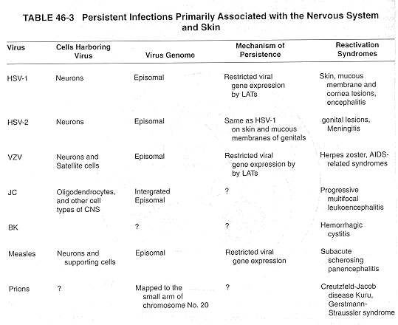

Herpes Simplex Virus Types 1 and 2
During acute herpes simplex virus (HSV) infection (see Ch. 68), virus and/or viral components (e.g., nucleocapsids) containing viral genetic material ascend in nerve axons from the initial site of infection to the sensory gangliamainly the trigeminal ganglia HSV-l, and the lumbar and sacral ganglia for HSV-2 (Fig. 46-4A).
In the sensory ganglia, the virus may cause a cytolytic infection or establish a latent, noncytolytic infection.
Sympathetic ganglia and other cell types of the central nervous system may also serve as sites of virus latency.
In the neuron, viral DNA is maintained as an extrachromosomal plasmid (episome) with 1 to 20 copies per cell. Current studies are examining the possibility that latent virus is restricted by virus DNA-encoded antisense RNA molecules known as latency-associated transcripts (LATs). Transcription of LATs is regulated by LAT promoter elements. The LAT promoter region contains a series of consensus elements, including a TATA box, Sp1 binding motifs, cAMP response element and LAT promoter binding factor. Reactivation of latent infection and an associated down regulation of the LAT promoter, often occurs after various stress-related stimuli, e.g., heat, cold, ultraviolet light, unrelated immune hypersensitivity reactions, pituitary or adrenal hormones, immunosuppression, and emotional disturbance. When the latent virus is reactivated, its genome passes anterograde in axons to the epithelium, where productive replication takes place (Fig. 46-4B).
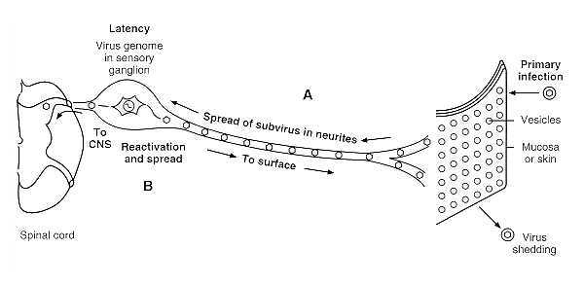
FIGURE 46-4 Establishment and reactivation of latent herpesvirus infections. (A) Establishment of herpes simplex virus or varicella-zoster virus latency in ganglia after primary infection of skin or mucosa. (B) Reactivation of virus in ganglion and spread through nerves to skin or mucosa to cause surface lesions or retrograde spread through nerves to central nervous system to cause encephalitis (infrequent).

Varicella-Zoster Virus
After recovery from acute varicella (chickenpox), the virus establishes latency in multiple ganglia of the human neuraxis (Fig. 46-4A). Years later, the virus may reactivate, and the distribution of lesions in the skin corresponds closely to areas of innervation (dermatome) from an individual dorsal root ganglion (Fig. 46-4B). However, in immunocompromised patients, life-threatening disseminated infections can occur. Studies suggest that the virus is harbored in sensory ganglia (trigeminal and/or dorsal) and satellite cells. In these cells, limited transcription may take place from some, but not all, of the immediate early and early genes of the latent viral genome. Thus, expression of latent varicella-zoster virus genes appears to be different from that of HSVs. Where mainly non-polyadenylated LATs that are antisense to immediate early transcripts are expressed and accumulate in neuronal cells. VZV-encoded LATs are polyadenylated transcripts of the sense direction that have a short half-life and are detectable in non-neuronal, satellite cells and in ganglia as well. However, there is no significant viral protein synthesis detectable from the polyadenylated transcripts during latency. The molecular basis of latency and reactivation of latent virus has not been fully characterized.

Measles Virus
Measles is normally an acute self-limited disease in which the virus appears to be eliminated. In rare individuals, however, virus persists in the brain despite apparent humoral and cellular immune responses. Possible mechanisms of persistence include
- the immunologically privileged status of the brain,
- antiviral antibody-induced internalization of viral antigens,
- altered and restricted virus expression and
- replication as a result of mutations in the virus genome.
A late (5 to 15 years) sequela of acute measles infection is subacute sclerosing panencephalitis (SSPE), which occurs in about 1/100,000 individuals who have had measles. This persistent virus infection is manifested by progressive mental deterioration, involuntary movements, muscular rigidity, and coma (see Ch. 59). During SSPE, mature virions, containing antisense RNA, are rarely produced. The inability of measles virus to complete its replication cycle is associated with a variety of transcriptional and translational anomalies which affect the expression, stability, or function of the matrix (M), fusion (F) and hemagglutinin (H) genes. In affected neurons there is an accumulation of inclusion bodies containing nucleocapsids, and surface proteins (H, F and M). Virus-infected cells may avoid immune surveillance by mutation in the M protein encoding gene that may explain restricted production and budding of virus and syncytia formation in SSPE, which favors persistence. SSPE patients have high titers of anti-measles antibodies in both serum and cerebrospinal fluid; however, antibody to M protein is often lacking.

Human Papovaviruses
The papovaviruses (JC and BK) are widely distributed in the human population, as evidenced by the presence of specific antibodies in 70-80% of adult sera. BK virus has been associated with hemorrhagic cystitis; however, the site of persistence is not known. The JC virus is thought to persist in the kidney, and is reactivated when the host immune system is impaired (e.g., HIV infection, immunosuppressive therapy, pregnancy). JC virus is regularly isolated from brain cells of patients with progressive multifocal leukoencephalopathy (PML), a fatal demyelinating disease.
The mechanism of persistence for both viruses can be related to the encoded T antigens, which are functionally similar, but antigenically distinct from SV40 T antigen. The latent JC virus genome can randomly integrate into cellular DNA and, when excision of viral DNA is induced, the latent genome becomes activated, infectious virus is produced, and disease (PML) may develop.

Prions
The subacute spongiform virus encephalopathies are a unique type of slow virus infection caused by agents called unconventional viruses or prions (see Ch. 71). Many lines of evidence have converged to argue that these infectious agents are composed largely, if not entirely, of prion protein (PrP) molecules. These proteins are encoded by wild type or mutated cellular genes that are excluded from the particles. The human PrPs gene can be mapped to the short arm of chromosome 20. A long incubation period (often years to decades) with slowly rising and spreading infection precedes the onset of clinical illness and is followed by chronic progressive disease. The host shows no inflammatory response, no humoral or cellular immune response, and no interferon production. Immunosuppression of the host has no effect on pathogenesis or progression of disease. The human subacute spongiform virus encephalopathies include kuru, Creutzfeldt-Jakob disease, Gerstmann-Straussler-Scheinker syndrome and fatal familial insomnia.

Digestive System
Of the numerous viruses that infect the digestive system, most (the enteroviruses and reoviruses) are considered to be acute viruses that cause infections even though some may continue to be shed for months or even years. Persistent infections may be caused by hepatitis viruses, adenoviruses, and parvoviruses (Table 46-4).
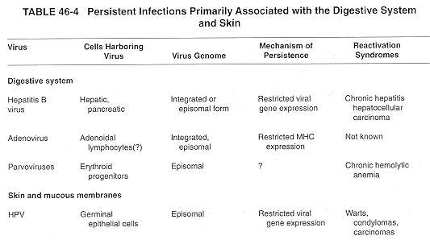

Hepatitis B Virus
Persistent Hepatitis B Virus (HBV) infection may be either chronic or latent, depending on the host cell type (see Ch. 70). Chronic hepatitis develops in about 10-15 percent of hepatitis B patients. The presence of viral surface antigen (HBsAg) or core antigen (HbcAg) in serum serves as a marker of persistent infection. In chronic infections, HBV productively infects hepatocytes and maintains a low level of virus production over a long period. Integration is not required for virus replication, but it may be a crucial event for long-term perpetuation of the virus genome. In addition, HBV is capable of causing latent infections (e.g., of peripheral blood lymphocytes or bone marrow cells) in which viral gene expression is very limited.
The factors that determine the development of chronic infection with HBV have not been fully identified. Immune tolerance to the surface protein of HBV appears to be one of the factors involved in the development of the carrier state. The chronic infection is related to an inefficient T-cell response to viral components critical for protective immunity. For example, there is a significant deficiency of HLA-DR2 and an excess of HLA-DR7 in patients with chronic persistent HBV infection. It appears that the HLA-DR7 molecule is unable to present the appropriate HBsAg epitope in a configuration that can be effectively recognized by helper T cells. There is strong epidemiological evidence of a causal relationship between persistent HBV infection and development of hepatocellular carcinoma.

Other Hepatitis Viruses
Chronic persistent infections of hepatitis C (HCV) and type D virus (HDV) is found throughout the world.
Individuals who have antibody to hepatitis C should be considered potentially persistently infected, and the presence of viral RNA in infections by hepatitis C are associated with chronic persistent or active hepatitis, cirrhosis, and hepatocellular carcinoma.
Hepatitis type D (delta agent; HDV), a defective virus that requires active replication of coinfecting HBV for its own reproduction, may exacerbate hepatitis B (see Ch. 70). HDV acquires an HBsAg coat for transmission. The mechanism of this interaction is currently being studied. There is no evidence that hepatitis A or E causes persistent infections.

Adenoviruses
Adenoviruses (AdV) typically cause acute disease of the respiratory and gastrointestinal tracts of human beings. The high incidence of adenovirus infections in organ transplant (kidney, bone marrow) recipients and AIDS patients suggests that these infections most probably represent reactivation of a latent adenovirus infection. For example, AdV can persist latently for years in adenoids and tonsils and often are shed in the feces for many months after the initial infection.
The mechanism and the cell type harboring the latent virus in vivo is presently unknown. In vitro studies have shown that the strategies of C-type AdV (types AdV2, AdV5) to evade immune recognition involve the e3 early genomic region. Protein(s) of the e3 region alter the expression, post-translational modification and transport of the major histocompatibility complex (HLA class I). In addition, E3 down-regulates the e1a gene product, the immunodominant cytotoxic T cell determinant. It is possible that similar mechanisms operate in the host during natural persistent infection.

Parvoviruses
The replication of the simplest DNA viruses, the parvoviruses, is dependent on functions supplied by replicating host cells (Parvovirus genus) or by coinfection with helper viruses, usually adenovirus (Dependovirus genus). Both genuses have been shown to develop persistent infection in humans.
For example, parvovirus B19 infects primarily the erythroid progenitors, causing chronic hemolytic anemia, neutropenia, and persistent arthritis mainly in immunocompromised individuals.
The dependovirus group of parvoviruses (adeno-associated viruses; AAV) can be isolated from fecal, ocular, or respiratory specimens and from penile and condylomatous lesions during simultaneous adenovirus infections. The AAV integrate into host cell DNA and replicate with it, only to be excised and induced to replicate when the latently infected cells are superinfected with adenoviruses. The dependoviruses are not known to be pathogenic.

Skin
Of the viruses that cause acute infections of the skin and mucous membranes, herpesviruses (see above) and papillomaviruses (Table 46-4) are also capable of establishing persistent infections.

Human Papillomaviruses
The ubiquity of latent papillomavirus infections is emphasized by the frequent, often acute outbreak of warts in immunosuppressed patients and pregnant women. HPVs specifically infect basal or germ cells of the epidermis. The virus genome persists in episomal form, as a result of the multiple DNA-protein and protein-protein interactions between viral and cellular regulatory factors. In latency, viral DNA replication and transcription are maintained at very low levels and regulated by negative cellular factors (e.g., NF-IL6, p53, Oct-1, YY1) and low levels of early viral proteins (E1 and E2). For example, the viral E1 replication protein functions as an E2 co-repressor when bound to the origin of DNA replication. Productive viral replication occurs only in terminally-differentiated skin cells (see Fig. 66-4). Where, presumably in response to differentiation-specific signals, viral transcription accelerates, DNA synthesis begins and virions assemble (see Ch. 66). Persistent HPV infections are associated with a number of skin and cervical cancers (see Ch. 47).

Control of Persistent Infections
Successful medical treatment for persistent or chronic virus infections is presently being developed. Attempts to control latent virus reactivation have included vaccination and treatment with interferon and various antiviral compounds. For example, experimental vaccines against HSV-1 or -2 may reduce the number of reactivation syndromes, but do not eliminate latent virus. Hepatitis B vaccines significantly reduce the percent of chronic HBV carriers. Interferon reacts with specific receptors, activating cytoplasmic cascades that stimulate cellular genes encoding a number of proteins which lead to the repression of virus (e.g., HBV, HCV, HPV, HIV). Suppression of latent HSV, VZV and CMV reactivation has been achieved in many immunocompromised patients receiving acyclovir and/or ganciclovir treatment. Zidovudine (AZT), alone or in combination with additional factors (e.g., interferon, soluble CD4 derivatives), demonstrated some limited success in influencing chronic HIV infections. Also, health education is an important component in preventing the spread of infections that tend to persist.

REFERENCES
Andre FE, Zuckerman AJ: Review: protective efficacy of hepatitis B vaccines in neonates. J Med Virol 44:144, 1994
Antoni BA, Stein SB. Rabson AB: Regulation of human immunodeficiency virus infection: implications for pathogenesis. Adv Virus Res 43:53, 1994
Baron S, Dianzani F: The interferons: a biological system with therapeutic potential in viral infections. Antiviral Res 24:97, 1994
Brauweiler A, Garl P, Franklin AA, Giebler HA, Nyborg JK: A molecular mechanism for human T-cell leukemia virus latency and Tax transactivation. J Biol Chem 162:12814, 1995
Gonda MA: Molecular biology and virus-host interactions of lentiviruses. Ann N.Y. Acad Sci 724:23, 1994
Kennedy PGE, Steiner I: A molecular and cellular model to explain the differences in reactivation from latency by herpes simplex and varicella-zoster viruses. Neuropathol Appl Neurobiol 20:368, 1994
Korner H, Burgert H-G: Down-regulation of HLA antigens by the adenovirus type 2 E3/19K protein in a T-lymphoma cell line. J Virol 68:1442, 1994
Laughlin MA, Pomerantz RJ: Cellular latency in HIV-1 infection. Clin Lab Med 14:239, 1994
Mayer V, Ebbesen P: Persistent viral infections in human carcinogenesis. Eur J Cancer Prev 3:5, 1994
Miyashita E, Thorley-Lowson DA: A new form of Epstein-Barr virus latency in vivo. Curr Top Microbiol Immunol 194:136, 1995
Prusiner SB: Biology and genetics of prion diseases. Annu Rev Microbiol 48:655, 1994
Turek LP: The structure, function and regulation of papillomaviral genes in infection and cervical cancer. Adv Virus Res 44:305, 1994
Wagstaff AJ, Faulds D, Goa KL: Acyclovir: a reappraisal of its antiviral activity, pharmacokinetic properties and therapeutic efficacy. Drugs 47:153, 1994

