Multiplication

Bernard Roizman

General Concepts
The pathologic effects of viral diseases result from
- toxic effect of viral genes products on the metabolism of infected cells,
- reactions of the host to infected cells expressing virus genes,
- modifications of cellular functions by the interaction of cellular DNA or proteins with viral gene products (see chapter 44.)
In many instances, the symptoms and signs of acute viral diseases can be directly related to the destruction of cells by the infecting virus. The keys to understanding how viruses multiply are a set of concepts and definitions.
To multiply, a virus must first infect a cell.
- Susceptibility defines the capacity of a cell or animal to become infected.
- Host range of a virus defines both the kinds of tissue cells and the animal species which it can infect and in which it can multiply. Viruses differ considerably with respect to their host range. Some viruses (e.g. St. Louis encephalitis) have a wide host range whereas the host range of others (e.g. human papillomaviruses) may be a specific set of differentiated cells of one species (e.g human keratinocytes). Determinants of the host range and susceptibility are discussed in the next section.
When an individual becomes exposed to a virus with a human host range, the cells that become immediately infected are the susceptible cells at the portal of entry (see chapter 45.) Infection of these cells may not be sufficient to cause clinically demonstrable disease. All too frequently the disease is the consequence of infection of target cells (e.g., central nervous system) by virus introduced into the body directly (e.g. the bite of a mosquito) or made in the susceptible cells at the portal of entry. In many instances (e.g., respiratory infections, genital herpes simplex infections), the target cells are at the portal of entry.
In the course of infection, the virus introduces into the cell its genetic material RNA or DNA accompanied in many instances by essential proteins. The sizes, compositions, and gene organizations of viral genomes vary enormously. Viruses appear to have evolved by different routes and while no single pattern of replication has prevailed, two concepts are key to the understanding of how viruses multiply.
- First, the ability of a virus to multiply and the fate of an infected cell hinge on the synthesis and function of virus gene products the proteins. Nowhere is the correlation between structure and function, between the sequence and arrangement of genetic material and the mechanism of expression of genes more apparent than in viruses. The diversity of mechanisms by which viruses ensure that their proteins are made is reflected but, unfortunately, not always deduced from their genomic structure.
- Second, although viruses differ considerably in the number of genes they contain, all viruses encode a minimum of three sets of functions which are expressed by the proteins they specify. Viral proteins:
- ensure the replication of the viral genomes,
- package the genome into virus particles - the virions and,
- alter the structure and/or function of the infected cell. The capacity to remain latent, a feature essential for the survival of some viruses in the human population, is an additional function expressed by the gene products of some viruses.
The strategy employed by viruses to ensure the execution of these functions varies:
- In a few instances (papovaviruses), viral proteins merely assist host enzymes to replicate the viral genome.
- In most instances (e.g., picornaviruses, reoviruses, herpesviruses), it is the viral proteins that replicate the virus genome , but even the most self-dependent virus utilizes at least some host proteins in this process. In all instances, it is the viral proteins which package the genome into virions even though host proteins or polyamines may complex with viral genomes (e.g., papovaviruses) before or during the biogenesis of the virus particle. The effects of viral multiplication may range from cell death to subtle, but potentially very significant, changes in cell function and in the spectrum of antigens expressed on the cell surface.
A few years ago, our knowledge concerning reproductive cycles of viruses stemmed mainly from analyses of the events occurring in synchronously infected cells in culture; we knew little concerning viruses that had not yet been grown in cultured cells. Recently, molecular cloning and expression of viral genes enriched enormously our knowledge concerning viruses which grow poorly if at all (e.g., human hepadnaviruses, human papillomaviruses) in cells in culture.
The reproductive cycles of all viruses exhibit several common features (Figure 42-1)
- First, shortly after infection and for up to several hours thereafter, only small amounts of parental infectious virus can be detected. This interval is known as the eclipse phase; it signals the fact that the viral genomes have been exposed to host or viral machinery necessary for their expression, but that progeny virus production has not yet increased to a detectable level.
- There follows the maturation phase, an interval in which progeny virions accumulate in the cell or in the extracellular environment at exponential rates. After several hours (e.g., picornaviruses) or days (cytomegalovirus), cells infected with lytic viruses cease all their metabolic activity and lose their structural integrity. Cells infected with non-lytic viruses may continue to synthesize viruses indefinitely. The reproductive cycle of viruses ranges from 8 hrs (picornaviruses) to more than 72 hrs (some herpesviruses). The virus yields per cell range from more than 100,000 poliovirus particles to several thousand poxvirus particles.
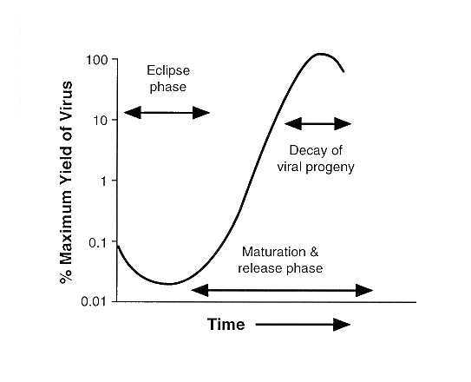FIGURE 42-1 Reproductive cycle of viruses infecting eukaryotic cells. The time scale varies for different viruses; it may range from 8 hrs (e.g., poliovirus) to more than 72 hrs (e.g., cytomegalovirus).
Infection of a susceptible cell does not automatically insure that viral multiplication will ensue and that viral progeny will emerge. This is among the most important conceptual developments in virology to evolve and should be stressed in some detail. Infection of susceptible cells may be productive, restrictive, or abortive.
- Productive infection occurs in permissive cells and is characterized by production of infectious progeny.
- Abortive infection can occur for two reasons. 1)Although a cell may be susceptible to infection, it may be non-permissive allowing a few, but not all, viral genes to be expressed for reasons that are rarely known. 2)Abortive infection may also result from infection of either permissive or non-permissive cells with defective viruses, which lack a full complement of viral genes.
- Lastly, cells may be only transiently permissive, and the consequences are 1)either that the virus persists in the cell until the cell becomes permissive 2)or that only a few of the cells in a population produce viral progeny at any time. This type of infection has been defined as restrictive by some and restringent by others.
This classification is neither trivial or gratuitous; its significance stems from the observation that cytolytic viruses which normally destroy the permissive cell during productive infection may merely injure, but not destroy, abortively infected, permissive or non-permissive cells. The consequences of this injury may be the expression of host functions which transform the cell from normal to malignant. Persistence of the viral genomes is a more common consequence of restrictive and abortive infections.

Initiation of Infection
To infect a cell, the virus must
- attach to the cell surface,
- penetrate into the cell, and
- become sufficiently uncoated to make its genome accessible to viral or host machinery for transcription or translation.

Attachment
Attachment constitutes specific binding of a virion protein (the anti-receptor) to a constituent of the cell surface (the receptor). The classic example of an anti-receptor is the hemagglutinin of influenza virus (an Orthomyxovirus). The anti-receptors are distributed throughout the surfaces of viruses infecting human and animal cells. Complex viruses such herpes simplex virus (a herpesvirus) may have more than one species of anti-receptor molecule. Mutations in the genes specifying anti-receptors may results in a loss of the capacity to interact with certain receptors. The cellular receptors identified so far are largely glycoproteins, but include sialic acid and heparan sulfate.
Attachment requires ions in concentrations sufficient to reduce electrostatic repulsion but it is largely temperature and energy independent. The susceptibility of a cell is limited by the availability of appropriate receptors and not all cells in an otherwise susceptible organism express receptors. Human kidney cells lack receptors for poliovirus when they reside in the organ, but receptors appear when renal cells are propagated in cell culture. Susceptibility should not be confused with permissiveness. While chick cells are insusceptible to poliovirions because they lack receptors for attachment of the virus, they are fully permissive because they produce infectious virus following transfection with intact viral RNA extracted from poliovirus particles. Attachment of viruses to cells in some instances (e.g., picornaviruses leads to irreversible changes in the structure of the virion. In other instances, if penetration does not ensue, the virus can detach itself and readsorb to a different cell. In the latter category are orthomyxoviruses and some paramyxoviruses which carry a neuraminidase on their surface. These viruses can elute from their receptors by cleaving neuraminic acid from the polysaccharide chains of the receptors.

Penetration

Penetration is an energy-dependent step. It occurs almost instantaneously after attachment and involves one of three mechanisms, i.e.,
- translocation of the virion across the plasma membrane,
- endocytosis of the virus particle resulting in accumulation of virions inside cytoplasmic vacuoles and
- fusion of the cellular membrane with the virion envelope.
Non-enveloped viruses penetrate by the first two mechanisms. For example, in the course of adsorption of the poliovirus to the cell, the capsid becomes modified and loses its integrity as it is translocated into the cytoplasm. In the case of viruses which penetrate as a consequence of fusion of their envelopes with the plasma membrane (e.g., herpesviruses), the envelope remains in the plasma membrane, whereas the internal constituents spill into the cytoplasm. Fusion of viral envelopes with the plasma membrane requires the interaction of specific viral proteins in the viral envelope with proteins in the cellular membrane.

Uncoating
Uncoating is a general term applied to the events occurring after penetration which set the stage for the viral genome to express its functions. In the case of most viruses, the virion disaggregates, alone or with the aid of cellular components (enzymes) and only the nucleic acid or a nucleic acid-protein complex is all that remains of the virus particle before expression of viral functions. 1)Adenovirus, herpesvirus, and papillomavirus nucleo capsids are transported to the nuclear pore where the viral DNA is released directly into the nucleus. 2)In cells infected with orthomyxoviruses, the particle is taken up into an endocytic vesicle. 3)An ion channel embedded in the viral envelope acidifies the virus particle, alters the structure of the hemagglutinin and enables the fusion of the viral envelope with the membrane of the vesicle and the release of viral ribonucleoprotein (RNP) into the cytoplasm. 4)In the exceptional case of reoviruses, only portions of the capsid are removed, and the viral genome expresses all of its functions even though it is never fully released from the capsid. 5)The poxvirus genome is uncoated in two stages: whereas in the first stage the outer covering is removed by host enzymes, the release of viral DNA from the core appears to require the participation of viral gene products made after infection.

The Strategies of Viral Multiplication

Viruses must conform to the constraints imposed by cellular functions.
In the course of their evolution, viruses have evolved several different strategies to deal with
  - encoding and organization of viral genes,
  - (ii) expression of viral genes,
  - (iii) the replication of viral genomes and
  - (iv) assembly and maturation of viral progeny.
Before these are considered in some detail, it is should be reiterated that the synthesis of viral proteins by the host protein synthesizing machinery is the key event in viral replication. Irrespective of the size, composition, and organization of its genome, the virus must present to the eukaryotic cell protein synthesizing machinery a messenger RNA that the cell can recognize as such and translate.
The cell does impose two constraints on viruses.
- First, the cell synthesizes its own mRNA in the nucleus by transcribing its DNA followed by post-transcriptional processing of the transcript. The cell lacks, therefore,
  - the enzymes necessary to synthesize mRNA from a viral RNA genome, either in the nucleus or in the cytoplasm and
  - enzymes capable of transcribing viral DNAs in the cytoplasm. The consequence of this constraint is that only viruses whose genomes consist of DNA which reaches the nucleus can take advantage of cell transcriptases to synthesize their mRNAs. All other viruses have had to develop their own transcriptases to generate mRNA.
    - The second constraint is that the protein synthesizing machinery of eukaryotic cells is equipped to translate monocistronic messages, inasmuch as it does not usually recognize internal initiation sites within mRNAs. The consequences of this constraint are that viruses direct the synthesis of a separate mRNA for each polypeptide (functionally monocistronic messages) or of one or more mRNAs encoding a large precursor "polyprotein" which is subsequently cleaved into individual proteins. In rare instances (e.g, retroviruses), by a specific frameshift determined by its structure or paramyxoviruses by insertion of two non-coded nucleotides into the transcribed RNA), the same coding domain of the viral genome directs the synthesis of two distinct sets of proteins.

Viruses vary with respect to structure and organization of their genomes.
Viral genes are encoded in either RNA or DNA genomes. These genomes can be either single-stranded or double-stranded. In addition, these genomes can be monopartite in which all viral genes are contained in a single chromosome, and multipartite in which the viral genes are distributed in several chromosomes and together constitute the viral genome. To avoid confusion, we shall designate as "genomic" only the nucleic acid found in virions. Among the RNA viruses, reovirus is the representative of the best known family which contains a double-stranded genome, and this genome is multipartite, consisting of 10 segments or chromosomes. The genomes of single-stranded RNA viruses are either monopartite (picornaviruses, togaviruses, paramyxoviruses, rhabdoviruses, coronaviruses, retroviruses) or multipartite (orthomyxoviruses, arenaviruses and bunyaviruses). All RNA genomes are linear molecules. Some, (e.g. picornaviruses) contain a covalently linked polypeptide or an amino acid at the 5' end of the RNA.
All known DNA viruses infecting vertebrate hosts contain a monopartite genome. Except for the parvovirus genomes, all are fully or at least partially double-stranded. Individual parvovirus virions contain linear single-stranded DNA; in some genera (e.g., adeno-associated virus), both complementary strands of the DNA are packaged but in different virus particles. The genomes of papova and papilloma viruses are closed circular DNA molecules. While the genomes of both adenoviruses and herpesviruses are linear double-stranded molecules, one strand at each end of the adenovirus genome is covalently linked to a protein, whereas the herpesvirus DNAs exhibit a 3' single nucleotide extension at each terminus. The DNAs of poxviruses are also linear, but in this instance the 3' terminus of each strand is covalently linked to the 5' terminus of the complementary strand forming a continuous loop. The DNA of hepatitis B virus is a circular double-stranded molecule in which each strand has a gap.

Viruses differ in the manner in which they express their genes and replicate their genomes.
It is convenient to discuss the RNA viruses first and to focus primarily on the function of the genomic RNA.

Single-stranded RNA viruses
The linear single-stranded RNA viruses form 3 groups.
- Picornaviruses and togaviruses are examples of the first group. These genomes have two functions (Figures 42-2 and 42-3).
  - The first of these functions is to serve as a messenger RNA. By convention, viruses whose genomes can and do serve as messengers are known as plus (+) strand viruses. Following entry into the cell, picornavirus RNA binds to ribosomes and is translated in its entirely (Figure 42-2). The product of this translation - the polyprotein - is then cleaved by proteolytic enzymes. While secondary cleavages clearly involve virus-specified proteases, there is good evidence that the polyprotein itself is enzymatically active in trans, that is, each molecule cannot cleave itself but it can cleave other polyproteins.
  - The second function of the genomic RNA is to serve as a template for the synthesis of a complementary (-) strand RNA by a polymerase derived from cleavage of the polyprotein. The (-) RNA strand then serves in turn as a template to make more (+) RNA strands. The progeny (+) strands can then serve as (a) mRNA or (b) templates to make more (-) RNA strands.
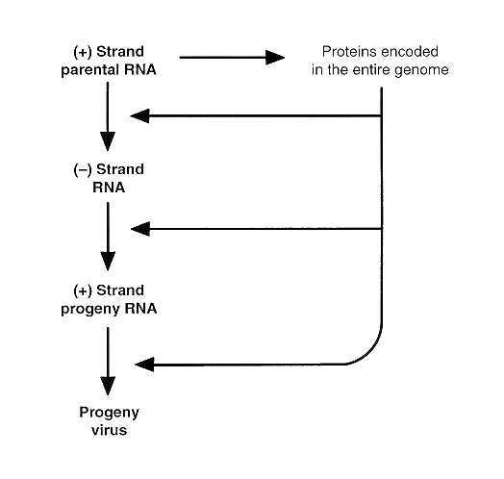
FIGURE 42-2 Flow of events during the replication of picornaviruses.
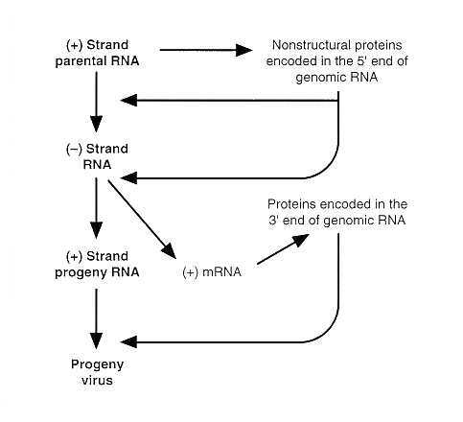
FIGURE 42-3 Flow of events during the replication of togaviruses.
Togaviruses and some of the other (+) strand RNA viruses differ in one respect from picornaviruses (Figure 42-3). Specifically, only a portion of the genomic RNA is available for translation in the first round of protein synthesis (Figure 42-3). The probable function of the resulting products is to transcribe the genomic RNA to yield a full length (-) RNA strand. This (-) RNA strand serves as a template for two size classes of (+) RNA molecules. The first one is a small mRNA encompassing the region of the genomic RNA not translated in the first round. The resulting polyprotein is cleaved into proteins whose main function is to serve as structural components of the virions. The second class of (+) RNA is the full-sized genomic RNA, which is packaged into virions. Several mRNA species are made in cells infected with coronaviruses, caliciviruses or hepatitis E viruses.
Central to the replication of (+) strand viruses is the capability of the genomic RNA to serve as mRNA after infection. The consequences are two-fold.
- First, enzymes responsible for the replication of the genome are made after infection and need not be brought into the infected cell by the virion. This is why naked RNA extracted from virions is infectious.
- Second, because all (+) strand genomes are monopartite, and therefore have all their genes linked in a single chromosome, the initial products of translation of both genomic RNA and of mRNA species are necessarily a single protein. The translation products of picornaviruses and togaviruses must then be cleaved to yield the individual proteins found in the virion or in the infected cell.
Orthomyxoviruses, paramyxoviruses, bunyaviruses, arenaviruses, and rhabdo-viruses (Figure 42-4) comprise the second set of single-stranded RNA viruses defined as the minus (-) strand viruses. It is convenient to separate the (-) strand viruses into two groups, i.e., the multipartite (orthomyxoviruses, bunyaviruses and arenaviruses) from the monopartite (paramyxoviruses and rhabdoviruses). Characteristically, their genomic RNAs must serve two template functions, in the first step for the synthesis of mRNA, and in the second for the synthesis of complementary (+) strands which serve as a template to make viral progeny genomes. Because their genome must be transcribed to make mRNA, and the cell lacks the appropriate enzymes, all minus-strand viruses package in the virion a transcriptase along with the viral genome. The transcription of the viral genome is the first event after entry of the viruses into cells; the process yields functionally monocistronic mRNAs (+ strands) each specifying a single protein. Replication begins under the direction of newly synthesized viral proteins; a full-length (+) strand is made and serve as a template for the synthesis of (-) strand genomic RNAs (Figure 42-4). To reiterate, in contrast to the + strand viruses, the (-) strand viruses serves as templates for transcription only, first for the synthesis of mRNA and then for the transcription of a (+) strand which serves as a template for a minus strand. The consequences are three-fold.
- First, the virus must bring into the infected cell the transcriptase to make its mRNAs. It follows,
- second, that naked RNA extracted from virions is not infectious.
- Third, the mRNAs produced are gene unit length they specify a single polypeptide.
However, selective (but not arbitrary) observance of RNA splicing signals may result in multiple mRNAs, each specifying a different protein being transcribed from the same region of genomic RNA. Consequently the (+) transcript which functions as mRNA is different from the (+) strand RNA which serves as the template for progeny virus even though both are synthesized on the genomic RNA! Thus, in the case of the multipartite genomes, the + strand RNA which serves as mRNA has a cap at its 5' end and poly(A) at its 3' end and may not contain all of the non-coding sequences contained in the genomic RNA. The advantage is that the signals which determine abundance of translated protein are embedded in the RNA itself. In the case of the monopartite (-) strand viruses, the mRNA encodes one protein only, the abundance of the mRNA is determined by the position of the template on the genomic RNA (the further away from the transcription initiation site, the less abundant is the mRNA, and the abundance of the protein product is directly related to the abundance of the mRNA).
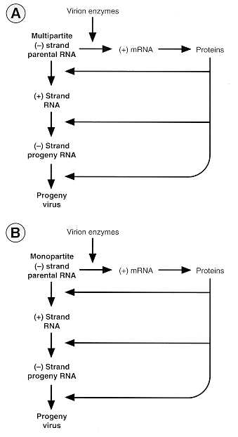
FIGURE 42-4 Flow of events during the replication of orthomyxoviruses and paramyxoviruses.
The bipartite (2 RNA segments) arenaviruses and some of the tripartite (3 RNA segments) bunyaviruses are ambisense; i.e., they contain a RNA which has both (+) and (-) polarity. In this instance the viral genome acts initially, having (-) strand polarity in that they are transcribed to make (+) strand mRNAs. These encode proteins which enable the synthesis of complementary (+) strand RNA. The (+) strand RNAs are then transcribed to make two kinds of (-) strand RNA. One set functions as the (-) strand genomic RNA which is packaged into virions. The second set represents partial sequences of the ambisense genomic RNA. Although by definition this RNA is (-) strand since it contains sequences of the same polarity as the genomic RNA, it acts as mRNA to encode viral proteins. Retroviruses comprise the third group of RNA viruses (Figure 42-5). Characteristically, retrovirus genomes are monopartite, but diploid, and the two strands are either partially hydrogen-bonded to another macromolecule or base-paired in a fashion as yet unknown. Following infection, the sole known function of the genomic RNAs is to serve as a template for the synthesis of viral DNA. Inasmuch as eukaryotic cells lack enzymes competent to perform this function, the virion contains, in addition to the genome, an RNA-dependent DNA polymerase (reverse transcriptase) as well as a mixture of host transfer RNAs, one of which serves as a primer. The key steps in the genome transcription are
- binding of the tRNA - reverse transcriptase complex to the genomic RNA,
- synthesis of a DNA molecule complementary to the genomic RNA coupled with the digestion of the RNA by a viral ribonuclease (RNase H, also packaged in the virion) specific for RNA in RNA-DNA hybrids, and
- synthesis of the complementary DNA strand and completion of a linear DNA molecule containing in its entirety the sequences contained in the genomic RNA, but with the duplication of two small sequences, one from the 3' terminus of the RNA duplicated at the 5' terminus of the DNA, and one from the 5' terminus of the RNA duplicated at the 3' terminus of the DNA. The double-stranded DNA is then translocated into the nucleus where it is integrated into the host genome by viral proteins. Virus gene expression may not follow immediately. When it occurs, the integrated viral DNA is transcribed by the host RNA polymerase II. The products of transcription are genome-length RNA molecules and shorter, gene-cluster length mRNAs, which are translated to yield polyproteins. The polyproteins are then cleaved to yield the individual viral proteins. The synthesis of at least one protein is accomplished by a ribosomal frameshift. Only the genome length transcript is packaged into virions.
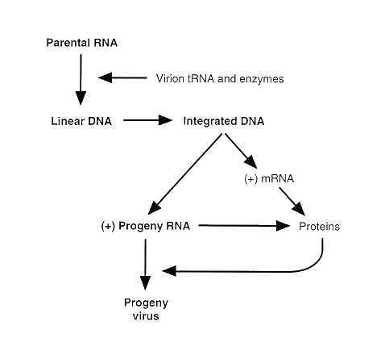
FIGURE 42-5 Flow of events during the replication of retroviruses.
Retroviruses vary in the complexity of their genomes. All retrovirus genomes encode response elements (cis-acting sites) for cellular transacting factors which may be tissue specific and for transcription initiation by the host RNA polymerase. The more complex lentiviruses (a subfamily of retroviruses) encode transacting factors which regulate the abundance and order of expression of viral proteins.

Double-stranded RNA viruses
The double-stranded, multipartite reovirus genome is transcribed within the partially opened capsid by a polymerase packaged into the virion and the 10 different mRNA (+ strands) species are extruded through the exposed vertices of the capsid (Figure 42-6). The mRNAs molecules have two functions.
- First, they are translated as monocistronic messages to yield the viral proteins.
- Second, one RNA of each of the 10 species assemble within a precursor particle in which they serve as a template for the synthesis of the complementary strand yielding double stranded genome segments.
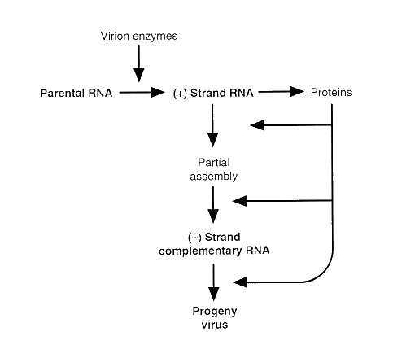FIGURE 42-6 Flow of events during the replication of reoviruses.

DNA virus genomes
The DNA viruses can be split into 4 groups. 1)Papovavirus, adenovirus and herpesvirus genomes are transcribed and replicated in the nucleus, and therefore can utilize the transcriptional enzymes of the host for generation of mRNA. As could be expected, the DNAs of these viruses are infectious. The transcriptional program consists of at least two cycles of transcription for papovaviruses, and at least three for herpesviruses (Figure 42-7) and adenoviruses. In each instance, the structural or virion polypeptides are made from mRNA generated from the last cycle of transcription.
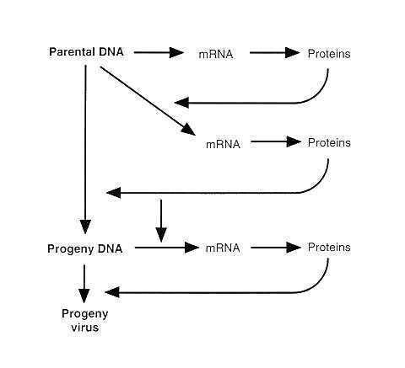FIGURE 42-7 Flow of events during the replication of herpesviruses (herpes simplex viruses).
2)The poxviruses constitute the second group. Although poxvirus DNAs have been detected in the nucleus, the transcription and most of the other events in the reproductive cycle appear to take place in the cytoplasm. The genome is transcribed by a viral enzyme. The initial transcription occurs in the core of the virion. Many questions concerning the reproductive cycle of this virus remain unresolved.
3)Parvoviruses constitute the third group. One human parvovirus, the adeno-associated virus, requires adenoviruses or herpes simplex viruses as helper viruses for its multiplication. In the absence of a helper virus, the genome appears to integrate into a specific locus of a human chromosome. Other human parvoviruses are capable of multiplying without the assistance of a "helper virus." Viral replication involves the synthesis of a DNA strand complementary to the single-stranded genomic DNA in the nucleus and the transcription of the genome.
4)The hepadna viruses exemplified by hepatitis B virus constitutes the 4th group (Figure 42-8). The DNA of this virus is first repaired and converted into a closed circular molecule by a DNA polymerase packaged in the virion, and then transcribed into two classes of RNA molecules, i.e. a mRNA specifying proteins and a genomic RNA which is transcribed by a reverse transcriptase to make the genomic DNA.
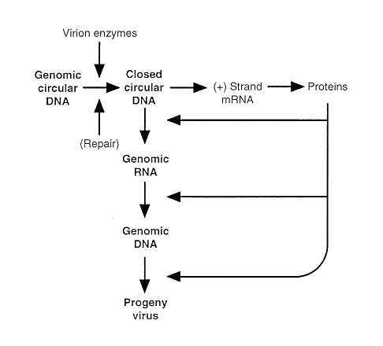
FIGURE 42-8 Flow of events during the replication of Hepadna viruses (hepatitis B virus).

Viruses differ with respect to their assembly, maturation and egress from infected cells.
Viruses have evolved two fundamental strategies for their assembly, maturation and egress from the infected cell.
- The first, exemplified by the non-enveloped viruses, such as picornaviruses, reoviruses, papovaviruses, parvoviruses, and adenoviruses, involves intracellular assembly and maturation. In the case of picornaviruses, 60 copies each of virion proteins designated as VP0, VP1 and VP3 assemble in the cytoplasm into a procapsid. Viral RNA is then packaged into the procapsid, and in the process VP0 is cleaved to yield two polypeptides, VP2 and VP4. The cleavage causes a rearrangement of the capsid into a thermodynamically stable structure in which the RNA is shielded from access by nucleases. Reoviruses also assemble in the cytoplasm. In contrast, adenoviruses, papovaviruses and parvoviruses assemble in the nucleus. As a rule, all viruses which assemble and acquire infectivity inside depend largely, but not entirely, on the disintegration of the infected cell for their egress. The disintegration of the infected cell and the shut off of host macromolecular metabolism, however, are frequently the functions of viral structural proteins.
- The second strategy is employed by enveloped viruses exemplified by all (-) strand RNA viruses, togaviruses and retroviruses and combines the last step of virion assembly with its egress from the infected cell. In the case of these enveloped viruses, the viral proteins carrying appropriate signal sequences or other recognition markers become inserted into both the inner and outer surface of the plasma membrane or of other cytoplasmic membranes. The proteins projecting from the outer surface usually become glycosylated by host enzymes and aggregate into patches displacing host membrane proteins. Viral nucleocapsids bind to special virus- specified proteins lining the cytoplasmic side of these patches or to cytoplasmic domains of viral glycoproteins (e.g., togaviruses) and become wrapped up by the patch. In the process, the nascent virion is "extruded" or "buds" into the extracellular environment. In some instances (e.g., orthomyxoviruses and paramyxoviruses), cleavage and rearrangement of one species of surface protein occurs during or after extrusion and imparts to the newly formed virion the capability of infecting cells.
Virus assembly and maturation by extrusion from the cell surface provides a more efficient mechanism of egress inasmuch as it does not depend on the disintegration of the infected cell. Indeed, viruses that mature and egress in this fashion vary considerably in their effects on host cell metabolism and integrity. They range from highly cytolytic (e.g., togaviruses, paramyxoviruses, rhabdoviruses) to viruses which are frequently non-cytolytic (e.g., retroviruses). By virtue of the insertion of the viral glycoproteins into the cell surface, however, these viruses impart upon the cell a new antigenic specificity and the infected cell can and does become a target for the immune mechanisms of the host.
The herpesvirus nucleocapsid is assembled in the nucleus. Unlike other enveloped viruses, the envelopment and maturation occur at the inner lamella of the nuclear membrane. The enveloped virus accumulates in the space between the inner and outer lamellae of the nuclear membrane, in the cisternae of the cytoplasmic reticulum, and in vesicles carrying the virus to the cell surface. The enveloped virus is uniquely shielded from contact with the cytoplasm. Herpesviruses are cytolytic and invariably destroy the cells in which they multiply. Like other enveloped viruses, herpesviruses impart to the infected cell new antigenic specificities.

Variability in Viral Genomes and Viral Multiplication
A major focus of research in virology today is on the role of genetic variation within the various species of viruses, on defective viruses, and on restrictive and abortive infections in human disease. Interest in these phenomena stems from several considerations. Among these are the observations that
  - the spectrum of clinical disease caused by many of the viruses infecting humans varies considerably in severity and symptomatology,
  - some viruses (e.g., human lentiviruses, influenza, and miscellaneous other RNA viruses) mutate at high rate,
  - that many years after primary infections, individuals may exhibit symptoms of recurrent infections, of chronic debilitating diseases of the central nervous system, and of malignancy apparently related to that infection. Our understanding of the interrelationships of these phenomena may be summarized in the following discussion.
Viruses belonging to the same species and family may differ enormously. For example, whereas epidemiologically related strains of human herpesviruses are generally identical, unrelated strains are readily differentiated by restriction enzyme polymorphism. This variability, as significant as it appears, pales by the observation that successive isolates of human immunodeficiency viruses may differ in nucleotide sequence. The notion that some naturally occurring strains are more likely to cause severe illness than others is more anecdotal than proven, but is not farfetched.
On passage, viruses tend to yield defective mutants. It is convenient to classify defective viruses into two groups.
- Viruses in the first group lack one or more essential genes and therefore are incapable of independent replication without a helper virus. Interest in this group stems from the suspicion that specific types of defective viruses (e.g., papillomaviruses) can transform infected cells from normal to malignant or, transactivate (e.g., herpesviruses) oncogenic viruses in causing the cell to become malignant.
- The second group comprises viruses which contain mutations and deletions and therefore cannot replicate in an efficient fashion. Interest in the latter stems largely from the suspicion that chronic debilitating infections of the central nervous system might in some fashion be related to viruses that are sluggish in their replication, in their ability to destroy the infected cells, or in their ability to alter the infected cell sufficiently to make it a target for the immune system of the host. Genetically engineered viruses lacking one or several genes and which might be classified as defective may ultimately be viruses' greatest gift to mankind: the means for the introduction of genes to complement genetic defects or to selectively destroy cancer cells.
Restrictive and abortive infections are of interest chiefly because the cell may survive and perpetuate the viral genome indefinitely for the life of the host. The cell restrictively infected with a competent virus (e.g., herpesviruses) may be a latent reservoir of virus which can replicate and disseminate when the cell is triggered to become permissive. A cell abortively infected with a defective virus may also survive and, given the appropriate stimulus, may become malignant (e.g., papillomaviruses). In some instances, restrictive infections may be related to the requirement that the virus be maintained in a specific cell in order to be perpetuated with its natural host. Undoubtedly these phenomena will be the focus of investigation for many years to come.

REFERENCES
Baltimore D: Expression of animal virus genomes. Bacteriol Rev 35:234, 1971
Fields BN, Knipe DM, Howley P, Chanock RM, et al (eds.): Fields' Virology 3rd Ed. Raven Press, New York, N.Y. 1995
Narayan O, Clements JE: Biology and pathogenesis of lentiviruses. J Gen Virol 70:1617, 1989
Palese P, Roizman B (eds): Genetic variation of viruses. Ann NY Acad Sci 354:1, 1980

