Principles of Diagnosis

John A. Washington

General Concepts

Manifestations of Infection
The clinical presentation of an infectious disease reflects the interaction between the host and the microorganism. This interaction is affected by the host immune status and microbial virulence factors. Signs and symptoms vary according to the site and severity of infection. Diagnosis requires a composite of information, including history, physical examination, radiographic findings, and laboratory data.

Microbial Causes of Infection
Infections may be caused by bacteria, viruses, fungi, and parasites. The pathogen may be exogenous (acquired from environmental or animal sources or from other persons) or endogenous (from the normal flora).

Specimen Selection, Collection, and Processing
Specimens are selected on the basis of signs and symptoms, should be representative of the disease process, and should be collected before administration of antimicrobial agents. The specimen amount and the rapidity of transport to the laboratory influence the test results.

Microbiologic Examination
Direct Examination and Techniques: Direct examination of specimens reveals gross pathology. Microscopy may identify microorganisms. Immunofluorescence, immuno-peroxidase staining, and other immunoassays may detect specific microbial antigens. Genetic probes identify genus- or species-specific DNA or RNA sequences.
Culture: Isolation of infectious agents frequently requires specialized media. Nonselective (noninhibitory) media permit the growth of many microorganisms. Selective media contain inhibitory substances that permit the isolation of specific types of microorganisms.
Microbial Identification: Colony and cellular morphology may permit preliminary identification. Growth characteristics under various conditions, utilization of carbohydrates and other substrates, enzymatic activity, immunoassays, and genetic probes are also used.
Serodiagnosis: A high or rising titer of specific IgG antibodies or the presence of specific IgM antibodies may suggest or confirm a diagnosis.
Antimicrobial Susceptibility: Microorganisms, particularly bacteria, are tested in vitro to determine whether they are susceptible to antimicrobial agents.
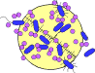

INTRODUCTION
Some infectious diseases are distinctive enough to be identified clinically. Most pathogens, however, can cause a wide spectrum of clinical syndromes in humans. Conversely, a single clinical syndrome may result from infection with any one of many pathogens. Influenza virus infection, for example, causes a wide variety of respiratory syndromes that cannot be distinguished clinically from those caused by streptococci, mycoplasmas, or more than 100 other viruses.
Most often, therefore, it is necessary to use microbiologic laboratory methods to identify a specific etiologic agent. Diagnostic medical microbiology is the discipline that identifies etiologic agents of disease. The job of the clinical microbiology laboratory is to test specimens from patients for microorganisms that are, or may be, a cause of the illness and to provide information (when appropriate) about the in vitro activity of antimicrobial drugs against the microorganisms identified (Fig. 10-1).
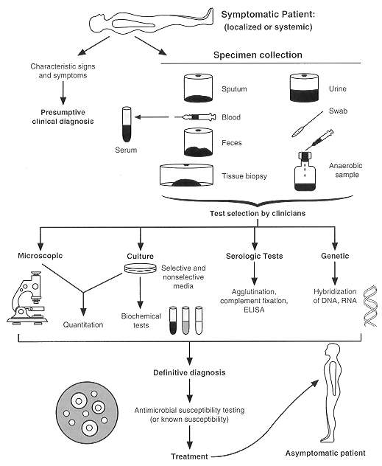
FIGURE 10-1 Laboratory procedures used in confirming a clinical diagnosis of infectious disease with a bacterial etiology.
The staff of a clinical microbiology laboratory should be qualified to advise the physician as well as process specimens. The physician should supply salient information about the patient, such as age and sex, tentative diagnosis or details of the clinical syndrome, date of onset, significant exposures, prior antibiotic therapy, immunologic status, and underlying conditions. The clinical microbiologist participates in decisions regarding the microbiologic diagnostic studies to be performed, the type and timing of specimens to be collected, and the conditions for their transportation and storage. Above all, the clinical microbiology laboratory, whenever appropriate, should provide an interpretation of laboratory results.

Manifestations of Infection
The manifestations of an infection depend on many factors, including the site of acquisition or entry of the microorganism; organ or system tropisms of the microorganism; microbial virulence; the age, sex, and immunologic status of the patient; underlying diseases or conditions; and the presence of implanted prosthetic devices or materials. The signs and symptoms of infection may be localized, or they may be systemic, with fever, chills, and hypotension. In some instances the manifestations of an infection are sufficiently characteristic to suggest the diagnosis; however, they are often nonspecific.

Microbial Causes of Infection
Infections may be caused by bacteria (including mycobacteria, chlamydiae, mycoplasmas, and rickettsiae), viruses, fungi, or parasites. Infection may be endogenous or exogenous. In endogenous infections, the microorganism (usually a bacterium) is a component of the patient's indigenous flora. Endogenous infections can occur when the microorganism is aspirated from the upper to the lower respiratory tract or when it penetrates the skin or mucosal barrier as a result of trauma or surgery. In contrast, in exogenous infections, the microorganism is acquired from the environment (e.g., from soil or water) or from another person or an animal. Although it is important to establish the cause of an infection, the differential diagnosis is based on a careful history, physical examination, and appropriate radiographic and laboratory studies, including the selection of appropriate specimens for microbiologic examination. Results of the history, physical examination, and radiographic and laboratory studies allow the physician to request tests for the microorganisms most likely to be the cause of the infection.

Specimen Selection, Collection and Processing
Specimens selected for microbiologic examination should reflect the disease process and be collected in sufficient quantity to allow complete microbiologic examination. The number of microorganisms per milliliter of a body fluid or per gram of tissue is highly variable, ranging from less than 1 to 10⁸ or 10¹⁰ colony-forming units (CFU). Swabs, although popular for specimen collection, frequently yield too small a specimen for accurate microbiologic examination and should be used only to collect material from the skin and mucous membranes.
Because skin and mucous membranes have a large and diverse indigenous flora, every effort must be made to minimize specimen contamination during collection. Contamination may be avoided by various means. The skin can be disinfected before aspirating or incising a lesion. Alternatively, the contaminated area may be bypassed altogether. Examples of such approaches are transtracheal puncture with aspiration of lower respiratory secretions or suprapubic bladder puncture with aspiration of urine. It is often impossible to collect an uncontaminated specimen, and decontamination procedures, cultures on selective media, or quantitative cultures must be used (see above).
Specimens collected by invasive techniques, particularly those obtained intraoperatively, require special attention. Enough tissue must be obtained for both histopathologic and microbiologic examination. Histopathologic examination is used to distinguish neoplastic from inflammatory lesions and acute from chronic inflammations. The type of inflammation present can guide the type of microbiologic examination performed. If, for example, a caseous granuloma is observed histopathologically, microbiologic examination should include cultures for mycobacteria and fungi. The surgeon should obtain several samples for examination from a single large lesion or from each of several smaller lesions. If an abscess is found, the surgeon should collect several milliliters of pus, as well as a portion of the wall of the abscess, for microbiologic examination. Swabs should be kept out of the operating room.
If possible, specimens should be collected before the administration of antibiotics. Above all, close communication between the clinician and the microbiologist is essential to ensure that appropriate specimens are selected and collected and that they are appropriately examined.

Microbiologic Examination

Direct Examination
Direct examination of specimens frequently provides the most rapid indication of microbial infection. A variety of microscopic, immunologic, and hybridization techniques have been developed for rapid diagnosis (Table 10-1).
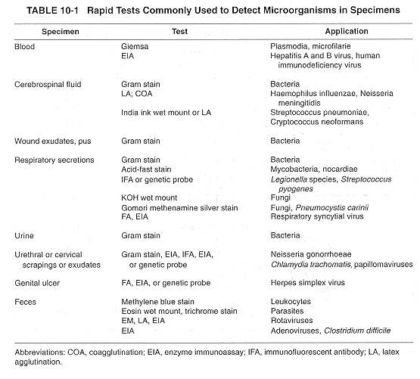

Sensitivity and Specificity
The sensitivity of a technique usually depends on the number of microorganisms in the specimen. Its specificity depends on how morphologically unique a specific microorganism appears microscopically or how specific the antibody or genetic probe is for that genus or species. For example, the sensitivity of Cram stains is such that the observation of two bacteria per oil immersion field (X 1,000) of a Gram-stained smear of uncentrifuged urine is equivalent to the presence of > 10⁵ CFU/ml of urine. The sensitivity of the Gram-stained smear for detecting Gram-negative coccobacilli in cerebrospinal fluid from children with Haemophilus influenzae meningitis is approximately 75 percent because in some patients the number of colony-forming units per milliliter of cerebrospinal fluid is less than 10⁴. At least 10⁴ CFU of tubercle bacilli per milliliter of sputum must be present to be detected by an acid-fast smear of decontaminated and concentrated sputum.
An increase in the sensitivity of a test is often accompanied by a decrease in specificity. For example, examination of a Gram-stained smear of sputum from a patient with pneumococcal pneumonia is highly sensitive but also highly nonspecific if the criterion for defining a positive test is the presence of any Gram-positive cocci. If, however, a positive test is defined as the presence of a preponderance of Gram-positive, lancet-shaped diplococci, the test becomes highly specific but has a sensitivity of only about 50 percent. Similar problems related to the number of microorganisms present affect the sensitivity of immunoassays and genetic probes for bacteria, chlamydiae, fungi and viruses. In some instances, the sensitivity of direct examination tests can be improved by collecting a better specimen. For example, the sensitivity of fluorescent antibody stain for Chlamydia trachomatis is higher when endocervical cells are obtained with a cytobrush than with a swab. The sensitivity may also be affected by the stage of the disease at which the specimen is collected. For example, the detection of herpes simplex virus by immunofluorescence, immunoassay, or culture is highest when specimens from lesions in the vesicular stage of infection are examined. Finally, sensitivity may be improved through the use of an enrichment or enhancement step in which microbial or genetic replication occurs to the point at which a detection method can be applied.

Techniques
For microscopic examination it is sufficient to have a compound binocular microscope equipped with low-power (1OX), high-power (40X), and oil immersion (1OOX) achromatic objectives, 10X wide-field oculars, a mechanical stage, a substage condenser, and a good light source. For examination of wet-mount preparations, a darkfield condenser or condenser and objectives for phase contrast increases image contrast. An exciter barrier filter, darkfield condenser, and ultraviolet light source are required for fluorescence microscopy.
For immunologic detection of microbial antigens, latex particle agglutination, coagglutination, and enzyme-linked immunosorbent assay (ELISA) are the most frequently used techniques in the clinical laboratory. Antibody to a specific antigen is bound to latex particles or to a heat-killed and treated protein A-rich strain of Staphylococcus aureus to produce agglutination (Fig. 10-2). There are several approaches to ELISA; the one most frequently used for the detection of microbial antigens uses an antigen-specific antibody that is fixed to a solid phase, which may be a latex or metal bead or the inside surface of a well in a plastic tray. Antigen present in the specimen binds to the antibody as in Fig. 10-2. The test is then completed by adding a second antigen-specific antibody bound to an enzyme that can react with a substrate to produce a colored product. The initial antigen antibody complex forms in a manner similar to that shown in Figure 10-2. When the enzyme-conjugated antibody is added, it binds to previously unbound antigenic sites, and the antigen is, in effect, sandwiched between the solid phase and the enzyme-conjugated antibody. The reaction is completed by adding the enzyme substrate.
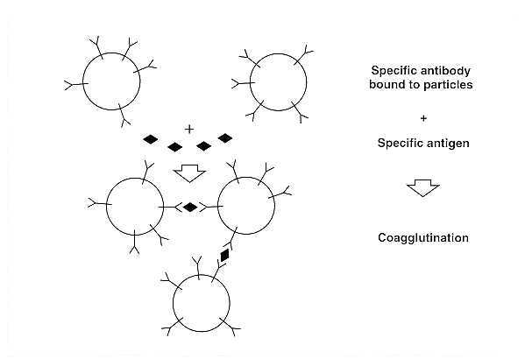
FIGURE 10-2 Agglutination test in which inert particles (latex beads or heat-killed S aureus Cowan 1 strain with protein A) are coated with antibody to any of a variety of antigens and then used to detect the antigen in specimens or in isolated bacteria.
Genetic probes are based on the detection of unique nucleotide sequences with the DNA or RNA of a microorganism. Once such a unique nucleotide sequence, which may represent a portion of a virulence gene or of chromosomal DNA, is found, it is isolated and inserted into a cloning vector (plasmid), which is then transformed into Escherichia coli to produce multiple copies of the probe. The sequence is then reisolated from plasmids and labeled with an isotope or substrate for diagnostic use. Hybridization of the sequence with a complementary sequence of DNA or RNA follows cleavage of the double-stranded DNA of the microorganism in the specimen.
The use of molecular technology in the diagnoses of infectious diseases has been further enhanced by the introduction of gene amplication techniques, such as the polymerase chain reaction (PCR) in which DNA polymerase is able to copy a strand of DNA by elongating complementary strands of DNA that have been initiated from a pair of closely spaced oligonucleotide primers. This approach has had major applications in the detection of infections due to microorganisms that are difficult to culture (e.g. the human immunodeficiency virus) or that have not as yet been successfully cultured (e.g. the Whipple's disease bacillus).

Culture
In many instances, the cause of an infection is confirmed by isolating and culturing microorganism either in artificial media or in a living host. Bacteria (including mycobacteria and mycoplasmas) and fungi are cultured in either liquid (broth) or on solid (agar) artificial media. Liquid media provide greater sensitivity for the isolation of small numbers of microorganisms; however, identification of mixed cultures growing in liquid media requires subculture onto solid media so that isolated colonies can be processed separately for identification. Growth in liquid media also cannot ordinarily be quantitated. Solid media, although somewhat less sensitive than liquid media, provide isolated colonies that can be quantified if necessary and identified. Some genera and species can be recognized on the basis of their colony morphologies.
In some instances one can take advantage of differential carbohydrate fermentation capabilities of microorganisms by incorporating one or more carbohydrates in the medium along with a suitable pH indicator. Such media are called differential media (e.g., eosin methylene blue or MacConkey agar) and are commonly used to isolate enteric bacilli. Different genera of the Enterobacteriaceae can then be presumptively identified by the color as well as the morphology of colonies.
Culture media can also be made selective by incorporating compounds such as antimicrobial agents that inhibit the indigenous flora while permitting growth of specific microorganisms resistant to these inhibitors. One such example is Thayer-Martin medium, which is used to isolate Neisseria gonorrhoeae. This medium contains vancomycin to inhibit Gram-positive bacteria, colistin to inhibit most Gram-negative bacilli, trimethoprim-sulfamethoxazole to inhibit Proteus species and other species that are not inhibited by colistin and anisomycin to inhibit fungi. The pathogenic Neisseria species, N gonorrhoeae and N meningitidis, are ordinarily resistant to the concentrations of these antimicrobial agents in the medium.
The number of bacteria in specimens may be used to define the presence of infection. For example, there may be small numbers (< 10³ CFU/ml) of bacteria in clean-catch, midstream urine specimens from normal, healthy women; with a few exceptions, these represent bacteria that are indigenous to the urethra and periurethral region. Infection of the bladder (cystitis) or kidney (pyelone-phritis) is usually accompanied by bacteriuria of about > 10⁴ CFU/ml. For this reason, quantitative cultures (Fig. 10-3) of urine must always be performed. For most other specimens a semiquantitative streak method (Fig. 10-3) over the agar surface is sufficient. For quantitative cultures, a specific volume of specimen is spread over the agar surface and the number of colonies per milliliter is estimated. For semiquantitative cultures, an unquantitated amount of specimen is applied to the agar and diluted by being streaked out from the inoculation site with a sterile bacteriologic loop (Fig. 10-3). The amount of growth on the agar is then reported semiquantitatively as many, moderate, or few (or 3+, 2+, or 1+ ), depending on how far out from the inoculum site colonies appear. An organism that grows in all streaked areas would be reported as 3+.
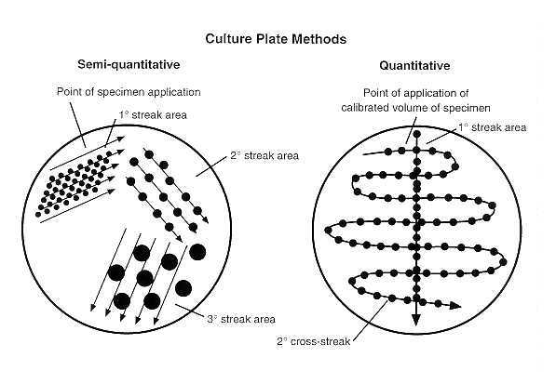
FIGURE 10-3 Quantitative versus semiquantitative culture, revealing the number of bacteria in specimens.
Chlamydiae and viruses are cultured in cell culture systems, but virus isolation occasionally requires inoculation into animals, such as suckling mice, rabbits, guinea pigs, hamsters, or primates. Rickettsiae may be isolated with some difficulty and at some hazard to laboratory workers in animals or embryonated eggs. For this reason, rickettsial infection is usually diagnosed serologically. Some viruses, such as the hepatitis viruses, cannot be isolated in cell culture systems, so that diagnosis of hepatitis virus infection is based on the detection of hepatitis virus antigens or antibodies.
Cultures are generally incubated at 35 to 37°C in an atmosphere consisting of air, air supplemented with carbon dioxide (3 to 10 percent), reduced oxygen (microaerophilic conditions), or no oxygen (anaerobic conditions), depending upon requirements of the microorganism. Since clinical specimens from bacterial infections often contain aerobic, facultative anaerobic, and anaerobic bacteria, such specimens are usually inoculated into a variety of general purpose, differential, and selective media, which are then incubated under aerobic and anaerobic conditions (Fig. 10-4).
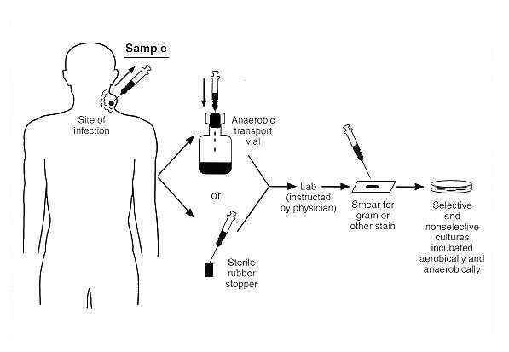
FIGURE 10-4 General procedure for collecting and processing specimens for aerobic and/or anaerobic bacterial culture. The duration of incubation of cultures also varies with the growth characteristics of the microorganism. Most aerobic and anaerobic bacteria will grow overnight, whereas some mycobacteria require as many as 6 to 8 weeks.

Microbial Identification
Microbial growth in cultures is demonstrated by the appearance of turbidity, gas formation, or discrete colonies in broth; colonies on agar; cytopathic effects or inclusions in cell cultures; or detection of genus- or species-specific antigens or nucleotide sequences in the specimen, culture medium, or cell culture system.
Identification of bacteria (including mycobacteria) is based on growth characteristics (such as the time required for growth to appear or the atmosphere in which growth occurs), colony and microscopic morphology, and biochemical, physiologic, and, in some instances, antigenic or nucleotide sequence characteristics. The selection and number of tests for bacterial identification depend upon the category of bacteria present (aerobic versus anaerobic, Gram-positive versus Gram-negative, cocci versus bacilli) and the expertise of the microbiologist examining the culture. Gram-positive cocci that grow in air with or without added CO₂ may be identified by a relatively small number of tests (see Ch. 12). The identification of most Gram-negative bacilli is far more complex and often requires panels of 20 tests for determining biochemical and physiologic characteristics. The identification of filamentous fungi is based almost entirely on growth characteristics and colony and microscopic morphology. Identification of viruses is usually based on characteristic cytopathic effects in different cell cultures or on the detection of virus- or species-specific antigens or nucleotide sequences.

Interpretation of Culture Results
Some microorganisms, such as Shigella dysenteriae, Mycobacterium tuberculosis, Coccidioides immitis, and influenza virus, are always considered clinically significant. Others that ordinarily are harmless components of the indigenous flora of the skin and mucous membranes or that are common in the environment may or may not be clinically significant, depending on the specimen source from which they are isolated. For example, coagulase-negative staphylococci are normal inhabitants of the skin, gastrointestinal tract, vagina, urethra, and the upper respiratory tract (i.e., of the nares, oral cavity, and pharynx). Therefore, their isolation from superficial ulcers, wounds, and sputum cannot usually be interpreted as clinically significant. They do, however, commonly cause infections associated with intravascular devices and implanted prosthetic materials. However, because intravascular devices penetrate the skin and since cultures of an implanted prosthetic device can be made only after incision, the role of coagulase-negative staphylococci in causing infection can usually be surmised only when the microorganism is isolated in large numbers from the surface of an intravascular device, from each of several sites surrounding an implanted prosthetic device, or, in the case of prosthetic valve endocarditis, from several separately collected blood samples. Another example, Aspergillus fumigatus, is widely distributed in nature, the hospital environment, and upper respiratory tract of healthy people but may cause fatal pulmonary infections in leukemia patients or in those who have undergone bone marrow transplantation. The isolation of A fumigatus from respiratory secretions is a nonspecific finding, and a definitive diagnosis of invasive aspergillosis requires histologic evidence of tissue invasion.
Physicians must also consider that the composition of microbial species on the skin and mucous membranes may be altered by disease, administration of antibiotics, endotracheal or gastric intubation, and the hospital environment. For example, potentially pathogenic bacteria can often be cultured from the pharynx of seriously ill, debilitated patients in the intensive care unit, but may not cause infection.

Serodiagnosis
Infection may be diagnosed by an antibody response to the infecting microorganism. This approach is especially useful when the suspected microbial agent either cannot be isolated in culture by any known method or can be isolated in culture only with great difficulty. The diagnosis of hepatitis virus and Epstein-Barr virus infections can be made only serologically, since neither can be isolated in any known cell culture system. Although human immunodeficiency virus type 1 (HIV-1) can be isolated in cell cultures, the technique is demanding and requires special containment facilities. HIV-1 infection is usually diagnosed by detection of antibodies to the virus.
The disadvantage of serology as a diagnostic tool is that there is usually a lag between the onset of infection and the development of antibodies to the infecting microorganism. Although IgM antibodies may appear relatively rapidly, it is usually necessary to obtain acute- and convalescent-phase serum samples to look for a rising titer of IgG antibodies to the suspected pathogen. In some instances the presence of a high antibody titer when the patient is initially seen is diagnostic; often, however, the high titer may reflect a past infection, and the current infection may have an entirely different cause. Another limitation on the use of serology as a diagnostic tool is that immunosuppressed patients may be unable to mount an antibody response.

Antimicrobial Susceptibility
The responsibility of the microbiology laboratory includes not only microbial detection and isolation but also the determination of microbial susceptibility to antimicrobial agents. Many bacteria, in particular, have unpredictable susceptibilities to antimicrobial agents, and their susceptibilities can be measured in vitro to help guide the selection of the most appropriate antimicrobial agent.
Antimicrobial susceptibility tests are performed by either disk diffusion or a dilution method. In the former, a standardized suspension of a particular microorganism is inoculated onto an agar surface to which paper disks containing various antimicrobial agents are applied. Following overnight incubation, any zone diameters of inhibition about the disks are measured and the results are reported as indicating susceptibility or resistance of the microorganism to each antimicrobial agent tested. An alternative method is to dilute on a log2 scale each antimicrobial agent in broth to provide a range of concentrations and to inoculate each tube or, if a microplate is used, each well containing the antimicrobial agent in broth with a standardized suspension of the microorganism to be tested. The lowest concentration of antimicrobial agent that inhibits the growth of the microorganism is the minimal inhibitory concentration (MIC). The MIC and the zone diameter of inhibition are inversely correlated (Fig. 10-5). In other words, the more susceptible the microorganism is to the antimicrobial agent, the lower the MIC and the larger the zone of inhibition. Conversely, the more resistant the microorganism, the higher the MIC and the smaller the zone of inhibition.
The term susceptible means that the microorganism is inhibited by a concentration of antimicrobial agent that can be attained in blood with the normally recommended dose of the antimicrobial agent and implies that an infection caused by this microorganism may be appropriately treated with the antimicrobial agent. The term resistant indicates that the microorganism is resistant to concentrations of the antimicrobial agent that can be attained with normal doses and implies that an infection caused by this microorganism could not be successfully treated with this antimicrobial agent.
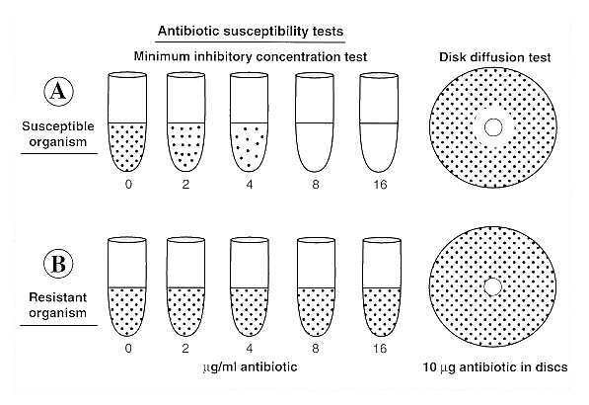
FIGURE 10-5 Two methods for performing antibiotic susceptibility tests. (A) Disk diffusion method. (B) Minimum inhibitory concentration (MIC) method. In the example shown, two different microorganisms are tested by both methods against the same antibiotic. The MIC of the antibiotic for the susceptible microorganism is 8 µg/ml. The corresponding disk diffusion test shows a zone of inhibition surrounding the disk. In the second sample, a resistant microorganism is not inhibited by the highest antibiotic concentration tested (MIC > 16 µg/ml) and there is no zone of inhibition surrounding the disk. The diameter of the zone of inhibition is inversely related to the MIC.

REFERENCES
Baron EJ, Pererson LR, Finegold SM (eds): Bailey and Scott's Diagnostic Microbiology. 9th ed. CV Mosby, St. Louis, 1994
Koneman EW, Allen SD, Schreckenberg PC, Winn WC (eds): Atlas and Textbook of Diagnostic Microbiology. 4th ed. JB Lippincott, Philadelphia, 1992
Kunin CM: Detection, Prevention and Management of Urinary Tract Infections. 4th ed. Lea & Febiger, Philadelphia, 1987
Murray PR, Baron EJ, Pfaller MA, Tenover PC, Yolken RH (eds): Manual of Clinical Microbiology. 6th ed. American Society for Microbiology, Washington, DC, 1995
Pennington JE (ed): Respiratory Infections: Diagnosis and Management. 3rd ed. Raven Press, New York, 1994
Woods GL, Washington JA: The Clinician and the Microbiology Laboratory. Mandell GL, Bennett JE, Dolin R (eds): Principles and Practice of Infectious Diseases. 4th ed. Churchill Livingstone, New York, 1995

