Leptospira

Russell C. Johnson

General Concepts

Clinical Manifestations
Leptospira interrogans causes leptospirosis, a usually mild febrile illness that may result in liver or kidney failure.

Structure, Classification, and Antigenic Types
Leptospira is a flexible, spiral-shaped, Gram-negative spirochete with internal flagella. Leptospira interrogans has many serovars based on cell surface antigens.

Pathogenesis
Leptospira enters the host through mucosa and broken skin, resulting in bacteremia. The spirochetes multiply in organs, most commonly the
- central nervous system,
- kidneys, and
- liver.
They are cleared by the immune response from the blood and most tissues but persist and multiply for some time in the kidney tubules. Infective bacteria are shed in the urine. The mechanism of tissue damage is not known.

Host Defenses
Serum antibodies are responsible for host resistance.

Epidemiology
Leptospirosis is a worldwide zoonosis affecting many wild and domestic animals. Humans acquire the infection by contact with the urine of infected animals. Human-to-human transmission is extremely rare.

Diagnosis
Clinical diagnosis is usually confirmed by serology. Isolation of spirochetes is possible, but it is time-consuming and requires special media.

Control
Animal vaccination and eradication of rodents are important. Treatment with tetracycline and penicillin G is effective. No human vaccine is available.

Borrelia

Clinical Manifestations
Borrelia recurrentis (louse borne) and B hermsii and B turicatae (tick borne) cause relapsing fevers:
- influenza-like febrile diseases that
- follow a relapsing and remitting course. Myocarditis is a rare sequela.
Borrelia burgdorferi causes Lyme disease, a
- multisystem,
- relapsing febrile disease
- with a rash and
- manifestations such as arthritis, carditis, and neuritis.

Structure, Classification, and Antigenic Types
Like Leptospira, Borrelia is a
- flexible,
- spiral-shaped,
- Gram-negative spirochete
- with internal flagella.
- Borrelia species are differentiated primarily on the basis of vectors and DNA homology.

Pathogenesis
Borrelia is transmitted by tick or louse bites. The relapsing-fever borreliae cause recurrent febrile bacteremias separated by remissions during which the borreliae are sequestered in tissues; each resurgence involves a change in cell surface antigens. Lyme disease may have different manifestations at different times; recurrences and late sequelae may appear for many years. The pathogenesis of borrelial diseases is not understood.

Host Defenses
Serum antibodies are responsible for host resistance.

Epidemiology
The tick-borne relapsing fevers and Lyme disease are zoonoses with rodents as the major reservoir; incidence and distribution depend mainly on the biology of the tick vectors. Louseborne relapsing fever has no animal reservoir and causes epidemics in crowded, unsanitary populations.

Diagnosis
The clinical diagnosis is confirmed by serology and also by microscopic visualization of the organism in blood of relapsing fever patients.

Control
Areas known to harbor infected ticks and lice should be avoided. Tetracycline is an effective treatment. No vaccines are available.

Spirillum

Clinical Manifestations
Spirillum causes rat bite fever, with ulceration at the site of the bite, lymphadenopathy, rash, and a relapsing fever.

Structure, Classification, and Antigenic Types
Spirillum is Gram negative but, unlike Leptospira and Borrelia, has a rigid cell wall and external flagella. Spirillum species are differentiated on the basis of cell morphology.

Pathogenesis
Spirillum is transmitted by the bite of an infected rat. The mechanism of pathogenesis is not understood.

Host Defenses
Serum antibodies are responsible for host resistance.

Epidemiology
Rat bite fever occurs worldwide but is most common in Asia.

Diagnosis
The clinical diagnosis is confirmed by microscopic visualization of the organism in exudates from the initial lesion, aspirates of involved lymph nodes, or blood. No specific serologic test is available.

Control
Eradication of rodents is the main means of control. Treatment with penicillin is effective. No vaccine is available.
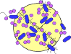

INTRODUCTION
Leptospira, Borrelia, and Spirillum cause disease characterized by clinical stages with remissions and exacerbations. Leptospira organisms are
- very thin,
- tightly coiled,
- obligate aerobic spirochetes characterized by a unique flexuous type of motility.
- The genus is divided into two species: the pathogenic leptospires L interrogans and the free-living leptospire L biflexa. Serotypes of L interrogans are the agents of leptospirosis, a zoonotic disease. The primary hosts for this disease are wild and domestic animals, and the disease is a major cause of economic loss in the meat and dairy industry. Humans are accidental hosts in whom this disseminated disease varies in severity from subclinical to fatal. The first human case of leptospirosis was described in 1886 as a severe icteric illness and was referred to as Weil's disease; however, most human cases of leptospirosis are nonicteric and are not life-threatening. Recovery usually follows the appearance of a specific antibody.
In contrast to the pathogenic leptospires, serotypes of L biflexa exist in water and soil as free-living organisms. Although L biflexa has been isolated from mammalian hosts on occasion, no pathology has been found, and it does not infect experimental animals. Because of the widespread distribution of L biflexa in fresh water and the capability of leptospires to pass through 0.45 to 0.22-µm-pore-size sterilizing filters, they have been found as contaminants of filter-sterilized media.
Borrelia species are responsible for the relapsing fevers and Lyme disease. The organisms are transmitted to humans primarily by lice or ticks. Relapsing fevers are acute recurrent illnesses characterized by febrile episodes that recede spontaneously but generally reappear with decreasing intensity and duration. Borrelia recurrentis is responsible for the louse-borne or epidemic type of relapsing fever with humans serving as the reservoir host. The disease does not occur in the United States. In the western United States and Canada B hermsii and B turicatae are the most frequent causes of tick-borne or endemic type of relapsing fever, with B hermsii responsible for most human cases. Rodents are the primary reservoir for these borreliae. Lyme disease is another tick-borne illness and is caused by B burgdorferi. The disease occurs in the north temperate zone. The majority of cases in the United States occur in the north central and northeastern states and California. Rodents are the major reservoir for this spirochete. Antibodies play an important role in immunity to borrelial infections.
A single member of the genus Spirillum, S minum, is pathogenic for humans. Spirillum minum causes one type of rat bite fever, which is characterized by recurrent fever. The pathogenesis of the organism is obscure, but the host can produce a spirillicidal antibody.

Leptospira

Clinical Manifestations
Clinical manifestations of leptospirosis are associated with a general febrile disease and are not sufficiently characteristic for diagnosis. As a result, leptospirosis often is initially misdiagnosed as meningitis or hepatitis. Typically, the disease is
- biphasic,
- which an acute leptospiremic phase
- followed by the immune leptospiruric phase.
The three organ systems most frequently involved are the
- central nervous system,
- kidneys, and
- liver (Fig. 35-1).
After an average incubation period of 7 to 14 days, the leptospiremic acute phase is evidenced by abrupt onset of fever, severe headache, muscle pain, and nausea; these symptoms persist for approximately 7 days. Jaundice occurs during this phase in more severe infections. With the appearance of antileptospiral antibodies, the acute phase of the disease subsides and leptospires can no longer be isolated from the blood. The immune leptospiruric phase occurs after an asymptomatic period of several days. It is manifested by a fever of shorter duration and central nervous system involvement (meningitis). Leptospires appear in the urine during this phase and are shed for various periods depending on the host. The more severe form of leptospirosis is frequently associated with infections having the serotype icterohaemorrhagiae and is often referred to as Weil's disease.
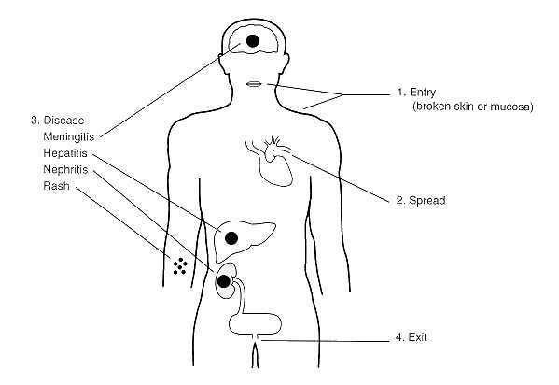
FIGURE 35-1 Clinical manifestations of leptospirosis.

Structure, Classification, and Antigenic Types
Leptospira has the general structural characteristics that distinguish spirochetes from other bacteria (Fig. 35-2). The cell is encased in a three- to five-layer outer membrane or envelope. Beneath this outer membrane are the flexible, helical peptidoglycan layer and the cytoplasmic membrane; these encompass the cytoplasmic contents of the cell. The structures surrounded by the outer membrane are collectively called the protoplasmic cylinder An unusual feature of the spirochetes is the location of the flagella, which lie between the outer membrane and the peptidoglycan layer. They are referred to as periplasmic flagella. The periplasmic flagella are attached to the protoplasmic cylinder subterminally at each end and extend toward the center of the cell. The number of periplasmic flagella per cell varies among the spirochetes. The motility of bacteria with external flagella is impeded in viscous environments, but that of spirochetes is enhanced. The slender (0. 1 µm by 8 to 20 µm) leptospires are tightly coiled, flexible cells (Fig. 35-3). In liquid media, one or both ends are usually hooked. Leptospires are too slender to be visualized with the bright-field microscope but are clearly seen by dark-field or phase microscopy. They do not stain well with aniline dyes.
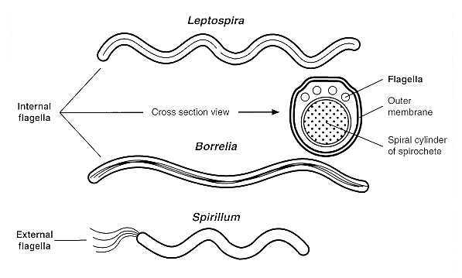
FIGURE 35-2 Morphological comparison of Leptospira, Borrelia, and Spirillum.
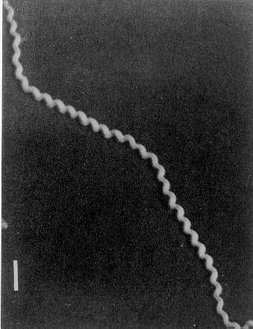
FIGURE 35-3 Electron micrograph of Leptospira interrogans serovar icterohaemorrhagiae. Bar equals 0.5 µm.
The leptospires have two periplasmic flagella, one originating at each end of the cell. The free ends of the periplasmic flagella extend toward the center of the cell, but do not overlap as they do in other spirochetes. The basal bodies of Leptospira periplasmic flagella resemble those of Gram-negative bacteria, whereas those of other spirochetes are similar to the basal bodies of Gram-positive bacteria. Leptospira differs from other spirochetes in lacking glycolipids and having diaminopimelic acid rather than ornithine in its peptidoglycan.
The leptospires are the most readily cultivated of the pathogenic spirochetes. They have relatively simple nutritional requirements; long-chain fatty acids and vitamins B1 and B12 are the only organic compounds known to be necessary for growth.
When cultivated in media of pH 7.4 at 30°C, their average generation time is about 12 hours. Aeration is required for maximal growth. They can be cultivated in plates containing soft (1 percent) agar medium, in which they form primarily subsurface colonies.
The two species, L interrogans and L biflexa, are further divided into serotypes based on their antigenic composition. More than 200 serotypes have been identified in L interrogans. The most prevalent serotypes in the United States are canicola, grippotyphosa, hardjo, icterohaemorrhagiae, and pomona. Genetic studies have demonstrated that serologically diverse serotypes may be present in the same genetic group. At least seven species of pathogenic leptospires have been identified by nucleotide analysis.

Pathogenesis
The mucosa and broken skin are the most likely sites of entry for the pathogenic leptospires (Fig. 35-1). A generalized infection ensues, but no lesion develops at the site of entry. Bacteremia occurs during the acute, leptospiremic phase of the disease. The host responds by producing antibodies that, in combination with complement, are leptospiricidal. The leptospires are rapidly eliminated from all host tissues except the brain, eyes, and kidneys. Leptospires surviving in the brain and eyes multiply slowly if at all; however, in the kidneys they multiply in the convoluted tubules and are shed in the urine (the leptospiruric phase). The leptospires may persist in the host for weeks to months; in rodents they may be shed in the urine for the lifetime of the animal. Leptospiruric urine is the vehicle of transmission of this disease.
The mechanism by which leptospires cause disease remains unresolved, as neither endotoxin nor exotoxins have been associated with them. The marked contrast between the extent of functional impairment in leptospirosis and the scarcity of histologic lesions suggests that most damage occurs at the subcellular level. Damage to the endothelial lining of the capillaries and subsequent interference with blood flow appear responsible for the lesions associated with leptospirosis. The most notable feature of severe leptospirosis is the progressive impairment of hepatic and renal function. Renal failure is the most common cause of death. The lack of substantial cell destruction in leptospirosis is reflected in the complete recovery of hepatic and renal function in survivors. Although spontaneous abortion is common in infected cattle and swine, only recently has a human case of fatal congenital leptospirosis been documented.
The host's immunologic response to leptospirosis is thought to be responsible for lesions associated with the late phase of this disease; this helps to explain the ineffectiveness of antibiotics once symptoms of the disease have been present for 4 days or more.

Host Defenses
Nonspecific host defenses appear ineffective against the virulent leptospires, which are rapidly killed in vitro by the antibody-complement system; virulent strains are more resistant to this leptospiricidal activity than are avirulent strains. Immunity to leptospirosis is primarily humoral; cell-mediated immunity does not appear to be important, but may be responsible for some of the late manifestations of the disease. Immunity to leptospirosis is serotype specific and may persist for years. Immune serum has been used to treat human leptospirosis and passively protects experimental animals from the disease. The survival of leptospires within the convoluted tubules of the kidneys may be related to the ineffectiveness of the antibody-complement system at this site. Previously infected animals can become seronegative and continue to shed leptospires in their urine, possibly because of the lack of antigenic stimulation by leptospires in the kidneys.

Epidemiology
Leptospirosis is a worldwide zoonosis with a broad spectrum of animal hosts. The primary reservoir hosts are wild animals such as rodents, which can shed leptospires throughout their lifetimes. Domestic animals are also an important source of human infections. Leptospires have been isolated from approximately 160 mammalian species in the temperate zone. The disease is more widespread in tropical countries, where the infectious agent may be one of many serotypes carried by a large variety of hosts.
Direct or indirect contact with urine containing virulent leptospires is the major means by which leptospirosis is transmitted. As mentioned above, leptospires from urine-contaminated environments, such as water and soil, enter the host through the mucous membranes and through small breaks in the skin. Moist environments with a neutral pH provide suitable conditions for survival of leptospires outside the host. Urine-contaminated soil can remain infective for as long as 14 days. In humans, leptospirosis has occurred in an infant being breast-fed by a mother with the disease. The cellular structure of leptospires causes them to be susceptible to killing by adverse conditions such as dehydration, exposure to detergents, and temperatures above 50°C. Most cases of leptospirosis occur during summer and fall.

Diagnosis
Because clinical manifestations of leptospirosis are too variable and nonspecific to be diagnostically useful, microscopic demonstration of the organisms, serologic tests, or both are used in diagnosis. The microscopic agglutination test is most frequently used for serodiagnosis. The organisms can be isolated from blood or urine on commercially available media, but the test must be requested specifically because special media are needed. Isolation of the organisms confirms the diagnosis.

Control
Human leptospirosis can be controlled by reducing its prevalence in wild and domestic animals. Although little can be done about controlling the disease in wild animals, leptospirosis in domestic animals can be controlled through vaccination with inactivated whole cells or an outer membrane preparation. If vaccines do not contain a sufficient immunogenic mass, the resulting immune response protects the host against clinical disease but not against development of the renal shedder state. Because a multiplicity of serotypes may exist in a given geographic region and the protection afforded by the inactivated vaccines is serotype specific, the use of polyvalent vaccines is recommended. Vaccines for human use are not available in the United States.
Although the leptospires are susceptible to antibiotics such as penicillin and tetracycline in vitro, use of these drugs in the treatment of leptospirosis is somewhat controversial. Treatment is most effective if initiated within a week of disease onset. At later times, immunologic damage may already have begun, rendering antimicrobial therapy less effective. Doxycycline has been used successfully as a chemoprophylactic agent for military personnel training in tropical areas.

Borrelia

Clinical Manifestations
Once the relapsing-fever borreliae have entered the host, they cause a generalized infection, apparent after an incubation period of approximately 1 week (Fig. 35-4). The onset of the disease, which is associated with numerous spirochetes in the blood is abrupt, with fever, headache, and muscle pain that persists for 4 to 10 days, followed by an afebrile period of 5 to 6 days correlated with the absence of spirochetemia. Usually, a single relapse occurs in louse-borne relapsing fever.
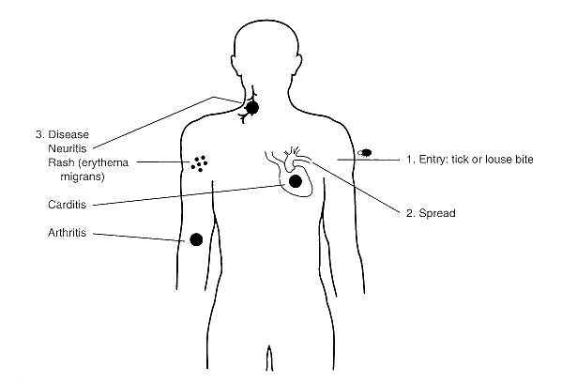
FIGURE 35-4 Pathogenesis of Borrelia infection.
The clinical features of relapsing fever, other than its recurrent pattern, are not diagnostic. The mortality in untreated epidemic relapsing fever can be higher than 40 percent, and myocarditis probably is the most common cause of death. The tick-borne relapsing fever is similar to the louse-borne disease, but is less severe (mortality, 0 to 8 percent), and several relapses of decreasing intensity are commonly experienced.

Structure, Classification, and Antigenic Types
Borrelia has morphologic characteristics similar to those of Leptospira, except that
- cells average 0.2 to 0.5 µm by 4 to 18 µm and
- have fewer coils (Fig. 35-5).
- Seven to twenty periplasmic flagella originate at each end and overlap at the center of the cell.
- In contrast to the Leptospira peptidoglycan, that of Borrelia contains ornithine rather than diaminopimelic acid. Basal bodies of periplasmic flagella of borreliae resemble those in Gram-positive bacteria. Because of their larger diameter, borreliae are more readily stained with aniline dyes than are other spirochetes. Their lipid components are unusual in that they include cholesterol; this substance has been found in only one other bacterial genus, Mycoplasma. The nutritional requirements of the borreliae are more complex than those of leptospires. Glucose, amino acids, long-chain fatty acids, N-acetylglucosamine, and several vitamins are some of their required organic nutrients. The borreliae are microaerophilic organisms. Borrelia hermsii has a generation time of 12 hours when cultivated in artificial media at 35°C compared with only 6 to 10 hours in the mouse.
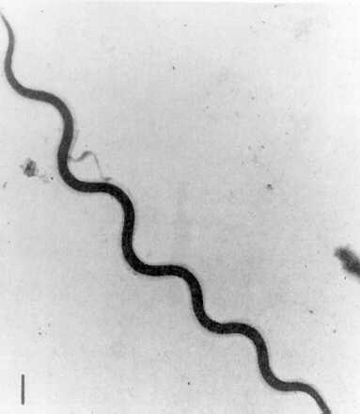
FIGURE 35-5 Electron micrograph of Borrelia hispanica. Bar equals 1 µm.

Pathogenesis
In most cases, borreliae must rely on an insect vector to transmit the organisms through the epidermis (Fig. 35-4). The site of entry is usually not prominent as the organisms are not clinically recognized until they enter the blood. The mechanisms by which they reach the bloodstream are unknown. The relapses are due to the ability of borreliae to undergo multiple cyclic antigenic variations (Fig. 35-6). As antibodies for the predominant antigenic type multiplying within the host appear, these organisms "disappear" from the peripheral blood and are replaced by a different antigenic variant within a few days. This process may occur several times in an untreated host, depending on the infecting Borrelia strain.
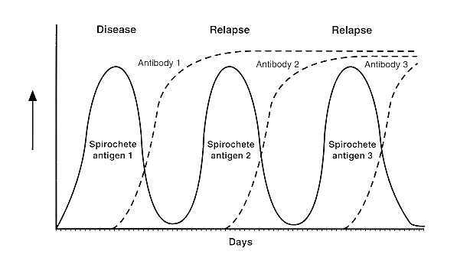
FIGURE 35-6 Immunoavoidance mechanism of Borrelia illustrating the emergence of antigenic variants during infection.
The mechanism by which borreliae cause Lyme disease has not been elucidated. Early Lyme disease is characterized by an
- expanding annular red rash,
- erythema migrans, in approximately 70 percent of patients,
- which is frequently accompanied by fever, fatigue, headache, and muscle and joint pain.
- Arthritis, neuritis, and carditis may also be present during early Lyme disease.
- Persistent neurologic and arthritic infections (lasting for months to years) may occur in some patients.
- In contrast to the relapsing fevers, there are very few spirochetes in Lyme disease, but viable B burgdorferi organisms are necessary for the disease to manifest itself. Although the disease has the same general features in the United States and Europe, arthritis occurs more frequently in the former and neurologic disease in the latter.

Host Defenses
Borrelia appears to be resistant to nonspecific host defense mechanisms and elicits an inflammatory response consisting of mononuclear cells. These spirochetes are rapidly killed in vitro by the antibody-complement system. Immunity to the borrelioses is primarily humoral, and immune serum passively protects experimental animals from infection. Several genospecies of B burgdorferi have been reported.

Epidemiology
Borrelia is transmitted to humans by the body louse or ticks. Borrelia recurrentis, the cause of louse-borne (epidemic) relapsing fever, is carried by the human louse Pediculus humanus. The louse ingests the bacterium while feeding on a borrelemic host. The organisms multiply in the hemolymph and central ganglion of the louse. Because other organs are not invaded, transovarial transmission does not occur in the louse. In addition, Borrelia organisms are released when the louse is injured by host activities such as scratching. Accordingly, one louse can infect only a single host and is infective only for its life-span of around 1 month. Therefore, humans rather than the louse are the reservoir of this disease. The louse-borne disease is called epidemic relapsing fever because it can be rapidly disseminated under conditions of overcrowding and poor personal hygiene, such as during wars and natural disasters. Relapsing fever, which depends on the aforementioned conditions favoring the multiplication and transfer of the human louse, has disappeared from the United States except for imported cases. Ethiopia appears to have the highest incidence of this disease.
The tick-borne relapsing fever is called endemic relapsing fever because it occurs whenever humans are exposed to infected ticks. The soft ticks Ornithodoros hermsi and O turicata most frequently transmit the disease in the United States. These ticks often obtain their blood meal at night, and because the tick bite is usually painless and feedings are short (5 to 20 minutes), people may not be aware of having been bitten. The designation of species of these borreliae is based on their vector (e.g., B hermsii is associated with O hermsi). Genetic studies have shown that this basis is incorrect. The two North American species, B hermsii and B turicatae, actually represent a single species. The ticks usually become infected by feeding on borrelemic rodents. In contrast to the louse, all tissues of the tick are invaded, resulting in transovarial transmission and the presence of borreliae in salivary and coxal (basal segment of appendage) secretions. These spirochetes in the salivary and coxal secretions enter the host through the bite wound while the tick is feeding (less than 1 minute may be required for transmission). The largest outbreak of tick-borne relapsing fever in the western hemisphere occurred in 1973 on the north rim of the Grand Canyon, where 62 persons staying in log cabins developed the disease.
Borrelia burgdorferi, the agent of Lyme disease, is transmitted by members of the Ixodes ricinus complex (hard ticks). In the northeastern and midwestern United States the spirochete is transmitted by the deer tick, I scapularis, whereas the western black-legged tick, I pacificus, is the primary vector in the western United States. However, only one Borrelia species, B burgdorferi, appears responsible for the disease in North America, and it does not undergo the antigenic changes of the relapsing-fever borreliae. Transovarial transmission of the spirochete is infrequent, with fewer than 1 percent of the larvae infected.
- The pinhead-sized nymph form of the tick is the primary source of human infections, but the
- disease can also be transmitted by the large adult female tick.
- Feedings are lengthy and require several days.
- The spirochetes are present in the midgut of the tick, and
- 12 to 24 hours is required before the spirochetes are transmitted.
- Within endemic areas of Lyme disease, 20 to 60 percent of I scapularis may be carriers of B burgdorferi and a similar percentage of white-footed mice, a major reservoir host, are infected. The white-tailed deer, although not a reservoir host for the spirochete, plays a critical role in the life cycle of the tick, and Lyme disease occurs in areas in which deer are present. Dogs and birds are important in the dispersal of infected ticks to new locations. The number of cases of Lyme disease reported in the United States is about 10,000 per year.

Diagnosis
Clinical features of the relapsing fevers other than their recurring pattern are not diagnostic. Diagnosis is based primarily on demonstration of the spirochetes in blood during febrile episodes by dark-field examination, use of stained blood smears, or mouse inoculation. Antibody detection by indirect immunofluorescence assay is available. There is strong cross-reactivity with antibodies to B burgdorferi and weaker reactivity with those to Treponema pallidum.
The characteristic expanding red skin lesion, erythema migrans, is diagnostic for Lyme disease. However, 30 percent of patients do not develop this rash. The usual symptoms of early disease (fever, fatigue, headache, and muscle and joint pain) are too nonspecific to be diagnostic. Although B burgdorferi has been isolated from blood, skin, and cerebrospinal fluid, this is a low yield procedure and is not recommended. Serologic tests are used most commonly for diagnosis of Lyme disease.
Unfortunately, most of the currently available tests are unable to detect early antibody responses to B burgdoferi (which may take up to two months to develop), thus the diagnosis of a patient without erythema migrans who is suspected of having early Lyme disease can be difficult. Moreover, false positive results may occur due to cross-reacting antibodies against other bacteria, especially T pallidum or other spirochetes, and patients with connective tissue disorders may demonstrate false serologic results. Despite these limitations, however, if patients being tested are carefully selected for symptoms compatible with Lyme disease and epidemiologic factors are included in consideration of the diagnosis, the positive predictive value of serologic tests can be quite acceptable, especially if positive serologic results are confirmed by a Western blotting procedure.
Many of the problems with serological testing for Lyme disease are based on interlaboratory differences in the substrate antigens, in antigen preparation, and in interpretive criteria. To improve the sensitivity and specificity of serodiagnosis of Lyme disease, evaluating serum samples from patients with symptoms of Lyme disease by a two-step process which includes a sensitive screening test such as immunofluorescence assay or enzyme immunoassay is recommended. Samples judged equivocal or positive by the screening should be further tested by Western blot. Both IgM and IgG Western blot should be performed for persons with suspected Lyme disease who present within the first four weeks of disease onset. Only IgG Western should be performed for patients presenting later because interpretation of IgM band patterns after that time is less reliable. Serologic testing of a convalescent serum sample two to four weeks after the first sample is recommended for patients who have symptoms of early Lyme disease and negative screening test results.

Control
Relapsing fevers and Lyme disease are prevented by avoiding the vectors. It is important to be aware of endemic areas and to take proper precautions. When in potential tick habitats, one should wear clothing that covers as much of the skin as possible and use tick repellents. Periodic skin inspection and tick removal prevent Lyme disease. A Lyme disease vaccine may be available in the near future. The relapsing-fever and Lyme disease borreliae have similar antibiotic susceptibilities.
- Early Lyme disease can be effectively treated with oral tetracyclines and semisynthetic penicillins.
- Arthritic and neurologic disorders are treated with high-dose intravenous penicillin G or ceftriaxone.
- Patients who have failed to respond to penicillin or tetracycline therapy have been effectively treated with ceftriaxone.

Spirillum
Spirillum is one cause and one form of rat bite fever. Spirillar rat bite fever is characterized by ulceration at the site of the bite, lymphadenopathy, rash, and a relapsing fever. The spirilla differ from the spirochetes in that the former possess the rigid cell wall and external flagella typical of Gram-negative bacterial morphology. A single species, S minus, is pathogenic for humans and is the agent of one type of rat bite fever, referred to as spirillar fever to distinguish it from that caused by Streptobacillus moniliformis (streptobacillary fever). Spirillum minus is an aerobic, short, spiral-shaped, Gram-negative rod (0.2 to 0.5 µm by 3 to 5 µm) with two to three coils and bipolar tufts of flagella. It has not been cultivated successfully on an artificial medium.
Rat bite fever is primarily a disease of wild rodents. Human infection follows the bite of a rodent or rodent-ingesting animal (Fig. 35-7). After an incubation period of about 2 weeks, the site of the bite becomes inflamed and painful, and a chancre-like ulceration may occur. Associated with this eruption are inflammation and enlargement of the adjacent lymphatics and lymph nodes, fever, headache, and a rash radiating from the wound site and lasting about 48 hours. In untreated patients the symptoms subside, only to reappear in 3 to 9 days. This relapsing fever may last for weeks to months. Because of the low incidence of this disease, little is know of its pathogenesis. Diagnosis is established by demonstrating S minus in dark-field preparations of lesions and adjacent lymph node exudates or blood. If this fails, laboratory animals free of spirilla are inoculated and examined for the development of a spirillemia. The disease has been successfully treated with penicillin. Improvement of sanitary conditions to minimize rodent contact with humans is the best preventive measure for rat bite fever.
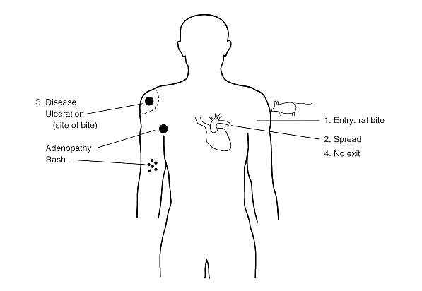
FIGURE 35-7 Pathogenesis of Spirillum infection.

REFERENCES
Baranton G, Postic D, Saint Girons I et al.:Delineation of Borrelia burgdorferi sensu stricto, Borrelia garinii sp nov and group VS 461 associated with Lyme borreliosis. Int J Syst Bacteriol 42:378, 1992
Burgdorfer W, Barbour AG, Hayes SF et al: Lyme disease: a tick-borne spirochetosis. Science 216:1317, 1982
Felsenfeld 0: Borrelia: Strains, Vectors, Human and Animal Borreliosis. Warren Green, St. Louis, 1971
Johnson RC (ed): The Biology of Parasitic Spirochetes. Academic Press, San Diego, 1976
Johnson RC (ed): Lyme disease. Rheum Dis Clin North Am 15:627, 1989
Kaufmann AE, Weyant RS: Leptospiraceae. In Murray PR, Baron EJ, Pfaller MA, Tenover FC, Yolken RH (eds): Manual of Clinical Microbiology. 6th Ed. American Society for Microbiology, Washington DC, 1995
Rahn DW, Malawista SE: Lyme disease: recommendations for diagnosis and treatment. Ann Int Med 114:472,1991
Schwan TG, Burgdorfer W, Rosa PA: Borrelia. In Murray PR, Baron EJ, Pfaller MA, Tenover FC, Yoken RH (eds): Manual of Clinical Microbiology. 6th Ed. American Society for Microbiology, Washington DC, 1995
Steere AC, Grodzicki RL, Kornblatt AN et al: The spirochetal etiology of Lyme disease. N Engl J Med 308:733, 1983

